

Personal Lines

Workflows & Procedures

*for*

Acrisure Insurance Partner Services of NY, LLC

v3.28.25

Table of Contents

How to Use this Document 6

Epic Browser 7

Logging in 7

Add the URL as a bookmark in the Chrome or Edge Browser 7

Browser Tabs 8

Connection Suite & New Functionality Popups 8

Logging out of Epic 9

Shutting Down Desktop 9

Epic Basics 10

Epic Icons 11

Keyboard Shortcuts 11

Home Base 12

Client Accounts 13

Account Sources 13

Servicing Roles 14

Locate Account 15

Close Out of an Account Record 16

Contacts 17

Contacts Overview 17

Add Additional Contacts 18

Activities 20

Home Base Open Activities 20

Activity Access Levels 21

Activity Workgroups 21

System Generated Activity Codes 22

Manual Activity Codes (F9) 25

Sticky Notes 27

Email 28

Microsoft Outlook Integration with Epic 28

Configuring Attach to Epic Plug-In in Outlook 28

Email from Distribution Manager 29

Faxing 33

From Distribution Manager 33

Attachments 34

Add Attachments and Documents by Dragging & Dropping into Epic 34

Attach using Add Attachment Button located in Attachment area: 35

Add Attachments and Documents using Attach to Epic Plug–In 36

Attachment Access Levels 37

Attachment Actions 37

Finding and viewing attachments/documents 38

Folder Structure 39

Folder View 39

Create a Form Letter 40

Access Filter 42

Policy Basics 43

Policy Sources – REQUIRED FIELD 43

Policy Types 44

Policy Statuses 45

Select the Correct Issuing Company (ICO) 46

Select the Correct Broker Payable Contract 46

Service Summary Rows and Stages 47

Change Policy Dates 50

Copy Policy 51

Print Application 52

ACORD Application Prefills 53

Multi-Year Policies 54

Continuous Policies (policies that do not expire) 55

New York Platform Epic Structure 56

Best Practice Guide 58

Attachments 58

Client Name 58

Personal Lines Account/Policy in a Business Name 58

Client Addresses 58

E-Signature 59

Relationship Summary 59

Pr/Br tab 60

Conditional Renewals 61

Carrier Access 60

**WORKFLOWS** 62

New Business Workflow 63

Add New Client Account (Prospect/Insured) 63

Quoting/Marketing/Binding 66

Change Client Type from Prospect to Insured 70

Add Policy Shell 71

BOR Workflow 74

1. Follow Add New Client Account for new clients or if existing client locate Client Account. 74

2. From the navigation panel, click Policies 74

Renew Policy Workflow 76

Renew Download 76

Renew Non-Download 76

Rewrite Policy Workflow 78

Remarket Download 79

Remarket Non-Download 82

Policy Received Workflow 84

Policy Received 84

Policy Change Workflow 87

Process Change Request (Existing Line) (CHGE, CHGI) 87

Process an Audit Received from the Carrier (CHGA): 90

Process Change Request (Add Line Mid-Term) 92

Endorsement Received from Carrier 95

Cancel Policy Workflow 97

Cancel Monoline Policy 97

Cancel a Policy Line from a Package Mid-Term 102

Notice of Cancellation for Non-Pay 104

Carrier Notice of Cancellation (Other than Non Payment) 106

Policy Not Renewed Workflow 108

Mark Policy as Not Renewed 108

Policy Reinstated Workflow 109

Reinstate Policy 109

Claims Workflow 111

Add New Manual Activity for Claim 111

Client Contracts/Services Workflow 112

Add New Client Contracts/Service 112

Client Contracts/Services – Service Codes 115

Sales Opportunities 116

Creating a new Opportunity 117

Updating the Opportunity 118

Working through the Individual Dashboard 120

**JOB AIDS** 123

JA.1 Epic Quotes 124

Search Available Carriers 124

One-Click Carrier Quoting (New Business) 124

Quoting via Live Fill 134

One-Click Carrier Quoting (Remarket Existing Policy) 136

JA.2 Marketing Module Lite 139

New Business + Rewrite/Remarket 139

Add Master Marketing Submission 139

Add QNEW/QREW Activity for each carrier 141

Create + Submit ACORD Applications 142

Carrier Responses Received 143

Carrier Selected for Binding 144

Move Binding Carrier Submission to Policies – Current/Renewed 145

JA.3 Accounting Activities 147

JA.4 Renewals Manager 148

Renewal Stages 148

Renewal Events 148

Renewal Manager Workflows 150

JA.5 Proofs of Insurance 153

Auto ID Cards in Epic 153

Evidence Processing in Epic 154

Certificate Processing in Epic 158

EPIC Binder 166

JA.6 DocuSign Integration 169

JA.7 Attachment Naming Conventions 172

JA.8 CSR24 – Set Up Portal User from EPIC Contacts 173

JA.9 CSR24 – Making Attachments Client Accessible 175

JA.10 Front End Batch Scanning in Epic Browser 176

JA.11 Creating a Proposal or Summary in Epic 179

General Information 179

Summary of Insurance + Proposals 180

JA. 13 Indio 182

New Business Submission Processing 182

E-Signature 183

JA. 14 Non-Insurance Product Policies 185

Add Policy 185

JA. 16 Conversion Cleanup – Update Incorrect Policy Type 186

Policy is in Submitted or Issued status: 186

Change Policy Type Header – If Applicable 187

Inactivate an Incorrect POLICY/ MIGRATED LINE(S) 189

Policy is In Process Status 190

JA. 17Policy Setup – Invoice Needed prior to Binding 192

Create Policy 192

Policies – Current/Renewed (no marketing module used) 192

Policies – Marketed (marketing module used) 194

Create Invoice Request for Accounting 196

Quote Rejected 197

JA. 18 Attachments – Rename or Move 198

Rename Attachments 198

Move Attachments 198

# How to Use this Document

|  |
| --- |
| This document contains valuable information relevant to the usage of EPIC, including **Epic Basics**, day-to-day **Workflows**, and **Job Aids. DO NOT PRINT THIS DOCUMENT.**  For optimal usage:   * Click the **View** menu at the top in the Microsoft Word toolbar * Checkmark **Navigation Pane**      * The left pane will open and show a listing of topics      * Click on the topic to jump to that section/page. * Hyperlinks within the document will lead to specific pages or Job Aids.      * Some hyperlinks will connect to a webpage outside of the document. |

# Epic Browser

## Logging in

|  |
| --- |
| 1. Open a web browser.    1. Chrome    2. Edge 2. Enter URL:    1. **Production/Live**: <https://acris03.appliedepic.com/#/>    2. **Test/Training**: <https://ve061t1web.appliedepic.com/#/> |

## Add the URL as a bookmark in the Chrome or Edge Browser

|  |  |  |
| --- | --- | --- |
| 1. In the browser URL address field, enter <https://acris03.appliedepic.com/#/>; press the keyboard enter key 2. Add to Bookmarks/Favorites as follows:  |  |  | | --- | --- | | **CHROME**    Click the star icon  Enter a name for the bookmark; click Done | **EDGE**    Click the star icon  Enter name and add to Favorites Bar; click Done | |

## Browser Tabs

|  |
| --- |
| Browser tabs will open at the top when accounts are located and selected    Use browser tools like Tab Grouping and Zoom, if desired.  To prevent connection issues, close out of a client by clicking the X above the Logout button, NOT the x in the browser tab |

## Connection Suite & New Functionality Popups

|  |
| --- |
| The Connection Suite is required to ensure full functionality and connection within Epic Browser. Acrisure IT manages all updates in the background for the Connection Suite Plugin. **Ignore these popups.** If you are receiving an error, follow the instructions to hard shutdown to ensure there’s a clean connection to all services run on your computer. If you are experiencing functionality issues after shutting down, submit a ticket to [support@acrisure.com](mailto:support@acrisure.com).  ***Reminder: A hard shut down of your computer should be done at the end of each workday.*** |

## Logging out of Epic

|  |
| --- |
| **\*\*IMPORTANT\*\***  When **closing out of Epic,** click the **LOGOUT** button at the top right in the blue Options Bar. **Do not X out.** Epic will not close properly which may cause issues when signing back in again.  **NO** |

**Shutting Down Desktop**

|  |  |  |  |  |  |  |
| --- | --- | --- | --- | --- | --- | --- |
| **\*\*IMPORTANT\*\***  Log out of Epic and SHUT DOWN your computer **at the end of each workday.**   |  |  | | --- | --- | | 1. Shut down the computer by clicking the Start Menu in the bottom left-hand corner of your desktop |  | | 1. Click Power |  | | 1. Click Shut Down |  | |

# Epic Basics



## Epic Icons

|  |  |  |  |
| --- | --- | --- | --- |
|  | Add New |  | Change column width |
|  | Edit |  | To define a search |
|  | Print list view |  | Executes search. These are cumulative. To begin a new search, click “Clear Filter” |
|  | Sortable column – ascending/descending |  | The logout button will close all open windows. If any screen requires validation (the process isn’t complete), the screen with display prior to closing |
|  | Change the order of items | **RIGHT CLICK** | Right clicking on a selected policy, activity or contact will often generate the same menu options as found in ACTIONS. |
|  | Collapses and opens sections of screen or moves full list from one screen to another |  | Click on the Paperclip to attach documents saved in Epic (Email) |
|  | Required Field – must complete |  | Click on the File to attach files saved on a local or network drive (Email) |
|  | Desired Field – agency would like field completed |  | Contacts in EPIC (from email) |
|  | Customize columns displayed in the list view |  | Contacts in Outlook (from email) |

## Keyboard Shortcuts

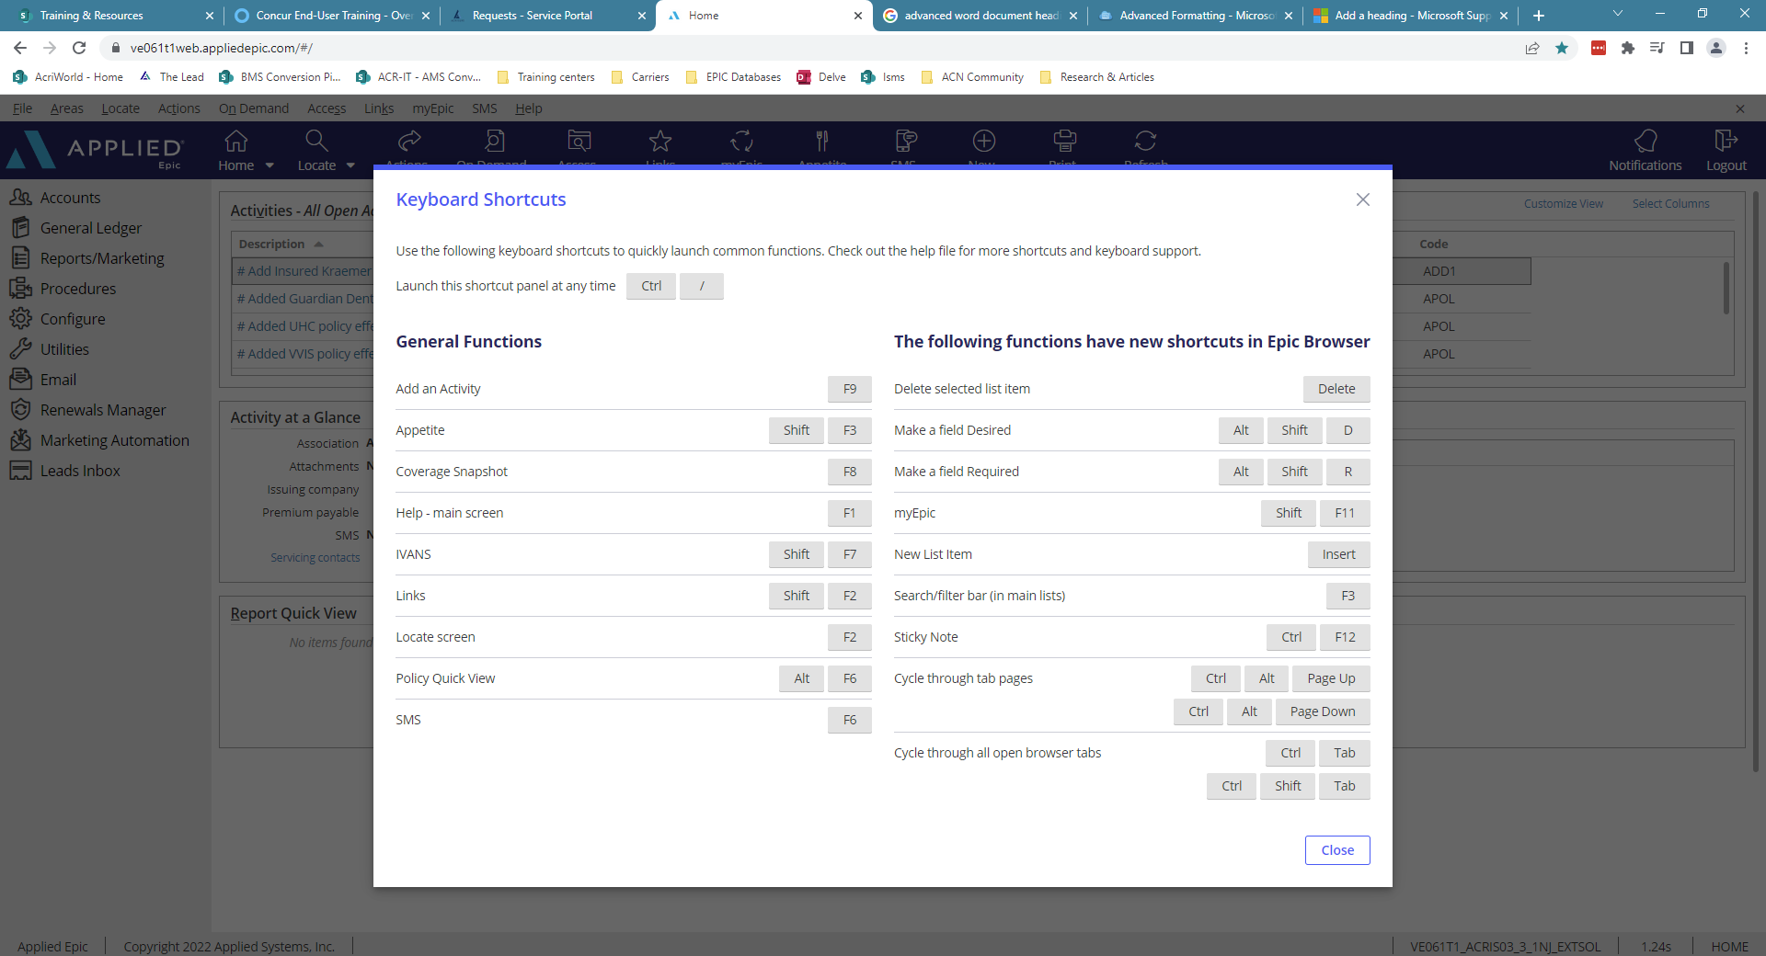

## Home Base

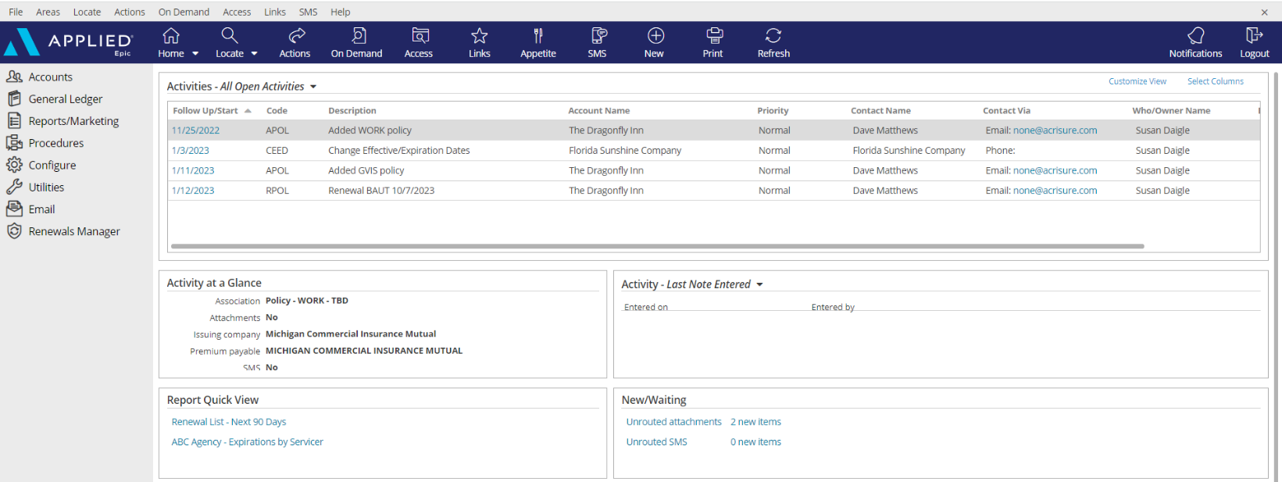

|  |
| --- |
| 1. **Open Activities** (suspense, follow up, to-do list)    * Use “**Select Columns**” to add columns to your view.    * The position of the columns can also be changed by clicking and dragging the column headers to the desired location.    * Sort columns in ascending or descending order by clicking on the column header. 2. **Activity at a Glance** – displays information about the highlighted activity. 3. **Activity Tasks** OR **Last Note Entered** – when a task within an activity is assigned to you, the task will appear here but only if the activity above, associated with the task, is highlighted. The view can be changed from “Activity – Tasks” to “Last Note Entered” by clicking the dropdown arrow and selecting the appropriate option. 4. **Report Quick View** – Created reports can be sent to Report Quick View for easy access. Just click the link and the report will open. Data displayed is in real time and will be refreshed as of the date it is opened. 5. **New/Waiting** – If your agency has opted to use Front End Scanning, scanned mail can be accessed by clicking the “Unrouted Attachments” link. The number of items in your “inbox” will also display. 6. **Navigation Panel** – Items listed here will direct you to distinct parts of Epic or to the client’s account. Items available will change depending on which screen is being utilized. This is known as the “View” panel. 7. **Blue Options Bar** – Each icon contains action options, which will change depending on which screen is being utilized. Think of this as the “Do” bar. 8. **Log Out button** – Clicking this button will close all the open screens/windows and log out of Epic. 9. **Locate** – Click the dropdown arrow to see a list of the last 20 accounts accessed |

## Client Accounts

### Account Sources

|  |  |  |  |  |  |  |  |  |  |  |  |  |  |  |  |  |  |  |  |  |  |  |  |  |  |  |  |  |  |  |  |  |  |  |  |  |  |  |  |  |  |  |  |  |  |  |  |
| --- | --- | --- | --- | --- | --- | --- | --- | --- | --- | --- | --- | --- | --- | --- | --- | --- | --- | --- | --- | --- | --- | --- | --- | --- | --- | --- | --- | --- | --- | --- | --- | --- | --- | --- | --- | --- | --- | --- | --- | --- | --- | --- | --- | --- | --- | --- | --- |
| |  | | --- | | 0. Cross Sell-Platform | | 1. AM/AE Solicited | | 1. Producer Solicited | | 2. Referral - Acrisure Cyber Services | | 2. Referral - Acrisure Title Partner | | 2. Referral - Association | | 2. Referral - Broker - Acrisure | | 2. Referral - Broker Non-Acrisure | | 2. Referral - Client | | 2. Referral - Employee | | Referral – Evolution Advisors | | 2. Referral - FBC Mortgage | | 2. Referral - Financial Partner/WM | | 2. Referral - GA | | 2. Referral - Loan Officer | | 2. Referral - Other | | 2. Referral - Payroll Firm | | 2. Referral - Realtor | | 2. Referral - TPA | | 3. Marketing - Acrisure.com | | 3. Marketing - Internet Search | | 3. Marketing - Other | | 3. Marketing - Social Media | | 3. Marketing - Telemarketing | | 3. Marketing - Tradeshow | | 4. Other/Unknown | | 5. Win Back | | 6. Call In/Walk In | | COI - Herrick Feinstein LLP | | FO – Addicus Advisors | | FO - Anchin | | FO - CapTrust | | FO - Chilton Trust | | FO - Corient | | FO - Crestbridge | | FO - GM Advisory Group | | FO - IQEQ | | FO - KKR | | FO - Lake Street Advisors | | FO - Mariner Wealth | | FO - Northern Trust ATL | | FO - Raymond James (ATL) | | FO - SAX LLP | | Referral - ADP | | Referral - Technology Partner | | Z. Update Needed | | **Account Source is a Required Field.**  **Be sure to select the appropriate Source for tracking and reporting purposes.**  If you do not know the policy source, select “**Update Needed**” so it can be updated when known. |

### Servicing Roles

|  |  |  |  |  |  |  |  |
| --- | --- | --- | --- | --- | --- | --- | --- |
| **External Service Team** | |  | | --- | | Acrisure Service Center | | Carrier Service Center | | GA - Emerson Reid | | GA - Martin Insurance Services * | | GA - PGM * | | GA - Suvaun * |   **When an account and/or policy is managed by an external service team (the Acrisure Service Center, a Carrier Service Center, or a General Agent on the EB side), select the appropriate one from the drop-down list.**  **Note:**  **An Acrisure-owned GA will be indicated by an asterisk.** |
| Marketing |
| P&C Producer 1 |
| P&C Producer 2 |
| P&C Servicer 1 |
| P&C Servicer 2 |
| P&C Claims |
| P&C Account Executive |
| Surety Producer 1 |
| Surety Servicer |
| EB Producer 1 |
| EB Producer 2 |
| EB Servicer 1 |
| EB Servicer 2 |
| EB Account Executive |
| Non-Insurance Producer |
| CRM Relationship Manager |
| Contract Producer/Consultant |
| Contract Servicer |

### Locate Account

|  |
| --- |
| * Click the **Locate** button to **search** for existing clients   **Locate By Options:**   * + **Account/Business Name** – *contains* anywhere in the account detail name field and business contact   + **Claims: Additional Party** – by involvement type, name, or phone number   + **Date of Loss** – by claim loss date - range   + **Email Address** – any contacts email address   + **Insurer Claim#** - must be exact & complete   + **Internal Claim#** - must be exact & complete   + **Invoice #** - must be exact number   + **Last name, first name** – *begins with* and will search account detail name field and individual contacts   + **Line ID** -begins with   + **Loan #** - must be exact   + **Lookup Code** – *begins with*   + **Phone Number** – must be exact & complete   + **Policy #** - *begins with*   + **Prior Account ID** – *begins with* (from your prior system)   + **Relationship** – relationship type and then account name   + **Sanction Search Reference #**   + **Street Address –** can contain any part of an address   + **Submission ID** – *begins with* (in marketing)   + **Vehicle Registration Number –** begins with * Click the **Locate** button to **add new** client accounts. * Click the **drop-down arrow** on the **Locate** button to access the last 20 accounts accessed (including client accounts, employee accounts, company accounts, etc.) |

### Close Out of an Account Record

|  |
| --- |
| Locating and selecting an account will create a new tab in the browser. **Close the account record by clicking the X above the Logout button** NOT by clicking the x within the tab at the top. |

## Contacts

### Contacts Overview

|  |  |
| --- | --- |
| **Individual Contact** | This is an additional individual contact (person) on the account. By choosing an individual contact, additional fields are made available, such as date of birth, SSN, marital status, driver's license number, etc. Click the lock to the right of the PII fields to secure the field, making it private. |
| **Primary Contact** | This is an **individual contact** that should be selected as the primary contact for the account. To make a contact **Primary,** click **ACTIONS** **> Change Primary Contact**. The Primary Contact is displayed in the Rolodex Card on the bottom left corner of the client’s account. |
| **Category** | Contacts are categorized based on their relationship to the Account: Contact Only—Policy Only—Both Contact & Policy |
| **Description** | Add **Description** to best represent the position or role of the contact (i.e., owner, manager, etc.) Select the appropriate description(s) for each Contact. This information is used for tracking and reporting. |
| **Classifications** | **Be sure to select** the appropriate contact classification. DM=Decision Maker; PC=Primary Contact   |  |  | | --- | --- | | __User - Benefits Technology | _HR Leader | | __User - CSR24/Portal | _Personal (DM) | | __User - HR Portal | _Personal (PC) | | __User - Indio | _Risk Management (PC) | | _Certificates | _Surety (DM) | | _Commercial (DM) | _Surety (PC) | | _Commercial (PC) | _Work Comp (DM) | | _Cyber (DM) | _Work Comp (PC) | | _Cyber (PC) | Safety-Retail (PC) | | _EB (DM) | Safety-Wholesale (PC) | | _EB (PC) |  | | _EB Compliance |  | | _EB Eligibility Contact |  | | _EB HRLS Compliance Summit |  | | _EB Plan Admin |  | |

### Add Additional Contacts

|  |
| --- |
| **Please view the New York Platform – Best Practice Guide for Addresses + Contacts.**  To set up a contact for CSR24/User Portal access: **CSR24/Portal Access.** |

#### Add Individual Contact

|  |
| --- |
| 1. From your client’s navigation panel, click **Contacts** 2. Click **Add (+)** 3. Select the **Individual** radio button 4. From **Add Contact**, enter details , **RED** is required: 5. **Name** 6. **Category,** indicate whether contact only, policy only, or both contact & policy 7. **Description**, select the appropriate description for this contact 8. From **Address**, enter details, **RED** is required: 9. If the account address is the same as the contact address, check the box for Use Account Address. 10. From **Primary Number**, enter details: 11. Enter phone number (indicate if mobile) and email address**NOTE: Email is a required field. If the contact does not have an email address, enter none@acrisure.com.** 12. Click **Detail** 13. Verify/Update the following tabs, **RED\*** is required, to add preferences and business information: 14. **Preferences** 15. **Personal** 16. Click **Save Contact** |

#### Add Business Contact

|  |
| --- |
| 1. From your client’s navigation panel, click **Contacts** 2. Click **Add (+)** 3. Select the **Business** radio button 4. From **Add Contact**, enter details , **RED** is required: 5. **Name** 6. **Category,** indicate whether contact only, policy only, or both contact & policy 7. **Description**, select the appropriate description for this contact 8. From **Address**, enter details, **RED** is required: 9. If the account address is the same as the contact address, check the box for Use Account Address. 10. From **Primary Number**, enter details:   a. Enter phone number (indicate if mobile) and email address**NOTE: Email is a required field. If the contact does not have an email address, enter none@acrisure.com.**   1. Click **Detail** 2. Click **Edit** 3. From **Edit Contact Summary,** verify/update. **NOTE: NAICS is a required field.** 4. Click **Save Contact Summary** 5. Verify/Update the following tabs, **RED\*** is required, to add preferences and business information. **NOTE: Identification Numbers is required, select from the Type dropdown.** 6. **P Preferences** 7. **Personal** 8. Click **Save Contact** |

## Activities

|  |
| --- |
| Activities track actions taken on each account and serve as reminders to follow up on various items and permanently document the file with the use of Notes within Activities.  Tasks breakdown activities into small assignments and allow multiple users to work on an activity. A Task has its own Status, can be added as needed and Notes within a Task can manage progress.  **Note:**  **Activities and notes within an Activity cannot be moved from account to account.**  **\*You can multi-select activities (CTRL + Click) and perform actions to multiple activities at the same time*.***  **NY Platform leaderships requests that you do not change the Activity description default unless prompted for data within, you may add to the end of the Activity description.** |

### Home Base Open Activities

|  |  |
| --- | --- |
| **Select Columns** | Check or uncheck the columns desired to reflect within the Home Base View |
| **Customize View** | Allows the addition of other Employee activities to reflect within your own open activities list (if given permission) |
| **\*Right Click to Manage** | * **Close Activity** – *follow up action is completed* * **Add Note** – *add notes related to the process that is still pending* * **Add Task** – *assign a portion of the activity process to someone else to work on* * **Change Follow-up Date/Time** – *if the deadline for completing the activity can be moved* * **Change Who/Owner** – *reassign the activity for someone else to take care of, which will move to their Home Base* * **View All Notes** – *Read all notes related to a specific activity process*      * **Take Ownership** – *If the activity is assigned to another person or a work group, you can reassign the activity to yourself* |

### Activity Access Levels

|  |  |  |  |  |  |  |  |
| --- | --- | --- | --- | --- | --- | --- | --- |
| |  | | --- | | **Description** | | Accounting | | Financials | | HIPAA | | Management | | Other Interests | |  | |

### Activity Workgroups

|  |  |  |  |  |  |  |  |  |  |  |  |  |  |  |  |  |  |  |  |  |  |  |  |  |  |  |  |  |  |  |  |  |  |  |  |  |  |  |  |  |  |  |  |  |  |  |  |  |
| --- | --- | --- | --- | --- | --- | --- | --- | --- | --- | --- | --- | --- | --- | --- | --- | --- | --- | --- | --- | --- | --- | --- | --- | --- | --- | --- | --- | --- | --- | --- | --- | --- | --- | --- | --- | --- | --- | --- | --- | --- | --- | --- | --- | --- | --- | --- | --- | --- |
| |  |  | | --- | --- | | **Code** | **Description** | | @APPAY | Applied Pay Default Work Group | | @EXT | External Default Group | | @LEADS | Leads Inbox Default Work Group | | ACCT | Accounting | | APAY | Accounting - Payables | | APRA | Acrisure Private Risk Advisors | | ARVW | Accounting Review | | CIDT | ACRISURE Centralized Interface Download Team | | DBSC | Direct Bill Service Center | | FCERT | Flatworld Certificates | | FLR | Flatworld Loss Runs | | INVO | Invoicing | | KCLC | Keevily CL Certificates | | PCERT | Patra Certificates | | PDR | Patra Document Retrieval | | PEP | Patra Endorsement Processing | | PLR | Patra Loss Runs | | PPC | Patra Policy Checking | | SA | Systems Analyst | | SCSC | Select - Carrier Service Center | | SGCL | Safety Group Claims | | SGCT | Safety Group Certificate | | SGRN | Safety Renewal | |

### System Generated Activity Codes

|  |  |  |
| --- | --- | --- |
| **Code** | **Description** | **Event** |
| ACLM | # Added claim for DOL &DateLoss& | Add Claim |
| ADD1 | # Add Insured &AcctName& | Add Account |
| ADD2 | # Add Prospect &AcctName& | Add Account |
| ADD3 | # Add Billing Company: &LookCode& &AcctName& | Add Account |
| ADD4 | # Add Issuing Company: &LookCode& &AcctName& | Add Account |
| ADD5 | # Add Broker: &LookCode& &AcctName& | Add Account |
| ADD6 | # Add Employee: &AcctName& | Add Account |
| ADD7 | # Add Finance Company | Add Account |
| ADJR | # Adjust Receipt | Adjust Receipt |
| ADSC | # Add Service | Add Service |
| AMMK | # Added master marketing submission for &AcctName& | New Marketing Submission |
| AOP | # Add Opportunity | Add Opportunity |
| APOL | #Added &PolDesc& policy effective &PolEffDate& | Add Policy |
| ARWO | # A/R Write-Off | A/R Write-Off |
| AUID | # Issued auto ID card | Issue Auto ID Card |
| BIND | # Issued binder &PolDesc& &PolEffDate &Policy#& | Issue Binder |
| BND1 | # Bind Policy via Master Marketing | Move Marketed Lines to Current Policies |
| BORB | # BOR Benefits - Agent Received Date: | Add Policy |
| BORP | # BOR P&C - Agent Received Date: | Add Policy |
| CBOR | # Canceled - Lost Policy via BOR Eff: &ServSumEffDate& &ServSumDesc& | Cancel Policy/Line |
| CCTI | # Change Client Type To Insured | Change Client Type |
| CCTP | # Change Client Type to Prospect | Change Client Type |
| CEED | # Change Effective/Expiration Dates | Change Effective/Expiration Dates |
| CERT | # Issued Certificate ( &OintNm& ) | Issue Certificate |
| CHGA | # Audit &ServSumEffDate& &ServSumDesc& | Endorse/Revise-Existing Lines |
| CHGE | # Change &ServSumEffDate& &ServSumDesc& | Endorse/Revise-Existing Lines |
| CHGI | # Internal Correction &ServSumEffDate& &ServSumDesc& | Endorse/Revise-Existing Lines |
| CHGL | # &ServSumEffDate& &ServSumDesc& | Endorse/Revise-Add Line Midterm |
| CPOL | # Canceled - Lost Policy Eff: &ServSumEffDate& &ServSumDesc& | Cancel Policy/Line |
| CREF | # Client Refund | Client Refund |
| CREW | # Canceled - Rewritten Policy Eff: &ServSumEffDate& &ServSumDesc& | Cancel Policy/Line |
| CS24 | # Client Portal Account Created &ContactName& | Client Portal Account Created |
| DSUS | # Processed downloaded policy suspense item | Process Downloaded Policy Suspense Item |
| ESIG | # Send to eSignature | Send to eSignature |
| EVID | # Issued Evidence of Insurance &PolDesc& &PolEffDate& | Issue Evidence of Insurance |
| LOS1 | # Lost Opportunity: &AcctName& | Close Opportunity |
| MDIS | # Mark Discrepency | Mark Discrepancy |
| MRDS | # Modify Revenue Deferral Schedule | Modify Revenue Deferral Schedule |
| PMT1 | # Receipt for Payment | Generate Receipt for Payment |
| PMT2 | # Receipt for Payment - SWEEP | Generate Receipt for Payment |
| PROP | # Proposal Generated | Proposal |
| RCER | # Renewed COI | Renew Certificate of Insurance |
| RCHK | # Reprint Checks | Reprint Checks |
| REIN | # Reinstated policy/line | Reinstate Policy/Line |
| RESC | # Renew Service | Renew Service |
| REVI | # Renewed EOP | Renew Evidence of Insurance |
| ROST | # Reopen Statement | Reopen Statement |
| RPOL | # Renewal &PolDesc& policy effective &PolEffDate& | Renew Policy |
| RTBI | Real-Time billing inquiry | Real-Time Billing Inquiry |
| RTCI | Real-Time claim inquiry | Real-Time Claim Inquiry |
| RTCW | Real-Time company website | Real-Time Company Website |
| RTEN | Real-Time endorsement | Real-Time Endorsement |
| RTIS | Real-Time policy issuance | Real-Time Issue |
| RTLR | Real-Time loss run | Real-Time Loss Run |
| RTMP | Real-Time payment made | Real-Time Make Payment |
| RTMV | Real-Time MVR | Real-Time MVR |
| RTNL | Real-Time first notice of loss for &DateLoss& | Real-Time 1st Notice of Loss |
| RTPF | Real-Time premium finance | Real-Time Premium Finance |
| RTPI | Real-Time policy inquiry | Real-Time Policy Inquiry |
| RTQT | Real-Time quote | Real-Time Quote |
| RTRA | Real-Time Reverse Alerts! | Real-Time Reverse Alerts! |
| RTRM | Real-Time rate manager | Real-Time Rate Manager |
| RTRT | Real-Time rate | Real-Time Rate |
| RTSS | Real-Time schedule submitted | Real-Time Schedule Submit |
| RVPR | # Revised Premium | Revise Premium |
| RVST | # Reverse Statement | Reverse Statement |
| SCAS | # Submitted to Carrier &PPEName& for quote on &PolDesc& | Submit to Carriers |
| SMR | # SMS Routed | SMS Routed |
| SMS | # SMS Sent | SMS Sent |
| SUMM | # Summary Generated | Proposal |
| VDIS | # Void Disbursement | Void Disbursement |
| VPMT | # Payment - Insufficient Funds | Void Payment |
| WON1 | # Won P&C Opportunity: &AcctName& | Close Opportunity |
| WON2 | # Won EB Opportunity: &AcctName& | Close Opportunity |
| WON3 | # Won Surety Opportunity: &AcctName& | Close Opportunity |
| WON4 | # Won RMS Opportunity: &AcctName& | Close Opportunity |
| WON5 | # Won Flood Consulting Opportunity | Close Opportunity |
| WON6 | # Won Flood Insurance Opportunity | Close Opportunity |
| WON7 | # Won Referral Opportunity | Close Opportunity |
| WON8 | # Won IND Opportunity: &AcctName& | Close Opportunity |
| WON9 | # Won FIN Opportunity: &AcctName& | Close Opportunity |

### Manual Activity Codes (F9)

#### For Accounting Workflow Activities – See [SharePoint](https://acrisure.sharepoint.com/:w:/s/ACR-ABSAccountingTeam/ESAdZgcBwPdJt0_n5-hNILkBueeqZpQWrGK6rg54rr9l7g?e=4LVSdM&clickparams=eyJBcHBOYW1lIjoiVGVhbXMtRGVza3RvcCIsIkFwcFZlcnNpb24iOiI0OS8yMzExMzAyODcyNCJ9) for Platform Activity Guide

#### Personal Lines Workflow Manual Activities

|  |  |
| --- | --- |
| **Code** | **Description** |
| **1DS1** | Service Transition to Digital Service |
| **1DS2** | Service Transition back to Regional Service |
| **GAID** | Carrier Requested Auto ID Card |
| **GAPT** | Appointment with &AcctName& |
| **GCAL** | Call from &AcctName& |
| **GCHG** | CSR24 Policy Change Request |
| **GCLM** | CSR24 Claim |
| **GCSA** | Cross Sell Agreement |
| **GNRN** | Policy Not Renewed |
| **GPOR** | CSR24 Client Self Setup on Portal |
| **GXFL** | Ex-date follow-up for &AcctName& |
| **PAPR** | PL - Appraisal |
| **PARV** | PL - Account Review |
| **PBFO** | PL - BOR Follow up |
| **PBIQ** | PL - Billing Inquiry |
| **PBND** | PL - Bind Request to Carrier |
| **PCIQ** | Coverage Inquiry |
| **PCN1** | PL - Carrier Notice of Cancellation |
| **PCN2** | PL - Notice of Cancellation for Non-Payment |
| **PCN3** | PL - Carrier Notice of Non-Renewal |
| **PCOI** | PL – COI Request |
| **PCPY** | PL – Direct Bill payment |
| **PCRF** | PL - Refer Claim to Claims Team |
| **PDBP** | PL – Direct Bill payment received |
| **PEOP** | PL - EOP Request |
| **PLCR** | PL - Loss Control Recommendation |
| **PLMS** | PL Marketing Submission |
| **PLRR** | PL - Renewal Review &PolExpDate& |
| **PMVR** | PL - MVR Request |
| **PNCO** | New PL Client Onboarding |
| **PPCK** | PL - Policy Checking |
| **PRMK** | Remarket Request |
| **PRSK** | Account At Risk |
| **PUND** | PL - Underwriting |
| **QNEW** | Quote - New Business |
| **QREW** | Quote - Renewal/Rewrite |

## Sticky Notes

|  |
| --- |
| You can add a sticky note to an area of an account (e.g., a client's contact area or detail for an employee), a specific item on the account (e.g., a policy, binder, or claim), or an area in the program (e.g., claims reports or unrouted attachments). The note displays when the area is accessed. |

|  |
| --- |
| 1. From your clients blue menu bar, click **New** 2. Click **Sticky Note** 3. Enter note details   **Helpful notes:**   1. Click the **Double Right Arrows,** to collapse note 2. Click the **Three Vertical Dots**, to manage sticky note 3. Click **X**, to delete sticky note 4. Click **+**, to add a new sticky note |

## Email

### Microsoft Outlook Integration with Epic

#### Set Outlook Email Integration Default

|  |
| --- |
| ***Setting Outlook as the Email Integration Option will allow the launch of Outlook from Epic. Emails sent from Epic will automatically attach to the client’s account and will also add a Sent Item in Outlook.***  ***This integration applies to emailing from Attachments or from any of the blue email links within a client’s account. This does NOT apply to the Distribution Manager.***   1. From the Home Base, click **Configure** from the left Navigation Panel 2. Click **User Options** and select **Email** 3. Select the Outlook radio button      1. Click **Finish.** |

### Configuring Attach to Epic Plug-In in Outlook

|  |
| --- |
| 1. Open Microsoft Outlook 2. Find **Attach to Epic** in the ribbon and click the down arrow next to the word **Applied**      1. Select Browser 2. Enter the Applied Epic Browser URL 3. Choose a Default Browser      1. X out of this window |

### Email from Distribution Manager

#### Set up Distribution Manager Email Account

|  |
| --- |
| 1. From the **Home Base**, click **Configure** from the left Navigation Panel 2. Click **User Options** and select **Distribution Email Accounts** 3. If more than one account is listed, **delete all except Primary Email Account**      1. Highlight Email Account and click the **Edit** pencil 2. Enter the Distribution Email Details as follows    * Associated Agency = select your Agency from the dropdown list    * Display Name = enter your full name    * Reply address = enter your email address 3. Mail Server Settings    * Check the box to Use external mail server    * Enter your email address 4. Click **Finish**   **NOTE: For those whose legal entity name is being retained (Public Entity, Financial Services, etc.) it is important NOT to use the Acrisure email address; use your legal entity’s email address.** |

#### Set up Distribution Email Signature

|  |
| --- |
| 1. From **Outlook**, Copy your email signature (Right Click/Copy or CTRL+C) 2. Go back to EPIC 3. From the **Home Base**, click **Configure** from the left Navigation Panel 4. Click **User Options** and select **Distribution Email Accounts** 5. With your DMS email account highlighted, click the edit pencil 6. Click the **Email Signature** tab 7. Click the **Add** button (+) 8. Enter a **Description** for your signature and check the **Default** box      1. In the white space below the format buttons, paste the email signature which was copied in Step 1 above (Right Click/Paste or CTRL+V) |

#### *If Acrisure Logo does not paste appropriately follow the steps below*

|  |
| --- |
| 1. Right click your Acrisure logo from your email signature inside of outlook and click Save as picture.      1. Go back into Epic, Click to Highlight box where logo should appear. 2. Select Insert/Edit Image Button 3. Search for Logo saved to your computer      1. Once Logo is selected click Open, then Click blue Ok button. 2. Resize Acrisure logo as needed. 3. Click **Finish** 4. The email signature will now be listed    Click Finish. |

#### Send Email from Distribution Manager

|  |
| --- |
| As part of the normal workflow, when the ACORD form is ready to print/send, utilize the **Distribution Manager** to send documents.   1. From the **Distribution** Tab, set delivery option to **Email** 2. The **From** field defaults to your email address, however the sender can be changed 3. Add **Signature** (should default) 4. Add more than one recipient, cc, or bcc 5. Enter body of the email with full HTML functionality (change font size/color, add logos, pictures, change alignment, etc. 6. If the documents need to be sent to multiple recipients, Click on **“To”** Button      1. Contact Address Book will open. Double click on the Contact Name to add as an additional recipient. Once all additional recipients are added, click **Finish.** |

## Faxing

### From Distribution Manager

|  |
| --- |
| As part of the normal workflow, when the ACORD form is ready to print/send, utilize **Distribution Manager** to send documents.   1. From the **Distribution** Tab, set delivery option to **email** 2. Select a “**From**” email address 3. In the “**To**” field, type **fax=1[area code + fax number]@efaxds.com** 4. Enter **Subject** line (required) 5. Enter message, if needed      1. Click **FINISH** to send. |

## Attachments

|  |
| --- |
| Attachments help you manage related information and documents for an account in a single location. Regularly attaching important files and email messages to the relevant areas of an account provides transparency and ensures that this information is easy to find even for users who are less familiar with the account. For example, attaching email correspondence to an account makes it easy to find in the system so you do not have to search a mailbox outside of the client’s account for it.  **Best Practices:**   * Click & drag emails, any policy documents, signed applications, supplemental forms, and any other “busy work” onto the Activity related to the process you are working on. * Be sure to include the added step of selecting the **policy folder** so the access button can be used to filter all related final policy documents and further filter by the policy folder, so you only see the PDF documents.   Please follow the **NY Platform Attachment Naming Conventions** when adding an Attachment. |

### Add Attachments and Documents by Dragging & Dropping into Epic

|  |
| --- |
| 1. Drag & Drop from Outlook, Network folder, or Desktop into Epic 2. Attach all Documentation to the corresponding ACTIVITY   **NOTE: When creating initial activity, it is Best Practice to attach Activity to the Policy level. If there is no Policy when Activity is created, attach Activity to the Account level.** |

### Attach using Add Attachment Button located in Attachment area:

|  |
| --- |
| 1. From your clients navigation panel, click **Attachments** 2. Click **Add (+)**    1. **Document**: 3. Click **Continue** 4. To **Create a Form Letter, including a C105**    1. **Existing File:** 5. Click **Continue** 6. Click **Continue** 7. Click **Browse** 8. Click **Choose Files** 9. Double click your file to choose 10. Click **OK** 11. Click **Finish**     1. **eForm:** 12. Check the applicable eForm 13. Click **Continue** 14. **Type**, select applicable Type from the drop down 15. Click **Finish** |

**Add Attachments and Documents using Attach to Epic Plug–In**

|  |
| --- |
| **Attaching New Email Using Attach to Epic Plug-In**   1. Click **NEW Email** Button in Outlook 2. Checkbox Attach to Epic Box 3. Add Client Email Address in the To Field, Type Title in Subject Line and Type out body of email. When finished with email and all relevant documents are attached, click **SEND**. 4. Attach To Tab will open in Browser. 5. Click Magnifying Glass to the right of the Code Field to Locate Client. Click **Finish** Once Account is found. 6. Under Attach To – Identify and select the appropriate dropdown (Policy or Activity) for where the Email and/or documents should be attached to. 7. Once all required fields are completed, Click **Finish** and email will be routed into Applied.   **Attaching Existing Email Using Attach to Epic Plug-In**   1. Right Click on existing email in Outlook and select Attach to Epic 2. Attach to Tab will open in Browser. 3. Click Magnifying Glass to the right of the Code Field to Locate Client. Click **Finish** Once Account is found. 4. Uncheck the **“Delete original after attaching”** box   **NOTE: If this box does not get un-checked, your email will be deleted from your outlook.**     1. Under Attach To – Identify and select the appropriate dropdown (Policy or Activity) for where the Email and/or documents should be attached to.   Once all required fields are completed, Click **Finish** and email will be routed into Applied. |

### Attachment Access Levels

|  |  |  |  |  |  |  |  |  |  |  |  |  |  |  |  |  |
| --- | --- | --- | --- | --- | --- | --- | --- | --- | --- | --- | --- | --- | --- | --- | --- | --- |
| Access levels allow restriction of access to attachments by granting security rights to certain groups. **The default Access Level = Public**.   |  |  | | --- | --- | | **Access Level** | **Description** | | 1 | HIPAA | | 2 | Accounting | | 3 | Management | | 4 | Client Financials | | 5 | HR Consulting | | 6 | Other Interests | | 7 | W9 | |

### Attachment Actions

|  |  |
| --- | --- |
| Click **ACTIONS** | * **Convert to PDF** – *Converts any document to PDF format in two clicks; can also combine multiple documents into one PDF document* * **Distribute Attachments** – *Uses Distribution Manager to email documents to client contacts* * **Edit Attachment Detail** – *Edit description, association, access levels, and folder* * **Move Attachment** – *Move attachment to another account, folder, etc.* * Policy Checking (Do Not Use) * **Reactivate Attachment** – *Used to remove an attachment from the Inactive area* * **Send via CSIO eDelivery –** NOT APPLICABLE * **Send to eSignature** – *Launches DocuSign* * **Send Via Email** – *Emails attachment through Outlook* |

### Finding and viewing attachments/documents

|  |
| --- |
| * **Important Policy Documents:** In the attachments list view, click the link “Show Only Important Policy Documents” to view all documents being previously marked as “Important”   To revert to all documents, click “Show All Documents.” This link serves as a filtering tool.     * **Filters:** Choose a filter: Ex. Attached within last 6 months.     Filtering by multiple Types of Business is also an option and can be set as the filter default |

### Folder Structure

|  |  |  |  |  |  |  |  |  |  |  |  |  |  |  |  |  |  |  |  |  |  |  |  |  |  |  |  |  |  |  |  |  |  |  |  |  |  |  |  |  |  |  |  |  |  |
| --- | --- | --- | --- | --- | --- | --- | --- | --- | --- | --- | --- | --- | --- | --- | --- | --- | --- | --- | --- | --- | --- | --- | --- | --- | --- | --- | --- | --- | --- | --- | --- | --- | --- | --- | --- | --- | --- | --- | --- | --- | --- | --- | --- | --- | --- |
| |  |  |  | | --- | --- | --- | | Property & Casualty | Applications |  | | Auto IDs |  | | Billing Correspondence |  | | Bind Requests/Signed Documents |  | | Binders |  | | Broker of Record |  | | Cancellations |  | | Applications |  | | Claims | Claim Correspondence  Claim Invoices  Claim Payments  Claims Analysis  Estimates  Loss Notice  Photos | | Conditional Renewal Notices |  | | Contracts |  | | Correspondence |  | | Loss Control / Inspections |  | | Loss Runs |  | | Marketing (New/Renewal) | Declinations  Proposals  Quotes  Submissions  Underwriting | | MVR's |  | | Policies |  | | Policies | Audits  Endorsement Correspondence  Endorsements  Policy Checking | | Proofs of Insurance |  | | Proposal |  | | Schedules |  | | Underwriting Support Docs | COPE  Penalty Notices  Financials/Budgets | |

### Folder View

|  |
| --- |
| * Use folders to organize client documents. Folder is mandatory, sub-folder is optional. * Folder structure is pre-determined by Acrisure * To see documents in folders, click Attachments view and select Folder View from the drop-down list * Select the folder (i.e., Correspondence, Invoices, Policies, etc.) * Click the expander in the left panel to see sub folders |

### Create a Form Letter

|  |
| --- |
| 1. From your client, click **Attachments** inthe left navigation panel 2. Click the **Add** button (+) 3. Select **Document** 4. Click **Continue**      1. Select a Template Folder (i.e. Commercial) 2. Select the Template form letter      1. Under the **Contact** tab, select the name of the Contact 2. Click the **Policy/Claim** tab and select a policy or claim to reference in the letter 3. Click **Continue** 4. Change attachment description if needed 5. Click **Finish** 6. Epic data will begin to merge with Microsoft Word and letter will open 7. Click **Enable Content** if needed      1. Enter data when prompted, update letter as needed. When finished, click the **X** at the top right to close the Word document 2. Click **Yes** to save document 3. Click **Yes** to save document as an Epic attachment 4. The Attachment will be saved in Word format, if sending the letter via email or to eSignature, be sure to convert to PDF first, as follows:    1. From Attachments, right click on your Word document    2. Select **Convert to PDF**    3. Click **Finish** 5. From Attachments, right click on you PDF document to **“Send Via Email”** to send from Outlook |

### Access Filter

|  |
| --- |
| The Access button will filter items for a specific policy, activity, transaction, within the **Client’s Account Example:**   1. From the policy screen, select a **policy** 2. Click the **Access** button 3. Select an option:    * **Activities** = displays all the activities associated with the selected policy    * **Attachments** = displays all the attachments associated with the selected policy    * **Claims** = displays all the claims associated with the selected policy    * **Opportunities** = displays all the sales opportunities associated with the selected policy    * **Services** = displays all the services associated with the selected policy    * **Proofs** = displays all the Proofs associated with the selected policy    * **Transactions** = displays all the transactions associated with the selected policy    * **Auditing** = displays all the documents a client has access to via the CSR24 Portal    * **Notifications** = displays notifications related to the selected policy   **Note: Use the Access button to filter attachments, Example: Highlight policy, Access/Attachments, and only the attachments associated with the policy will appear.** |

## Policy Basics

### Policy Sources – REQUIRED FIELD

|  |  |
| --- | --- |
| 0. Cross Sell-Platform | 4. Other/Unknown |
| 1. AM/AE Solicited | 5. Win Back |
| 1. Producer Solicited | 6. Call In/Walk In |
| 2. Referral - Acrisure Cyber Services | COI - Herrick Feinstein LLP |
| 2. Referral - Acrisure Title Partner | FO - Anchin |
| 2. Referral - Association | FO - CapTrust |
| 2. Referral - Broker - Acrisure | FO - Chilton Trust |
| 2. Referral - Broker - Non-Acrisure | FO - Corient |
| 2. Referral - Carrier | FO - Crestbridge |
| 2. Referral - Center of Influence | FO - GM Advisory Group |
| 2. Referral - Client | FO - IQEQ |
| 2. Referral - Employee | FO - KKR |
| 2. Referral - Family Office | FO - Lake Street Advisors |
| 2. Referral - FBC Mortgage | FO - Mariner Wealth |
| 2. Referral - Financial Partner/WM | FO - Northern Trust ATL |
| 2. Referral - GA | FO - SAX LLP |
| 2. Referral - Loan Officer | Referral - ADP |
| 2. Referral - Other | Referral - Technology Partner |
| 2. Referral - Payroll Firm | Z. AMS Conversion - Unknown |
| 2. Referral - Realtor | Z. Update Needed |
| 2. Referral - TPA | **Account Source is a Required Field.  Be sure to select the appropriate  Source for tracking and reporting purposes.**  If the policy source is unknown, select  “**Update Needed**” for update at a later time. |
| 3. Marketing - Acrisure.com |
| 3. Marketing - Internet Search |
| 3. Marketing - Other |
| 3. Marketing - Social Media |
| 3. Marketing - Telemarketing |
|  |
|  |
|  |
|  |
|  |
|  |
|  |
|  |
|  |
|  |
|  |

### Policy Types

|  |  |  |
| --- | --- | --- |
| **CODE** | **DESCRIPTION** | **APPLICATION DETAIL** |
| **PANI** | PER Animal Mortality | < None > |
| **PAU1** | PER Automobile | Personal Auto Detail |
| **PAU2** | PER Automobile - Antique/Collector | Personal Auto Detail |
| **PAU3** | PER Motorcycle | Personal Auto Detail |
| **PAU4** | PER Recreational Vehicle | Personal Auto Detail |
| **PAU5** | PER Golf Cart | < None > |
| **PAV1** | PER Aircraft | Personal Auto Detail |
| **PBR** | PER Builders Risk | Residential Section - Homeowners |
| **PCL1** | PER Cyber Liability | CF Cyber Privacy & Data Breach Insurance Info |
| **PCON** | PER Condominium | Residential Section - Homeowners |
| **PDF1** | PER Dwelling Fire | Residential Section - Dwelling Fire |
| **PDF2** | PER Dwelling Fire - Farm | Residential Section - Dwelling Fire |
| **PEP1** | PER Employment Practices Liability | < None > |
| **PEQ1** | PER Earthquake (HO) | Residential Section - Homeowners |
| **PEQ2** | PER Earthquake (DF) | Residential Section - Dwelling Fire |
| **PEQU** | PER Equine | < None > |
| **PFL1** | PER Flood (NFIP) | Flood Insurance Preferred Risk Policy Application |
| **PFL2** | PER Flood (Private) | Flood Insurance Preferred Risk Policy Application |
| **PFL3** | PER Flood - Excess | Flood Insurance Preferred Risk Policy Application |
| **PHO1** | PER Homeowners | Residential Section - Homeowners |
| **PIM** | PER Inland Marine | Inland Marine Detail |
| **PKR** | PER Kidnap & Ransom | < None > |
| **PLG1** | PER Group Personal Excess Liability | < None > |
| **PLG2** | PER Group Personal Cyber Liability | < None > |
| **PLIA** | PER Personal Liability | Residential Section - Homeowners |
| **PMH1** | PER Mobile Home | Residential Section - Mobile Home |
| **PPET** | PER Pet | < None > |
| **PPKG** | PER Personal Package | < None > |
| **PSEV** | PER Special Event (NR) | < None > |
| **PTEN** | PER Tenant | Residential Section - Homeowners |
| **PTRV** | PER Travel Accident | < None > |
| **PUMB** | PER Umbrella | Personal Umbrella Detail |
| **PVAL** | PER Valuable Articles and Fine Art | < None > |
| **PWAT** | PER Watercraft (Under 26') | Watercraft Detail |
| **PWC1** | PER Workers Compensation | < None > |
| **PWI1** | PER Wind (HO) | Residential Section - Homeowners |
| **PWI3** | PER Wind Deductible Buy Back | Residential Section - Homeowners |
| **PWI4** | PER Wind - Assigned Risk | Residential Section - Homeowners |
| **PWI5** | PER Wind (DF) | Residential Section - Dwelling Fire |
| **PYAC** | PER Watercraft (Over 26') | Watercraft Detail |

### Policy Statuses

|  |  |  |
| --- | --- | --- |
| **CODE** | **DESCRIPTION** | **WHEN USED** |
| **NEW** | New | New policy |
| **NBR** | New - BOR | New policy acquired via BOR |
| **CNW** | Cancelled (New) | Cancelled policy when original policy status was NEW |
| **CRN** | Cancelled (Renewal) | Cancelled policy when original policy status was REN |
| **CRW** | Cancelled – Rewritten (Flat or Mid-Term Rewrite) | Cancelled from original carrier and rewritten with another carrier |
| **X-N** | Not-Renewed (New) | Policy went to term but did not renew – original status = NEW  **(Carrier Non-Renews or client does not renew)** |
| **X-R** | Not-Renewed (Renewal) | Policy went to term but did not renew – original status = REN  **(Carrier Non-Renews or client does not renew)** |
| **REN** | Renewal | Renewed policy with same carrier |
| **REW** | Renewal – Rewrite (First Renewal w/ New Carrier) | Policy rewritten with another carrier on renewal |
| **NX1** | New – Cross Sell – Under 10K | New policy cross sold within the Platform if Total Annual Account revenue is under $10,000 |
| **NX2** | New – Cross Sell – Over 10K | New policy cross sold within the Platform if Total Annual Account revenue exceeds $10,000 |
| **RX1** | Renewal – Cross Sell – Under 10K | Renewal of a cross sold policy if Total Annual Account revenue is under $10,000 |
| **RX2** | Renewal – Cross Sell – Over 10K | Renewal of a cross sold policy if Total Annual Account revenue exceeds $10,000 |
| **ZER** | Created In Error | Use when deprecating policy for conversion cleanup, etc. |
| **ZIN** | Info Only | Use for Info Only policies which are not active with any carrier |

**If your policy status is NEW and you cancel + rewrite the policy mid-term, please reach out to your Head of Operations, Veronica Lent to discuss the appropriate policy status on the rewrite.**

### Select the Correct Issuing Company (ICO)

|  |
| --- |
| **When setting up a policy, it is critical that the correct writing/issuing company be selected. This selection will pre-fill the correct Billing Company (PPE).** |

### Select the Correct Broker Payable Contract

|  |
| --- |
| * If the PPE is a Broker, change the Premium Payable CA to BR and select the Broker from the dropdown list * Select the correct Payable Contract by clicking the dropdown arrow * **This step is critical to align accurate Accounting functions** |

### Service Summary Rows and Stages

|  |
| --- |
| Service Summary Rows **(SSR)** provide a chronological order of services provided to the account. Each service/action taken to a policy will be reflected in the service summary row in the order of most recent.  When viewing a policy in Epic it is essential to view the most recent Service Summary Row.  From the policy view screen in a client account click to highlight the policy. Once doing so the most recent Service Summary Row will highlight. To view a different service summary row, click to highlight.  **For example**: Service Summary #2 *will* display the policy details for the endorsement effective on the date noted on the Service Summary row. While Service Summary Row #1 *will not* reflect the added vehicle since Service Summary row #1 is the details of the policy when the policy term began.    **NOTE: When viewing a multi-line package, highlight one of the lines under the policy header to view the Service Summary Row. The screenshot below indicates if CPK1 is selected, there are no SSR’s displayed.**    **Single click on a line of business then the most recent Service Summary Row will default.**  **See below.** |

|  |
| --- |
| Having multiple Service Summary Rows to view, allows us to be able to see the policy details at any given date during the term. We can use these details to compare the changes made between one Service Summary Row and another. To compare Service Summary rows, go to Blue Options bar and click **ON Demand>Service Summary Comparison**  The list below explains what the various stages represent. **It is imperative to be sure the correct status of the policy is representative of the current stage of the policy details.**   * **In Process** – Policy details are not complete, and the application is open for edits * **Submitted** – It has been sent to the carrier for action and the application or endorsement is now locked down * **Issued** - Policy or endorsement has been issued by the carrier or confirmation of coverage received from carrier * **Not Issued** – Use only if policy or endorsement has not been issued by the carrier and it was previously in submitted stage * **Cancelled** – Cancellation has been confirmed by the carrier * **Migrated** – One time use for conversion and simulates the stage of submitted |

### Change Policy Dates

|  |  |  |
| --- | --- | --- |
| **SYSTEM GENERATED ACTIVITY** | | |
| Change Effective/Expiration Dates | **CEED** | # Change Effective/Expiratiomm Dates |

|  |
| --- |
| 1. Click your Policy 2. From the blue menu bar, click **Actions** 3. Click **Change Effective/Expiration Dates** 4. Click **Yes** 5. Verify/Update, **RED** is required: 6. Change effective date to 7. Change expiration date to 8. Change row effective date to, **all service summary row effective dates must fall within the policy term**. 9. Click **Finish** 10. **Activity**, **RED** is required: 11. **Code**, **CEED –** system generated activity for changing effective/expiration date 12. **Who/Owner** 13. **Follow up/Start** 14. **Status**, activity should remain Open until receipt of policy 15. **Notes** 16. **Status**, activity should default to Closed, Successful 17. **Notes** 18. Click **Finish** |

### Copy Policy

|  |
| --- |
| To reduce the time you spend manually reentering information when you write a piece of new business similar to an existing policy or split or merge business on one or more accounts, you can use the **Copy Policy**action to copy application and Servicing/Billing information to the same client, a new client, or from a prospect to a client.  **Note: This action does not copy attachments, transactions, activities, claims, Proofs of Insurance, or Service Summary information.** |

|  |
| --- |
| 1. Click your Policy, the policy needing to be copied. 2. From the blue menu bar, click **Actions.** 3. Click **Copy Policy** 4. From Copy Policy, verify/update, **RED** is required: 5. **Destination** 6. **Structure** 7. **Policy Detail** 8. **Lines of Business** 9. **Line Commission** 10. Click **Detail** 11. Policy has now been copied, from the navigation panel verify/update: 12. **Servicing/Billing** 13. **Commercial AP** 14. Line of Business details 15. From the navigation panel, click **X**   7. Click either:   1. **No, leave “In Process”**, to leave application “open” to edit   Click **Finish**   1. **Yes, perform action,** select **Submit Application** from the drop down to generate the Acord for distribution   Click **Finish**  **Submit Application:**  **Detail** tab, verify/update if applicable  **Forms/Attachments** tab, add/remove attachments & forms if needed  **Organization Contact**, verify  **Distribution**, select to email, fax, print  Click **Download & Print**, to preview  Click **Finish**  **Yes, perform action,** select **Update Stage to Submitted** from the drop down.  Click F**inish** |

### Print Application

|  |
| --- |
| 1. Click your Policy 2. From the blue menu bar, click **Actions** 3. Click Review **Application** 4. Verify/Update **Distribution** tab:   **Attach Without Distributing**  **Email**: **Send Email from Distribution Manager**  **Fax**: **From Distribution Manager**  **Print**:  For a **print preview**, click **Download & Print**  To **save a copy in Attachments**, select **Print** from the Via dropdown, click **Finish**. From there you can email directly out of attachments via a right click on your PDF and selecting **“Send via Email”** to link to your Outlook. |

### ACORD Application Prefills

|  |
| --- |
| Create application prefills for specific lines of business so you do not have to enter information manually.  Prefilled ACORD applications can be configured for your convenience via a support ticket to: [support@acrisure.com](mailto:support@acrisure.com) |

|  |
| --- |
| * **Example, creating a policy:**      * **Example, creating an application:** |

### Multi-Year Policies

|  |
| --- |
| For multi-year terms such as a 3-year policy term, the effective and expiration dates should reflect the full. three years. The estimated premium should also reflect the full 3-year premium amount. Commission agreements can be set up as a multi-year commission agreement. Please reach out to your New York Platform REA, Fran Chamberlain, for assistance with the Multi-Term Commission Schedule.    Example: Jane Smith has a three-year Crime policy. The full premium is being collected at the policy inception. If the client is being billed for the full three-year premium, the policy would be entered with an effective/expiration date of January 1, 2024, to January 1, 2027. |

### Continuous Policies (policies that do not expire)

|  |
| --- |
| * **Personal & Commercial Policies**:   + If an Agency Bill or Direct Bill policy and expiration date is known, enter as reflected on policy or binding documents.   + If a true continuous policy (i.e., E&O, Tail Coverage, etc.) where expiration date is not known and policy changes are not expected, enter the expiration date as 9999.   + If policy changes are expected, enter policy as an annual term and renew from year to year until coverage ends. * **Individual Life & Health & Employee Benefits Policies:**   + If expiration date is known, enter as reflected on policy or binding documents/service contract.   + If expiration date is not known, enter expiration date with a 9999 year. * **Client Contracts/Fee Policy Types:**   + If a service contract/fee policy type and expiration date is known, enter expiration date as reflected on service contract.   + If a service contract/fee policy type and expiration date is not known, enter expiration date as a one-year term and renew annually until the contract is cancelled.   + This process would be continued until the carrier is no longer collecting annual premiums or is cancelled. |

# New York Platform Epic Structure

|  |  |  |
| --- | --- | --- |
| **AGENCIES** | | |
| 1NY | Acrisure Insurance Partners Services of NY, LLC | |
| CLP | Cloud Peak, LLC | |
| **BRANCHES** | | |
| 1NY | Acrisure Insurance Partners Services of NY, LLC | |
| 2NY | California | |
| ALX | Alwex Insurance | |
| FGI | The Flanders Group | |
| HBA | H. BAS Solutions | |
| HNA | Huguenot National Insurance | |
| KCS | Kritzer Consulting Services | |
| KSS | Keevily Specialty Services LLC | |
| KSW | Keevily Spero-Whitelaw, Inc. | |
| MJD | MJD3 Associates | |
| OHL | Ohlert-Ruggiere Insurance Agency | |
| PJC | Patrick J. Cavallo Agency | |
| RCM | Robert C. Mangi | |
| SAD | Seely and Durland | |
| SWI | Strategic Wellness and Insurance Management | |
| TIA | Traza Insurance Agency | |
| TWG | The Whitmore Group | |
| ULB | United Labor Benefits & National Labor Benefits | |
| URS | TCE Insurance Services | |
| **DEPARTMENTS** | | |
| ARR | Risk Resources | |
| BEL | Benefits - Large (Eligible Lives of 100+) | |
| BEM | Benefits - Middle (Eligible Lives 20-99) | |
| BES | Benefits - Small (Eligible Lives 2-19) | |
| BND | Bonds | |
| CLL | Commercial - Large (50K+ Revenue) | |
| CLM | Commercial - Middle (5k-50K Revenue) | |
| CLS | Commercial - Small (<5k Revenue) | |
| ILF | Individual Life & Health | |
| OTH | Non-Insurance Products | |
| PEL | Personal Lines - Large (2.5K+ Revenue) | |
| PEM | Personal Lines - Middle (500-2.5K Revenue) | |
| PES | Personal Lines - Small (<500 Revenue) | |
| ACT | Accounting | |
| **\*PROFIT CENTERS** | | |
| ACT | Accounting |  |
| BEN | Employee Benefits |  |
| BND | Bonds |  |
| CLB | Commercial - Brokered |  |
| COM | Commercial | Core Business – Use when no other profit center applies |
| CPG | Construction |  |
| DCP | Dry Cleaners Program |  |
| EEA | PL Employee Account |  |
| HNW | PL HNW |  |
| MAF | PL Mass Affluent |  |
| OTH | Non-Insurance Products | Non-Insurance related revenue (ACS referrals, PEO brokering, Payroll Services referrals, etc.) |
| PER | PL Select |  |
| REG | Real Estate & Hospitality |  |
| RRB | Risk Resources - HR |  |
| RRC | Risk Resources - P&C |  |
| SGB | Safety Group – Brokered |  |
| SGN | Safety Group – Non-Brokered |  |
| TRA | Transportation |  |
| WCS | Specialty WC |  |
| KSS | KSS Wholesale |  |
| ZDB | DBH Tracking Only |  |
| XSC | Acrisure Service Center | **Home Office Use Only** |

**\*Commercial Lines Profit Centers should align with the type of business.**

**\*Personal Lines Profit Centers should align with the department.**

**PES = PER**

**PEM = MAF**

**PEL = HNW**

## Best Practice Guide

### Attachments

|  |
| --- |
| If an item is attached to a client in error the attachment should be renamed **ATTACHED IN ERROR** or, if it an item should have been attached to a different client, the item can be moved to the correct client.  **Job Aid:**  **Attachments – Rename or Move** |

### Client Name

|  |
| --- |
| * Enter only **ONE** business name, **not multiple** * Enter **legal** business name * Additional Business names, DBAs, or Subsidiary Names and Mortgagees needing to be invoiced, should be added to the **Contacts** area of the client account. |

### Personal Lines Account/Policy in a Business Name

|  |
| --- |
| If a Personal Lines account or policy is added or written under a business name (such as an LLC or Trust), add under the individual’s name. Then, add a **contact** that includes the business's name. |

### Client Addresses

|  |
| --- |
| **The mailing address should be entered in Account Detail whereas the location address should be entered in the application.** |

|  |
| --- |
| * **First Address Line**: Enter street address only – No PO Box, No Names or DBAs   + DO NOT add P.O. Box numbers; Add P.O. Box information as a separate contact using the L-Mailing description.   + It is okay to include Suite Number, Apartment Number, Floor Number with the street address.        * + **DO NOT INCLUDE DBA NAME OR NAME OF INSURED CONTACT IN THE FIRST LINE OF THE ADDRESS FIELD. See proper instructions on adding a** **DBA** **and a** **Contact****.** * **Be sure to enter City, State & Zip Code** * **Address validation tools** are used in Epic Browser and in AcriVision mapping and will create errors if the street address is not shown on the first line |

### E-Signature

|  |
| --- |
| **For all documents requiring E-Signature, Indio is the preferred platform method. For those who haven’t received formal training in Indio, DocuSign is available through Epic. This dual approach ensures that everyone can efficiently manage E-Signature, regardless of their familiarity with Indio as formal training rolls out to the platform.**  **Job Aid:**  **Indio**  **DocuSign** |

### Relationship/Relationship Summary

|  |
| --- |
| To generate a report that displays all an account's relationships:   * 1. From your clients left navigation panel, click **Account Detail**   2. From the blue menu bar, click **On Demand**   3. From the drop down, click **Relationship Summary**   To add a relationship:   * 1. From your clients left navigation panel, click **Account Detail**   2. Click **Account** tab   3. From **Relationships**, click **ADD (+)** add related accounts (i.e., account subsidiaries, parent/child):   **Account**  **Relationship Type**  **Role**  **+Relationship**, click for each additional relationship being added and repeat above steps 1-3. |

### Pr/Br tab

|  |
| --- |
| **Any amendments to the commission percentage are strictly prohibited unless you have obtained explicit approval from leadership.** |

### Policy Sharing via Multiple Clients

|  |
| --- |
| When multiple clients are sharing a policy, we can only recognize revenue from one account. To ensure clarity in policy management and accurate revenue recognition follow these steps to manage such policies:  **1ST** **Named Insured:**  Enter the policy under the name of the first insured client as you normally would.  **Additional Named Insured:**  For other clients who share the policy, **create a copy of the policy**.  Set the status of these additional copies to ZIN "Info Only" to indicate that these are not the main policies.  This allows the policy to be included on certificates while indicating that the main policy is managed under the primary insured client.  **Relationships:**  **Add a relationship** to all applicable accounts to show the connection between the 1ST named insured and the additional named insureds. |

### Carrier Access

|  |
| --- |
| To gain access to a carrier's site, including obtaining a login and password, reach out to:  [**nycarrieraccess@acrisure.com**](mailto:nycarrieraccess@acrisure.com) |

### Conditional Renewals

|  |
| --- |
| **What is a Conditional Renewal Notice?**  A conditional renewal notice is a communication sent by an insurance company to a policyholder regarding the renewal of their insurance policy. It is called "conditional" because it typically includes conditions or changes that the policyholder must meet or agree to in order for the policy to be renewed. These conditions may include things like changes in policy terms, coverage, or premiums. The purpose of the notice is to inform the policyholder about the upcoming renewal and any changes that will be implemented. It is important for policyholders to carefully review the conditional renewal notice and understand the implications and requirements outlined in it.  **What are the state notification requirements for sending out Conditional Renewal Notices?**   * New York Conditional Renewal Notices **must be** sent 60 days prior to the renewal. * New Jersey Conditional Renewal Notices **must be** sent 30 days prior to the renewal.   **What do I do when I receive a Conditional Renewal Notice?**   * Typically, Conditional Renewal Notices are sent via mail. Be sure to check your Unrouted attachments in Epic **DAILY** for Conditional Renewal Notices. * Once a Conditional Renewal Notice is received either via Email or Unrouted Attachments, **create a CREG activity** in Epic and make sure to connect it to the correct Policy/Line of Business. * If you are an Assistant Account Executive, reassign the activity to your Account Executive and let them know there is a Conditional Renewal Notice for the insured. Please also include a copy in your Pre-Renewal delivery to the Producer and Account Executive. * If you are an Account Executive, please notify the Producer so they can advise the insured. |

# WORKFLOWS



## New Business Workflow

|  |  |  |
| --- | --- | --- |
| **SYSTEM GENERATED ACTIVITY** | | |
| Add Insured | **ADD1** | # Add Insured &AcctName& |
| Add Prospect | **ADD2** | # Add Prospect &AcctName& |
| **Best Practice:**  **If Client also has Commercial Lines LOB, it is best practice to make a separate Commercial Lines account.** | | |

### Add New Client Account (Prospect/Insured)

|  |  |  |
| --- | --- | --- |
| 1. From the Homepage, click **Locate** 2. Click **Add (+)** 3. **Add Account**, **RED \*** is required:    1. Select to **Personal** radio button    2. **Type of Individual**, Personal. Multiple lines of business can be selected.   **Account Information:**   1. **Client Type**, select Prospect or Insured radio button 2. **Account Sources** 3. **Agency** 4. **Branch**   **Contact Information:**  **Primary Contact** , the person you speak to most often on behalf of this client:   * 1. Name   2. Date of Birth   3. Additional fields if applicable   **Additional Contact:**   1. Name 2. Date of Birth 3. Additional fields if applicable   **Address**, enter address (will be verified and auto filled when selected, and popup will appear if there are possible address duplicates found).  **Description**, enter address description, **this is not RED but is a MANDATORY FIELD PER PLATFORM LEADERSHIP.**  **Phone:**   1. **Type** 2. **Numbe**r 3. **Permission** 4. **SMS,** check to enable this number for SMS Text Messaging 5. **+Phone**, click for each additional phone # being added and repeat above steps a-d.   **Primary Contact SMS Opt-In:**   1. **Conversational**, check this box to enable conversational SMS for this number   **Email:**   1. **Primary Email** 2. **Primary Email Description**   **Contact Preferences:**   1. **Contact Via** 2. **Billing** 3. **Servicing**   **Marketing Preferences:**   1. **Do Not Market**, check if applicable 2. **Preferred Marketing Method** 3. **Allowed Marketing Methods**   **Agency Information:**   1. **Agency Defined Categories**, custom categories predetermined by the agency; used to tag an account for a specific reporting purpose (i.e., to mark as a VIP account, line of business, etc.)   **Relationships**, add related accounts (i.e., account subsidiaries, parent/child):   1. **Account** 2. **Relationship Type** 3. **Role** 4. **+Relationship**, click for each additional relationship being added and repeat above steps a-c 5. **Comments,** if applicable 6. Click **Save Account** 7. **Activity**, **RED** is required:    1. **Code**, choose the appropriate activity:   **ADD1** – used to add an insured  **ADD2** – used to add a prospect   * 1. **Who/Owner**   2. **Follow up/Start**   3. **Status**, defaults to Closed, Successful   4. **Notes,** (how account was acquired, what has been done for this account thus far, etc.)   5. Click **Finish**  1. Click **Servicing** tab, enter all servicing roles that apply | | |
| **MANUALLY GENERATED ACTIVITY** | | |
| Quote – New Business | **QNEW** | Created for documentation during the new business quoting process. |
| **SYSTEM GENERATED ACTIVITY** | | |
| Generate New Quote in Epic Quotes | **NPQS** | # New Personal Quote Started - &PolDesc& |
| Mark Quote as Sold in Epic Quotes | **MQS** | # Mark Quote Sold - &PolDesc& |
| **All new business + business won back after 1 year.** | | |
| Use **Epic Quotes** for rating **OR**  Use direct to online carrier portal for rating **OR**  Use **Marketing Module Lite** for **Carrier Submissions**  Create1 **QNEW** manual activity (F9) in Epic to gather + document your initial marketing efforts. This is not carrier specific.  1 system generated **NPQS** activity will be generated for policies being quoted through **Epic Quotes****,** to document file and save attachments followed by a system generated **MQS** activity to document file and save attachments related to a sold quote.  Create 1 **QNEW** manual activity (F9) for each carrier approached for **online carrier portal** or **Marketing Module Lite** to document file and save attachments. **Amount Qualifier/Premium Quoted must be added to the QNEW. If quoting multiple LOB’s with 1 carrier, add 1 QNEW for each carrier, noting the TOTAL quoted premium in the Amount field and break out quoted LOB premium in notes.**  **Reminder:**  **Issue EPIC Auto ID Cards**  **Issue Binder**  **Issue Certificate of Liability Insurance**  **Issue Evidence of Property Insurance**  Agency Billing/Accounting Activities found in [**SharePoint**](https://acrisure.sharepoint.com/:w:/s/ACR-ABSAccountingTeam/ESAdZgcBwPdJt0_n5-hNILkBueeqZpQWrGK6rg54rr9l7g?e=4LVSdM&clickparams=eyJBcHBOYW1lIjoiVGVhbXMtRGVza3RvcCIsIkFwcFZlcnNpb24iOiI0OS8yMzExMzAyODcyNCJ9)  Deliver endorsement and/or audit to client with agency invoice if applicable and **Create a Form Letter** | | |

### Quoting/Marketing/Binding

|  |
| --- |
| 1. Follow the link to **Add New Client Account (Prospect/Insured)** 2. Send New Business Questionnaire via **Indio**, questionnaire should be **attached** to account once returned. 3. Add a **QNEW** manual activity, for all documentation, this activity is used to gather all the initial marketing information, this is not to track carrier specific marketing efforts. 4. Locate you client 5. From the navigation panel, click **Activities** 6. Click **Add (+)** 7. Activity, **RED** is required: 8. **Code**, **QNEW** – used to document the new business process 9. **Description**, best practice is to leave the description that prefills based on your activity, adding in any data if prompted, you can add to the end of the description. 10. **Who/Owner** 11. **Follow up/Start** 12. **Status**, activity should be **Closed, Successful** if you are able to move on to the below steps to quote, i.e. your client was responsive to your efforts in gathering your initial marketing information; If you were successful and move on to quoting, this QNEW will be closed Successful if you bind or do not bind coverage. **Unsuccessful,** with reason, if your client was not responsive and you were unable to move on to the below steps to quote. 13. **Notes** 14. **Save Activity**   **After completing the above steps, follow the below process for your marketing method:**  **Epic Quotes:**   * 1. Follow the steps for rating via **Epic Quotes**   2. Activity, **RED** is required:  1. **Code**, **NPQS** – used to document file and save attachments during the quoting process 2. **Description**, best practice is to leave the description that prefills based on your activity, adding in any data if prompted, you can add to the end of the description. 3. **Who/Owner** 4. **Follow up/Start** 5. **Status**, activity should remain **Open** to document quoting process. All quoting related documents should be attached here up until binding. Activity to be closed Successful when bound; Unsuccessful with reason if quote is not taken. 6. **Notes** 7. Click **Finish**     1. If **Bound on Carrier Portal:**      * 1. Mark as **Sold**   2. Activity, **RED** is required:  1. **Code**, **MQS** – used to document file and save attachments during the final process of accepted quote. 2. **Description**, best practice is to leave the description that prefills based on your activity, adding in any data if prompted, you can add to the end of the description. 3. **Who/Owner** 4. **Follow up/Start** 5. **Status**, activity should remain **Open** to document final process. All final notes, official policy documents + correspondence should be attached. Activity to be closed Successful. 6. **Notes** 7. Click **Finish**     1. Follow the steps to **Add Policy Shell**   **Direct to Online Carrier Portal or Carrier Submission via Marketing Module Lite:**  If you are quoting/marketing/binding via **direct to online carrier portal** or **Marketing Module Lite**, 1 **QNEW** manual activity is required per carrier as noted above to document file and save attachments.  Note:   1. **Close QNEW as Successful if bound** 2. **Close QNEW as Unsuccessful if not taken, note activity and chose appropriate reason.**   **Add Manual Activity (F9):**   1. Locate you client 2. If you are working from **Policies-Current/Renewed**, highlight your policy. 3. If you are working with the Marketing Module Lite Module, from **Policies-Marketed**, highlight your Master Marketing Submission. 4. From the blue menu bar, click **New** 5. From the drop down, click **Activity** 6. Activity, **RED** is required: 7. **Code**, **QNEW** – used to document the new business process 8. **Description**, best practice is to leave the description that prefills based on your activity, adding in any data if prompted, you can add to the end of the description. 9. **Who/Owner** 10. **Follow up/Start** 11. **Status**, activity should remain **Open** to document quoting process. All quoting related documents should be attached here up until binding. Binding forward will be attached to your binding activity. 12. **Notes** 13. **Save & Go to Detail** 14. **Premium payable** drop down, select your Carrier (CA), Broker (External) (BR), Broker (Internal) (IN) 15. **Amount** drop down, select **Premium Quoted**, add in amount 16. From the navigation panel, click **X**   **Update Activity When Quote Selected:**  **Binding Carrier:**   1. Right click the **QNEW** activity 2. Click **Close** 3. **Closed,** Successful 4. **Notes,** add final notes 5. Click **Finish**   **Non-binding Carrier:**   1. Right click the **QNEW** activity 2. Click **Close** 3. **Closed**, Unsuccessful 4. **Reason**, pick the appropriate reason   **When bound on carrier website, follow the steps to** **add a policy shell** **in Epic**  **In place of New > Activity you may also opt to F9** |

|  |  |  |
| --- | --- | --- |
| **SYSTEM GENERATED ACTIVITY** | | |
| Change Client Type | **CCTI** | # Change Client Type To Insured |

### Change Client Type from Prospect to Insured

|  |
| --- |
| 1. Locate you client 2. From the navigation panel, click **Account Detail** 3. From the blue menu bar, click **Actions** 4. Click Change **Client Type** 5. Click **Yes** 6. Activity, **RED** is required: 7. **Code**, **CCTI** – used to document a change in client type 8. **Description**, best practice is to leave the description that prefills based on your activity, adding in any data if prompted, you can add to the end of the description. 9. **Who/Owner** 10. **Follow up/Start** 11. **Status**, Closed 12. **Notes** 13. Click **Finish** |

|  |  |  |
| --- | --- | --- |
| **SYSTEM GENERATED ACTIVITY** | | |
| Added a New Policy | **APOL** | # Added &PolType& policy effective &PolEffDate& |

### Add Policy Shell

|  |
| --- |
| 1. Locate your client 2. From the navigation panel, click **Policies** 3. Click **ADD (+)** 4. Select the **Contracted** radio button 5. **Policy Details**, **RED** is required: 6. **Type,** select policy type, description will prefill but can be added to, Ex. Home Owners (123 Street; 321 Street) 7. **Policy #**, enter policy # or TBD if unknown 8. **Effective/Expiration** 9. **Source** 10. **Agency****,** select 1NY unless this is United Labor Benefits & National Labor Benefits business via Whitmore Group, then chose CLP. 11. **Branch****,** select1NY unless the entity you work for is in earnout or must use its legal business name, all branches in these circumstances will be available in the drop down. 12. **Department** 13. **Line of Business**, **RED** is required: 14. **Status**,NEW 15. **Issuing Location** 16. **Bill type**,Agency or Direct 17. **Profit Center** = Personal Lines Profit Centers should align with the department. (Note: Options shown in the dropdown are based on Department selected) 18. **Issuing Company** 19. **Premium Payable Entity**, BR – Broker (External), CA – Carrier, IN – Broker (Internal) dropdown. 20. **Payable Contract**, if BR is selected for Premium Payable Entity, select the appropriate Payable contact. 21. **Line Commission**, **RED** is required: 22. **Use commission agreement**, check box 23. **Type**, % 24. **Percent**, if no commission agreement exists in Epic, enter carrier policy commission %, if unknown enter 1%. If you are adding a Package, be sure to enter the Line Commission for each line of business. 25. **Line Estimated Premium/Commission**, **RED** is required: 26. **Premium**, enter estimated annual premium only (no taxes or fees). If you are adding a Package, be sure to enter the Line Premium for each line of business. 27. Click **Calculate**      1. Click **Detail** 2. **Activity**, **RED** is required: 3. **Code**, **APOL –** system generated activity for adding a new policy 4. **Who/Owner** 5. **Follow up/Start** 6. **Status**, activity should remain Open until receipt of policy 7. **Notes** 8. **Status**, activity should remain Open until receipt of policy 9. **Notes** 10. Click **Finish** 11. Click **OK**, at least one producer/broker commission must be defined 12. **Billing** tab: 13. **Send Invoice To,** verify including Delivery method 14. **Servicing** tab: 15. **Servicing Contacts**, enter servicing team 16. **Pr/BR Commissions** tab: 17. Click **Add (+)** 18. **Pr/Br** drop down, select **PPAY**: Producer Payable (employees), **BPAY**: Broker Payable (outside brokers) 19. **Code** drop down, select appropriate, commission agreement will be checked and default based on the line of business Status Description 20. **Production credit %**, be sure to enter 100% Production Credit (this is not commission related but gives the Producer/Advisor credit for booking the business written).   **NOTE:** BPAYs never receive Production Credit   1. Click **Finish** 2. **Non-Download Carriers only, from the navigation panel, update policy details. Download Carriers skip this step.** 3. From the navigation panel, click **X** 4. Click either: 5. **No, leave “In Process”**, to leave application “open” to edit   Click **Finish**   1. **Yes, perform action,** select **Submit Application** from the drop down to generate the Acord for distribution   Click **Finish**  **Submit Application:**  **Detail** tab, verify/update if applicable  **Forms/Attachments** tab, add/remove attachments & forms if needed  **Organization Contact**, verify  **Distribution**, select to email, fax, print  Click **Download & Print**, to preview  Click **Finish**   1. **Yes, perform action,** select **Update Stage to Submitted** from the drop down.   Click **Finish**  Click **Finish**, when prompted again |

|  |  |  |
| --- | --- | --- |
| **SYSTEM GENERATED ACTIVITY** | | |
| Add policy acquired via BOR | **BORP** | # BOR P&C - Agent Received Date: |

### BOR Workflow

|  |
| --- |
| 1. Follow **Add New Client Account** for new clients or if existing client locate Client Account. 2. From the navigation panel, click **Policies** 3. Click **ADD (+)**, select **Prospective or Contracted** 4. **Policy Details**, **RED** is required:    1. **Type,** select policy type, description will prefill but can be added to. Ex. Excess Liability (2ND Layer 5x10), Property (123 This Street).    2. **Policy #**, enter policy # or TBD if unknown    3. **Effective/Expiration**    4. **Source**    5. **Agency****,** select 1NY unless this is United Labor Benefits & National Labor Benefits business via Whitmore Group, then chose CLP.    6. **Branch****,** select1NY unless the entity you work for is in earnout or must use its legal business name, all branches in these circumstances will be available in the drop down.    7. **Department** 5. **Line of Business**, **RED** is required:    1. **Status**,BOR    2. **Issuing Location**    3. **Bill type**    4. **Profit Center** , Profit Center should align with department    5. **Issuing Company**    6. **Premium Payable Entity**, BR – Broker (External), CA – Carrier, IN – Broker (Internal) dropdown.    7. **Payable Contract**, if BR is selected for Premium Payable Entity, select the appropriate Payable contact. 6. **Line Commission**, **RED** is required:    1. **Use commission agreement**, check box    2. **Type**, %    3. **Percent**, if enter no commission agreement exists in Epic, enter carrier policy commission %, if unknown enter 1%. If you are adding a Package, be sure to enter the Line Commission for each line of business. 7. **Line Estimated Premium/Commission**, **RED** is required:    1. **Premium**, enter estimated annual premium only (no taxes or fees). If you are adding a Package, be sure to enter the Line Premium for each line of business. 8. Click **Calculate** 9. Click **Detail** 10. **Activity**, **RED** is required. Chose the **BORP** system generated activity for adding a policy via BOR.     1. **Who/Owner**     2. **Follow up/Start**     3. **Status**, activity should remain Open until receipt of policy     4. **Notes** 11. Click **Finish** 12. Click **OK**, at least one producer/broker commission must be defined. 13. **Billing** tab:     1. **Send Invoice To,** verify including Delivery method 14. **Servicing** tab:     1. **Servicing Contacts**, enter team 15. **Pr/BR Commissions** tab:     1. Click **Add (+)**     2. **Pr/Br** drop down, select **PPAY**: Producer Payable (employees), **BPAY**: Broker Payable (outside brokers).     3. **Code** drop down, select appropriate, commission agreement will default based on the line of business Status Description.     4. **Production credit %**, be sure to enter 100% Production Credit (this is not commission related but gives the Producer/Advisor credit for booking the business written). **NOTE:** BPAYs never receive Production Credit     5. Click **Finish** 16. **Non-Download Carriers only, from the navigation panel, update policy details. Download Carriers skip this step.** 17. From the navigation panel, click **X** 18. Click either:     1. **No, leave “In Process”**, to leave application “open” to edit     2. **Yes, perform action,** select Submit Application from the drop down to generate the Acord for distribution.     3. **Yes, perform action,** select Update Stage to Submitted from the drop down. 19. Click **Finish** 20. Click **Finish**, if prompted again |

## Renew Policy Workflow

|  |  |  |
| --- | --- | --- |
| **SYSTEM GENERATED ACTIVITY** | | |
| Actions > Renew | **RPOL** | # Renewal &PolType& &PolEffDate& |
| **All renewal business being placed with the incumbent carrier, no full submission needed to generate a quote, or an automatic exposure change with no applications needed.** | | |
| **Bind request from your client or policy should be in hand prior to doing the physical Actions > Renew in Epic to prevent inaccurate data from flowing into Auris.**  **Reminder:**  **Issue EPIC Auto ID Cards**  **Issue Binder**  **Issue Certificate of Liability Insurance**  **Issue Evidence of Property Insurance**  Agency Billing/Accounting Activities found in [**SharePoint**](https://acrisure.sharepoint.com/:w:/s/ACR-ABSAccountingTeam/ESAdZgcBwPdJt0_n5-hNILkBueeqZpQWrGK6rg54rr9l7g?e=4LVSdM&clickparams=eyJBcHBOYW1lIjoiVGVhbXMtRGVza3RvcCIsIkFwcFZlcnNpb24iOiI0OS8yMzExMzAyODcyNCJ9)  Deliver endorsement and/or audit to client with agency invoice if applicable and **Create a Form Letter** | | |

### Renew Download

|  |
| --- |
| **Notes:**   * Downloaded policies will automatically be renewed as **Issued** and policy status updated to **REN.** * Download will create and close and automatic **ZREN** activity. * Review the **Daily Download Report** and **Daily Suspense Report**, review, and update policy/client record with any missing information. * Policy Check for accuracy, open a **PPCK manual activity for policy checking** to 3RD Party Vendor, processor or account manager. * eDOC will be attached, vary by carrier. * Verify, update if needed, Premium and Commission Rate. |

|  |
| --- |
| Review upcoming renewal list 30 days in advance (or use Renewal Manager) |

### Renew Non-Download

|  |
| --- |
| 1. From your client, click on your **Policy** 2. From the blue menu bar, click **Actions** 3. From the Actions drop down, click **Renew** 4. Review/Update **Policy Detail**, **RED** is required:    1. **Type,** select policy type, description will prefill but can be added to, Ex. Home Owners (123 Street; 321 Street)    2. **Policy #**, enter policy # or TBD if unknown    3. **Effective/Expiration**    4. **Agency****,** select 1NY unless this is United Labor Benefits & National Labor Benefits business via Whitmore Group, then chose CLP.    5. **Branch****,** select1NY unless the entity you work for is in earnout or must use its legal business name, all branches in these circumstances will be available in the drop down.    6. **Department** 5. Review/Update **Line Detail**, **RED** is required:    1. **Line**    2. **Status**,REN    3. **Bill type,** Agency or Direct    4. **Profit Center**   (Note: Options shown in the dropdown are based on Department selected)   * 1. **Issuing Company**   2. **Premium Payable** entitiy, BR – Broker (External), CA – Carrier, IN – Broker (Internal) dropdown.   3. **Payable Contract**, if BR is selected for Premium Payable Entity, select the appropriate Payable contact.  1. **Line Commission**, **RED** is required:    1. **Use commission agreement**, check box    2. **Type**, %    3. **Percent**, if enter no commission agreement exists in Epic, enter carrier policy commission %, if unknown enter 1%. If you are adding a Package, be sure to enter the Line Commission for each line of business. 2. Click **Detail** 3. **Activity**, **RED** is required. Chose the **RPOL** system generated activity for renewing a new policy.    1. **Who/Owner**    2. **Follow up/Start**    3. **Status**, activity should remain Open until receipt of policy    4. **Notes** 4. Click **Finish** 5. From the navigation panel, review/update:    1. **Servicing/Billing:**  * **Policy** * **Line,** be sure to review/update each tab (Line, Billing, Servicing, Pr/Br Commissions)   1. **Personal AP**   2. **Policy Line coverage details**  1. Click **Actions** 2. Click **Update Stage to Submitted** 3. Click **Finish** |

## Rewrite Policy Workflow

|  |  |  |
| --- | --- | --- |
| **MANUALLY GENERATED ACTIVITY** | | |
| Quote – Renewal/Rewrite | **QREW** | Created for documentation during the rewrite quoting process for midterm or at renewal. |
| **SYSTEM GENERATED ACTIVITY** | | |
| Generate New Quote in Epic Quotes | **NPQS** | # New Personal Quote Started - &PolDesc& |
| Mark Quote as Sold in Epic Quotes | **MQS** | # Mark Quote Sold - &PolDesc& |
| **All renewal business with a change in exposures (non-automatic change) and/or full submission required being placed with the incumbent carrier + those out to market.** | | |

|  |
| --- |
| Use **Epic Quotes** for rating **OR**  Use email for rating **OR**  Use direct to online carrier portal **OR**  **Marketing Lite** for Carrier Submissions  1 system generated **NPQS** activity will be generated for policies being quoted through **Epic Quotes** to document file and save attachments followed by a system generated **MQS** activity to document file and save attachments related to a sold quote.  Create 1 **QREW** manual activity (F9) for each carrier approached for **email**, **online carrier portal** or **Marketing Module Lite** to document file and save attachments. **Amount Qualifier/Premium Quoted must be added to the QREW. If quoting multiple LOB’s with 1 carrier, add 1 QREW for each carrier, noting the TOTAL quoted premium in the Amount field and break out quoted LOB premium in notes.**  If you are **binding on a carrier website**, policy should be renewed in Epic from expiring via Actions > Renew.  If you are **binding** a policy with the **same carrier as expiring** with a **writing company change**, for example – a new program, your renewal policy status should be **REN** in lieu of **REW**.  If expiring carrier has already downloaded a renewal, and a new carrier is selected for the new term, follow the **Cancellation Workflow** to cancel the downloaded renewal flat and use the **CREW** activity code.  Policies rewritten from one carrier to a **new carrier** will use Actions > Copy Policy instead of Actions > Renew and the expiring carrier renewal download will need to be cancelled flat.  Copying the policy instead of renewing it will make sure the Rewritten policy is downloaded correctly. Confirming the expiring carrier renewal download is cancelled will remove the policy from Expiration and Potentially Missed Renewal reports.  If expiring carrier has already downloaded a renewal, and a new carrier is selected for the new term, follow the **Cancellation Workflow** to cancel the downloaded renewal flat and use the **CREW** activity code.  **If your policy status is NEW and you cancel + rewrite the policy mid-term, please reach out to your Head of Operations, Veronica Lent to discuss the appropriate policy status on the rewrite.**  **Reminder:**  **Issue EPIC Auto ID Cards**  **Issue Binder**  **Issue Certificate of Liability Insurance**  **Issue Evidence of Property Insurance**  Agency Billing/Accounting Activities found in [**SharePoint**](https://acrisure.sharepoint.com/:w:/s/ACR-ABSAccountingTeam/ESAdZgcBwPdJt0_n5-hNILkBueeqZpQWrGK6rg54rr9l7g?e=4LVSdM&clickparams=eyJBcHBOYW1lIjoiVGVhbXMtRGVza3RvcCIsIkFwcFZlcnNpb24iOiI0OS8yMzExMzAyODcyNCJ9)  Deliver endorsement and/or audit to client with agency invoice if applicable and **Create a Form Letter** |

|  |
| --- |
| Review upcoming renewal list 30 days in advance (or use Renewal Manager) |

|  |
| --- |
| **Policies rewritten from one carrier to a new carrier will use Actions > Copy Policy instead of Actions > Renew and the expiring carrier renewal download will need to be cancelled flat.**  **Copying the policy instead of renewing it will make sure the Rewritten policy is downloaded correctly. Confirming the expiring carrier renewal download is cancelled will remove the policy from Expiration and Potentially Missed Renewal reports.** |
| If Remarketed Policy **Downloads:**   1. Select **EXPIRING** policy term 2. Click **Actions > Copy Policy** 3. **Destination** – To current account 4. Verify **Structure** 5. **Policy Detail** 6. Description 7. Policy Number 8. Effective/Expiration Date 9. **Lines of Business** (if more than one line of business, each line needs to be updated) 10. Verify Line(s) of Business 11. Policy Status **REW – Rewrite** 12. Billing – **Agency** or **Direct** 13. Profit Center – Select from dropdown 14. Issuing Company/Premium Payable 15. **Line Commission –** Enter carrier commission percentage if known  * **If Commission is Unknown –** * Check the box to use commission agreement * Select the policy type with **Acrisure Estimated Rate** in the dropdown      * If commission agreements are **not** in dropdown; enter 1%  1. Click **Detail** 2. Policy Opens - Click **Servicing/Billing > Line** on left Navigation Panel 3. **Servicing** tab – Verify required Servicing Contacts 4. **Pr/Br Commissions** tab – Verify Commission Agreement 5. Click the **X** on the left Navigation Panel to close out of Policy Detail 6. If Policy has been Submitted to the Carrier for binding – Close Policy Detail > **Update Stage to Submitted** 7. Click **Finish** 8. When **Expiring** carrier has downloaded the renewal; proceed with one of the following options:  * Confirm for carrier Cancellation Download and update policy status to **CRW – Cancelled – Rewritten**   Follow the **Cancellation Workflow** to cancel the downloaded renewal flat. Policy status of **CRW – Cancelled – Rewritten** and utilize the **CREW** activity code if needed. |

### Remarket Non-Download

|  |
| --- |
| **If you are marketing via email, direct to online carrier portal:**  1 **QREW** activity is required per carrier as noted above to document file and save attachments.  **Note:**   1. **Close QREW as Successful if bound** 2. **Close QREW as Unsuccessful if not taken, note activity and chose appropriate reason.**   If you are **binding via email or direct on carrier portal**, policy should be renewed in Epic from expiring via Actions > Renew, follow the below steps:   1. From the navigation panel, click **Policies** 2. Click yourexpiring **Policy** 3. From the blue menu bar, click **Actions** 4. From the Actions drop down, click **Renew** 5. Review/Update **Policy Detail**, **RED** is required:    1. **Type,** select policy type, description will prefill but can be added to. Ex. Home Owners (123 Street; 321 Street)    2. **Policy #**, enter policy # or TBD if unknown    3. **Effective/Expiration**    4. **Agency****,** select 1NY unless this is United Labor Benefits & National Labor Benefits business via Whitmore Group, then chose CLP.    5. **Branch****,** select1NY unless the entity you work for is in earnout or must use its legal business name, all branches in these circumstances will be available in the drop down.    6. **Department** 6. Review/Update **Line Detail**, **RED** is required:    1. **Line**    2. **Status**, **REW** if policy is rewritten with another carrier or **REN** if policy is remaining with same carrier.    3. **Bill type,** Agency or Direct    4. **Profit Center**    5. **Issuing Company**    6. **Premium Payable** entitiy, BR – Broker (External), CA – Carrier, IN – Broker (Internal) dropdown.    7. **Payable Contract**, if BR is selected for Premium Payable Entity, select the appropriate Payable contact. 7. **Line Commission**, **RED** is required:    1. **Use commission agreement**, check box    2. **Type**, %    3. **Percent**, if enter no commission agreement exists in Epic, enter carrier policy commission %, if unknown enter 1%. If you are adding a Package, be sure to enter the Line Commission for each line of business. 8. Click **Finish** 9. **Activity**, **RED** is required. Chose the **RPOL** system generated activity for renewing a policy.    1. **Who/Owner**    2. **Follow up/Start**    3. **Status**, activity should remain Open until receipt of policy    4. **Notes** 10. Click **Finish** 11. Click **Actions** 12. Click **Update State to Submitted** 13. Click **Finish**   **If you are marketing via Marketing Lite, follow the link below:**  **Marketing Lite****, status**, **REW** if policy is rewritten with another carrier or **REN** if policy is remaining with same carrier.  1 **QREW** activity is required per carrier as noted above to document file and save attachments.  **Note:**   1. **Close QREW as Successful if bound** 2. **Close QREW as Unsuccessful if not taken, note activity and chose appropriate reason.** |

## Policy Received Workflow

|  |  |  |
| --- | --- | --- |
| **MANUALLY GENERATED ACTIVITY** | | |
| Created for policy checking via Third Party Vendor or Processor. | **PPCK** | PL – Policy Checking |
| **Third Party Vendor or Processor will create a note when policy checking is complete and will assign the PPCK activity back to the requestor.**  **Reminder:**  **Send Welcome Letter to Client** | | |

### Policy Received

|  |
| --- |
| **Policy received via Download:**  **With Policy Checking**  **Policy will download into Epic and an eDoc may be attached (this will vary, carrier by carrier).**  **Policy will download into Epic and an eDoc may be attached (this will vary, carrier by carrier). If eDoc is not received, follow standard document retrieval procedure. Verify, update if needed, Premium and Commission Rate.**  Review the **Daily Download Report** and **Daily Suspense Report**, review and update policy/client record with any missing information.   1. From your client, click on your policy 2. From the blue menu bar, click **New** 3. From the drop down, click **Activity** 4. **Activity**, **RED** is required: 5. **Code**, **PPCK** – activity for policy checking 6. **Description**, best practice is to leave the description that prefills based on your activity, adding in any data if prompted, you can add to the end of the description. 7. **Who/Owner**, assign to 3RD Party Vendor or Processor 8. **Follow up/Start** 9. **Status**, Open 10. **Notes** 11. **Save Activity** 12. The download will issue the policy line and update policy details. 13. Click on your policy if not highlighted 14. From the blue menu bar, click **Access** 15. From the drop down, select **Activities** 16. Click **Open Activities** 17. Right Click the appropriate **APOL, RPOL, BND1** 18. Click **Close** 19. Closed**, Successful** 20. Click **Finish**   **Policy received from Carrier via Email or Unrouted Attachments:**  **With Policy Checking**   1. **Attach**the Policy to the **APOL,** **RPOL or BND1** activity 2. From your client, click on your policy 3. From the blue menu bar, click **New** 4. From the drop down, **click Activity** 5. **Activity**, **RED** is required: 6. **Code**, **PPCK** – activity for policy checking 7. **Description**, best practice is to leave the description that prefills based on your activity, adding in any data if prompted, you can add to the end of the description. 8. **Who/Owner**, assign to 3RD Party Vendor or Processor 9. **Follow up/Start** 10. **Status**, Open 11. **Notes** 12. **Save Activity**   **Non-Download Carrier:**   1. From the navigation panel, click **Policies** 2. Click your policy 3. From the blue menu bar, click **Actions** 4. From the drop down, select **Issue/Not Issue Policy** 5. Verify/Update: 6. **Policy number** 7. **Effective/Expiration** 8. Select **Issue** 9. Verify **Issuing company** 10. Verify **Premium payable** 11. Verify **Payable contract**, if applicable 12. Verify **Status** 13. Click **Finish** 14. Click on your policy if not highlighted 15. From the blue menu bar, click **Access** 16. From the drop down, select **Activities** 17. Click **Open Activities** 18. Right Click the appropriate **APOL, RPOL, BND1** 19. Click Close 20. **Closed,** Successful 21. Click **Finish**   **Download Carrier:**   1. The download will issue the policy line and update policy details. 2. Click on your policy if not highlighted 3. From the blue menu bar, click **Access** 4. From the drop down, select **Activities** 5. Click **Open Activities** 6. Right Click the appropriate **APOL, RPOL, BND1** 7. Click Close 8. **Closed,** Successful 9. Click **Finish** |

## Policy Change Workflow

|  |  |  |
| --- | --- | --- |
| **SYSTEM GENERATED ACTIVITY** | | |
| Used when the carrier will process a change | **CHGE** | # Change &ServSumEffDate& &ServSumDesc& |
| Used when doing an internal update ONLY | **CHGI** | # Internal Correction &ServSumEffDate& &ServSumDesc& |
| Used when an audit is received | **CHGA** | # Audit &ServSumEffDate& &ServSumDesc& |
| **Best Practices**   * When endorsing a policy, the **Actions >Endorse/Revise Existing Line** workflow is **required** to create a detailed service summary row and to ensure the endorsement download comes through properly. The below steps must be done **within 24 hours** of binding the endorsement with the carrier.   **Reminder:**  **Issue EPIC Auto ID Cards**  **Issue Binder**  **Issue Certificate of Liability Insurance**  **Issue Evidence of Property Insurance**  Agency Billing/Accounting Activities found in [**SharePoint**](https://acrisure.sharepoint.com/:w:/s/ACR-ABSAccountingTeam/ESAdZgcBwPdJt0_n5-hNILkBueeqZpQWrGK6rg54rr9l7g?e=4LVSdM&clickparams=eyJBcHBOYW1lIjoiVGVhbXMtRGVza3RvcCIsIkFwcFZlcnNpb24iOiI0OS8yMzExMzAyODcyNCJ9)  Deliver endorsement and/or audit to client with agency invoice if applicable and **Create a Form Letter** | | |

### Process Change Request (Existing Line) (CHGE, CHGI)

|  |
| --- |
| **Activity: CHGE - Used when the carrier will process a change:**   1. Receive policy change request from client 2. From your client, click on your **Policy** 3. From the blue menu bar, click **Actions** 4. From the drop down, click **Endorse/Revise - Existing Line(s)**,add the following:    1. Effective date of change    2. Description of change    3. Click **Detail** 5. **Activity**, **RED** is required:    1. **Code**, choose the activity code that corresponds with the change:   **CHGE** – used when the carrier will process a change.   * 1. **Description**, best practice is to leave the description that prefills based on your activity, adding in any data if prompted, you can add to the end of the description.   2. **Who/Owner**   3. **Follow up/Start**   4. **Status**, **CHGE** activity should remain Open for follow.   5. **Notes**   6. Click **Finish**   **Downloaded Policies, processing on carrier website:**   1. Process changes on carrier website 2. **Attach**the bind confirmation, emails with client/carrier, etc., to the **CHGE** activity. 3. From the navigation panel, click **X** 4. Click **Yes, perform action** 5. From the drop down, click **Update Stage to Submitted** 6. Click **Finish** 7. Click **Finish**   **Non-Downloaded Policies Requiring an ACORD Change Request and/or emailing a request to the carrier:**   1. Update policy details in Epic to include the change requested. 2. From the blue menu bar, click **Actions** 3. Prepare change request:   **If ACORD Change Request is required:**   1. From the drop down, click **Submit Change Request** 2. Verify/Update **Detail** tab 3. Verify/Update **Remarks** tab 4. Verify/Update **Organization** tab 5. Verify/Update **Distribution** tab:   **Email**: **Send Email from Distribution Manager**  **Fax**: **From Distribution Manager**  **Print**:  For a **print preview**, click **Download & Print**  To **save a copy in Attachments**, select **Print** from the Aia dropdown, click **Finish**. From there you can email directly out of attachments via a right click on your PDF and selecting “Send via Email” to link to your Outlook.  **If ACORD Change is not required:**   * 1. From the drop down, click **Update Stage to Submitted**   2. Email your change to the carrier  1. **Attach**, emails with client/carrier, etc., to the **CHGE** activity. 2. Leave Activity Open for follow up.   **Activity: CHGI - Used when doing an internal update ONLY:**   1. From your client, click on your **Policy** 2. From the blue menu bar, click **Actions** 3. From the drop down, click **Endorse/Revise - Existing Line(s)**,add the following:    1. Effective date of change    2. Description of change    3. Click **Detail** 4. **Activity**, **RED** is required:    1. **Code**, choose the activity code that corresponds with the change:    2. **CHGI** – used when doing an internal update only    3. **Description**, best practice is to leave the description that prefills based on your activity, adding in any data if prompted, you can add to the end of the description.    4. **Who/Owner**    5. **Follow up/Start**    6. **Status**, **CHGI** which will default to Closed, Successful.    7. **Notes**    8. Click **Finish** 5. From the navigation panel, click **X** 6. Click **Yes, perform action** 7. From the drop down, click **Issue/Not Issue Endorsement** 8. Select **Issue** 9. Click **Finish** |

### Process an Audit Received from the Carrier (CHGA):

|  |
| --- |
| **Activity: CHGA - Used when an audit is received:**  **Downloaded Policies:**   1. Review audit from carrier, audit may come via eDOC, email or unrouted attachments. 2. Follow department standards for estimated or final audits. 3. Download will update the service summary row and issue the audit and update the **Line Estimated Premium** and **Commission**.   **Non-Downloaded Policies:**   1. Receive Audit from carrier. 2. From your client, click on your **Policy**, policy may be in **Policies – Expired/History** or **Policies – Current/Renewed** depending on how quick audit was/was not issued. 3. From the blue menu bar, click **Actions** 4. From the drop down, click **Endorse/Revise - Existing Line(s)**,add the following:    1. Effective date of audit    2. Description of audit    3. Click **Detail** 5. **Activity**, **RED** is required:    1. **Code**, choose the activity code that corresponds with the change:   **CHGA** – used when an audit is received.   * 1. **Description**, best practice is to leave the description that prefills based on your activity, adding in any data if prompted & AP/RP info.   2. **Who/Owner**   3. **Follow up/Start**   4. **Status**, **CHGA** activity should remain Open for follow up   5. **Notes**   6. Click **Finish**  1. Update policy details in Epic to include the audit change 2. From the blue menu bar, click **Actions** 3. From the drop down, click **Issue/Not Issue Endorsement** 4. Click Line tab:    1. Click the **Issue** radio button 5. Click Close Open Activities tab**\***:    1. Click on the appropriate CHGE activity    2. Click the **Closed** radio button    3. From the Closed drop down, select Successful    4. Notes, if needed   **\*If audit is disputed, leave CHGA activity open and attach any audit correspondence. Leave this activity open until dispute is resolved.**   1. Click **Finish** 2. Double click the appropriate policy if not already highlighted to open the policy 3. From the navigation panel, click **Servicing/Billing** 4. Click **Line** 5. Update **Line Estimated Premium** and **Commission** adding audit premium.   Line tab quick points:   * 1. If each line shares common data, utilize Apply to All Lines, i.e. common commision for a package policy.   2. Check Use commission agreement if not already selected.   3. If commision % is unknown, enter 1% to flag accounting.   4. Enter Estimated premium for EACH of the lines of Business for a policy with multiple LOB’s, i.e. package  1. From the navigation panel, click **X** 2. If agency bill, create a request to accounting for invoice:    1. Agency Billing/Accounting Activities found in [**SharePoint**](https://acrisure.sharepoint.com/:w:/s/ACR-ABSAccountingTeam/ESAdZgcBwPdJt0_n5-hNILkBueeqZpQWrGK6rg54rr9l7g?e=4LVSdM&clickparams=eyJBcHBOYW1lIjoiVGVhbXMtRGVza3RvcCIsIkFwcFZlcnNpb24iOiI0OS8yMzExMzAyODcyNCJ9) 3. Deliver audit to client with agency invoice if applicable:    1. **Create a Form Letter** |

|  |  |  |
| --- | --- | --- |
| **SYSTEM GENERATED ACTIVITY** | | |
| Used when adding a line mid-term to an existing policy. | **CHGL** | # Add Line Mid Term Test |
| **Best Practices**   * When adding a line mid term to an existing policy, the **ACTIONS>Endorse/Revise – Add Line Mid-Term** workflow is **required** to create a detailed service summary row and to ensure the endorsement download comes through properly. The below steps must be done **within 24 hours** of binding the endorsement with the carrier.   **Reminder:**  **Issue EPIC Auto ID Cards**  **Issue Binder**  **Issue Certificate of Liability Insurance**  **Issue Evidence of Property Insurance**  Agency Billing/Accounting Activities found in [**SharePoint**](https://acrisure.sharepoint.com/:w:/s/ACR-ABSAccountingTeam/ESAdZgcBwPdJt0_n5-hNILkBueeqZpQWrGK6rg54rr9l7g?e=4LVSdM&clickparams=eyJBcHBOYW1lIjoiVGVhbXMtRGVza3RvcCIsIkFwcFZlcnNpb24iOiI0OS8yMzExMzAyODcyNCJ9)  Deliver endorsement and/or audit to client with agency invoice if applicable and **Create a Form Letter** | | |

### Process Change Request (Add Line Mid-Term)

|  |
| --- |
| **Activity: CHGL - Used when adding a line mid term to an existing policy:**   1. Receive policy change request from client 2. From your client, click on your **Policy** 3. From the blue menu bar, click **Actions** 4. From the drop down, click **Endorse/Revise – Add Line Mid-Term**,add the following, RED is required:    1. Effective date of change    2. Description of change 5. **Line of Business**, **RED** is required:    1. Click **ADD (+)**    2. Line, select the **Policy Type** from the drop down    3. **Status**    4. **Issuing Location**    5. Verify, Agency or Direct    6. Verify, **Profit Center**    7. **Issuing Company**    8. **Premium Payable Entity**, BR – Broker (External), CA – Carrier, IN – Broker (Internal) dropdown.    9. **Payable Contract**, if BR is selected for Premium Payable Entity, select the appropriate Payable contact. 6. **Line Commission**, **RED** is required:    1. **Use commission agreement**, check box    2. **Type**, %    3. **Percent**, if enter no commission agreement exists in Epic, enter carrier policy commission %, if unknown enter 1%. If you are adding a Package, be sure to enter the Line Commission for each line of business.    4. Click **Detail** 7. **Activity**, **RED** is required:    1. **Code**, choose the activity code that corresponds with the change:   **CHGL** – used when adding a line mid-term to an existing policy  b. **Description**, best practice is to leave the description that prefills based on your activity, adding in any data if prompted, you can add to the end of the description.   1. **Who/Owner** 2. **Follow up/Start** 3. **Status**, **CHGL** activity should remain Open for follow. 4. **Notes** 5. Click **Finish**   **Downloaded Policies, processing on carrier website:**   1. Process changes on carrier website 2. **Attach**the bind confirmation, emails with client/carrier, etc., to the **CHGL** activity. 3. From the navigation panel, click **X** 4. Click **Yes, perform action** 5. From the drop down, click **Update Stage to Submitted** 6. Click **Finish** 7. Click **Finish**   **Non-Downloaded Policies Requiring an ACORD Change Request and/or emailing a request to the carrier:**   1. Update policy details in Epic to include the change requested. 2. From the blue menu bar, click **Actions** 3. Prepare change request:   **If ACORD Change Request is required:**   1. From the drop down, click **Submit Change Request** 2. Verify/Update **Detail** tab 3. Verify/Update **Remarks** tab 4. Verify/Update **Organization** tab 5. Verify/Update **Distribution** tab:   **Email**: **Send Email from Distribution Manager**  **Fax**: **From Distribution Manager**  **Print**:  For a **print preview**, click **Download & Print**  To **save a copy in Attachments**, click **Finish**. From there you can email directly out of attachments via a right click on your PDF and selecting “Send via Email” to link to your Outlook.  **If ACORD Change is not required:**   * 1. From the drop down, click **Update Stage to Submitted**   2. Email your change to the carrier  1. **Attach**, emails with client/carrier, etc., to the **CHGL** activity. 2. Leave Activity Open for follow up. |

### Endorsement Received from Carrier

|  |
| --- |
| **Downloaded Policies:**   1. Download will update the service summary row, issue the endorsement, and update the **Line Estimated Premium** and **Commission** adding the pro-rated endorsement premium not annualized endorsement premium. 2. Review daily download list. 3. From your client, **Attach**the endorsement to the **CHGE** or **CHGL** activity. Follow eDoc. procedure if applicable. 4. **If** **the endorsement is correct,** deliver the endorsement to the insured, attach email to the **CHGE** or **CHGL** activity    1. **Attach**the email to the **CHGE** or **CHGL** activity.    2. **Create a Form Letter**    3. Close activity 5. **If endorsement is incorrect**, re-open the **CHGE** or **CHGL** activity and send request back to the carrier for correction. When received, check again, deliver endorsement to the client, attach email, activity will close via download. 6. Update the Service Summary Row to include the AP/RP, this is a requirement of the download team:    1. Click the appropriate policy if not already highlighted.    2. From the blue menu bar, click **Actions**    3. From the drop down, click, **Change Service Summary Description**    4. Enter description in the **Change to** field, example:   **Original Description**: Add 2020 Ford #1234 w. LP; Add Auto LOB  **New Description**: Add 2020 Ford #1234 w. LP (AP $500); Add Auto LOB (AP $500)   * 1. Click **Finish**   **Non-Downloaded Policies:**   1. From your client, Attach the endorsement to the **CHGE** or **CHGL** activity. 2. **If** **the endorsement is correct** deliver the endorsement to the insured, attach email to the **CHGE** or **CHGL** activity, complete steps 8-10.    1. **Attach** the email to the **CHGE** or **CHGL** activity.    2. **Create a Form Letter** 3. **If endorsement is incorrect**, keep the **CHGE** or **CHGL** open and send request back to the carrier for correction. When received, check again, deliver endorsement to the client, attach email, close the **CHGE** or **CHGL** activity. **Do not complete steps 8-10 until correct endorsement is received.** 4. From the navigation panel, click **Policies** 5. Click the appropriate policy if not already highlighted 6. From the blue menu bar, click **Actions** 7. From the drop down, click **Issue/Not Issue Endorsement** 8. Click **Line** tab:    1. Click the **Issue** radio button 9. Click **Close Open Activities** tab:    1. Click on the appropriate **CHGE** or **CHGL** activity.    2. Click the **Closed** radio button    3. From the Closed drop down, select **Successful**    4. **Notes**, if needed 10. Click **Finish** 11. Double click the appropriate policy if not already highlighted to open the policy 12. From the navigation panel, click **Servicing/Billing** 13. Click **Line** 14. Update **Line Estimated Premium** and **Commission** adding the pro-rated endorsement premium not annualized endorsement premium.   Line tab quick points:   * 1. If each line shares common data, utilize Apply to All Lines, i.e. common commision for a package policy.   2. Check Use commission agreement if not already selected.   3. If commision % is unknown, enter 1% to flag accounting.   4. Enter Estimated premium for EACH of the lines of Business for a policy with multiple LOB’s, i.e. package.  1. From the navigation panel, click **X.** |

## Cancel Policy Workflow

|  |  |  |
| --- | --- | --- |
| **SYSTEM GENERATED ACTIVITY** | | |
| Policy cancelled due to BOR | **CBOR** | # Canceled – Lost Policy via BOR Eff: |
| Policy cancelled not rewriting | **CPOL** | # Canceled - Lost Policy Eff: &ServSumEffDate& &ServSumDesc& |
| Policy cancelled but we are rewriting | **CREW** | # Canceled - Rewritten Policy Eff: &ServSumEffDate& &ServSumDesc& |
| **Policy stage must be in issued status in order to Actions > Cancel** | | |

### Cancel Monoline Policy

|  |
| --- |
| 1. From your client, click on your policy 2. From the blue menu bar, click **Actions** 3. From the drop down, click **Cancel** 4. Cancel, **RED** is required:    1. Click, **Policy Release** radio button    2. **Cancellation effective**, add effective date of cancellation    3. **Description**    4. Click **Detail** 5. **Activity**, **RED** is required:    1. **Code**, choose the activity code that corresponds with the change:   **CBOR** – used when the policy is being cancelled due to a BOR  **CPOL** – used when the policy is being cancelled and not rewritten  **CREW** – used when the policy is being cancelled and rewritten   * 1. **Description**, best practice is to leave the description that prefills based on your activity, adding in any data if prompted, you can add to the end of the description.   2. **Who/Owner**   3. **Follow up/Start**   4. **Status**, activity should remain Open for follow up   5. **Notes**   6. Click **Finish**  1. From the navigation panel, click **Cancellation Req**.    1. From the drop down, click **Reason/Method**, **Addl Interest**, **Remarks** and enter data where needed if applicable. I.e.. Reason, Method of Cancellation, etc. 2. From the navigation panel, click **X** 3. Click **Finish** 4. To generate a **Lost Policy Release**:    1. Click your policy, if not already highlighted    2. From the blue menu bar, click **Print**    3. From the dropdown, click **Cancellation** 5. Verify/Update **Detail** tab:    * + **Print policy description**, 1 LPR per policy      + **Print line of business description**, 1 LPR per line of business per policy. Ex.1 LPR for each line of business of a package policy. 6. Verify/Update **Organization Contact** tab 7. Verify/Update **Distribution** tab:    * + For a **print preview**, click **Download & Print**      + From the Via dropdown, select **Attach Without Distributing**      + Click **Finish** 8. Click your policy if not already highlighted 9. From the blue menu bar, click **Access** 10. From the drop down, click **Attachments** 11. Click your Printed Cancellation Request (Eff. Date Here), this is your LPR 12. Right Click 13. From the dropdown, click Send to **eSignature** 14. Follow **Indio** or **DocuSign** workflow, **see best practice guide for E-Signature** |

#### Signed LPR Received:

|  |
| --- |
| 1. **Indio****:** 2. Will send a verification email that the LPR was signed. 3. **Attach**to the CBOR, CPOL or CREW Activity   **DocuSign****:**   * 1. Will send a verification email that the LPR was signed and will automatically attach the signed LPR to the Attachments are of the client’s account.  1. Add notes to the **CBOR, CPOL or CREW** Activity:    1. Click your policy, if not already highlighted    2. From the blue menu bar, click **Access**    3. From the dropdown, click **Activities**    4. Select **Open Activities**    5. Double click the appropriate activity, add notes    6. From the navigation panel, click **X**   **Submit Cancellation Request:**  **Submit Cancellation request through Carrier Website:**   1. Process cancellation on carrier website 2. **Attach**the cancellation confirmation, emails with the client/carrier, etc. to the **CBOR, CPOL** or **CREW** activity. 3. From the navigation panel, click **X** 4. Click **Yes, perform action** 5. From the drop down, click **Update Stage to Submitted** 6. Click **Finish**   **Submit Cancellation through Epic:**   1. Click your policy if not already highlighted 2. From the blue menu bar, click **Access** 3. From the drop down, click **Attachments** 4. Click your Printed Cancellation Request (Eff. Date Here) – Signed , this is your signed LPR 5. Right Click 6. From the drop down, select Send Via Email to bridge to Outlook and send to carrier 7. **Attach**your email, cancellation confirmation, emails with the client/carrier, etc. to the **CBOR, CPOL** or **CREW** activity. 8. From the navigation panel, click **X** 9. Click **Yes, perform action** 10. From the drop down, click **Update State to Submitted** 11. Click **Finish** |

#### Cancellation Confirmation Received from Carrier:

|  |
| --- |
| **Download Policies:**   1. Download will update the service summary stage to **Cancelled** 2. Review daily download list. 3. From your client, **Attach** the cancellation confirmation to the **CBOR**, **CPO**L or **CREW** activity, follow eDOC procedure if applicable. 4. Double click your policy 5. From the navigation panel, click **Servicing/Billing** 6. From the drop down, click **Line** 7. Verify/Update **Status**, cancellation status should be based on original policy status 8. From the navigation panel, click **X** 9. Click your policy 10. From the blue menu, click **Access** 11. From the drop down, click **Activities** 12. Click **Open Activities** 13. Click your activity 14. From the blue menu bar, click **Actions** 15. From the drop down, click **Close**:     1. **Closed = Unsuccessful**     2. **Reason**, select appropriate reason from the drop down     3. **Notes**     4. Click **Finish**.   **Non-Download Policies:**   1. From your client, **Attach** the cancellation confirmation to the **CBOR**, **CPOL** or **CREW** activity 2. Click your policy 3. From the blue menu, click **Access** 4. From the drop down, click **Activities** 5. Click **Open Activities** 6. Click your activity 7. From the blue menu bar, click **Actions** 8. From the drop down, click **Close**:    1. **Closed = Unsuccessful**    2. **Reason**, select appropriate reason from the drop down    3. **Notes**    4. Click **Finish**. 9. From the navigation panel, click **Policies** 10. Click your policy 11. From the blue menu bar, click **Actions** 12. From the drop down, click **Issue Cancellation** 13. **Line** tab:     1. **Status description**, cancellation status should be based on original policy status 14. Click **Finish** |

### Cancel a Policy Line from a Package Mid-Term

|  |
| --- |
| 1. From your client, click on **Policies** 2. From the blue menu bar click **Actions** 3. From the drop down, click **Cancel** 4. Cancel, **RED** is required:    1. Click, **Policy release** – if signed Lost Policy Release is needed, other click **Cancellation request**    2. **Cancellation effective**, add effective date of cancellation    3. **Description**    4. **Line(s) of Business,** uncheck all lines that are NOT being cancelled and check only the line that IS being cancelled    5. Click **Detail** 5. **Activity**, **RED** is required:   Code, choose the activity code that corresponds with the change:  **CBOR** – used when the policy is being cancelled due to a BOR  **CPOL** – used when the policy is being cancelled and not rewritten  **CREW** – used when the policy is being cancelled and rewritten   1. **Description**, best practice is to leave the description that prefills based on your activity, adding in any data if prompted, you can add to the end of the description. 2. **Who/Owner** 3. **Follow up/Start** 4. **Status,** activity should remain Open for follow up 5. **Notes** 6. **Save Activity**   **To generate a** **Lost Policy Release, if needed:**   1. Click your line of business within your policy, if not already highlighted 2. From the blue menu bar, click **Print** 3. From the dropdown, click **Cancellation** 4. Verify/Update **Detail** tab:    * 1. **Print policy description**, 1 LPR per policy      2. **Print line of business description**, 1 LPR per line of business per policy. Ex.1 LPR for each line of business of a package policy. 5. Verify/Update **Organization Contact** tab 6. Verify/Update **Distribution** tab:    * 1. For a **print preview**, click **Download & Print**      2. From the Via dropdown, select **Attach Without Distributing**      3. Click **Finish** 7. Click your policy if not already highlighted 8. From the blue menu bar, click **Access** 9. From the drop down, click **Attachments** 10. Click your Printed Cancellation Request (Eff. Date Here), this is your LPR 11. Right Click 12. From the dropdown, click Send to **eSignature** 13. Follow **DocuSign workflow**   **Submit Policy Line Cancellation Request:**   1. Process cancellation on carrier website 2. **Attach**the cancellation confirmation, emails with the client/carrier, etc. to the **CBOR. CPOL** or **CREW** activity. 3. From the navigation panel, click **X** 4. Click **Yes, perform action** 5. From the drop down, click **Update State to Submitted** 6. Click **Finish** 7. Click **Finish**   **Submit Cancellation through Epic:**   1. Click your policy if not already highlighted 2. From the blue menu bar, click **Access** 3. From the drop down, click **Attachments** 4. Click your Printed Cancellation Request (Eff. Date Here) – Signed, this is your signed LPR 5. Right Click 6. From the drop down, select **Send Via Email** to bridge to Outlook and send to carrier 7. **Attach**your email, cancellation confirmation, emails with the client/carrier, etc. to the **CBOR, CPOL** or **CREW** activity. 8. From the navigation panel, click **X** 9. Click **Yes, perform action** 10. From the drop down, click **Update State to Submitted** 11. Click **Finish** 12. Click **Finish**   **To process cancellation confirmation:** **Cancellation Confirmation Received from Carrier**  **Important Notes:**   * **The Cancellation status will only show on the Service Summary Line that was cancelled. All other lines will show N/A because the change/cancellation did not affect the other package lines.** * **The expiration date will change only for the line that was cancelled. The policy expiration date will not change.**   **ON RENEWAL, you will need to remember to uncheck the line that was cancelled so it will not be included in the package policy renewal term.** |

|  |  |  |
| --- | --- | --- |
| **MANUALLY GENERATED ACTIVITY** | | |
| PL - Notice of Cancellation for Non-Payment | **PCN2** | Used in documenting the notice of cancellation for non payment process |

### Notice of Cancellation for Non-Pay

|  |
| --- |
| **Pending Notice of Cancellation for Non-Payment Received:**   1. From your client, click on your policy 2. From the blue menu bar, click **New** 3. From the drop down, click **Activity** 4. **Activity**, **RED \*** is required: 5. **Code**, **PCN2** – PL Notice of Cancellation for Non-Payment 6. **Description**, best practice is to leave the description that prefills based on your activity, adding in any data if prompted, you can add to the end of the description. Add in policy type, carrier, effective date of cancellation & amount due. 7. **Who/Owner** 8. **Follow up/Start** 9. **Status**, activity should remain Open for follow up 10. **Notes** 11. **Save & Go to Detail** 12. **Tasks** tab, address tasks, attach task correspondence, add notes, etc 13. **Attach** the pending cancellation to the PCN2 activity 14. From the navigation panel, click **X**   **In place of New > Activity you may also opt to F9**  **Follow appropriate steps below based on if client did or did not make payment:**  **If client makes a payment by the due date:**   1. From your client, click on your policy 2. From the blue menu bar, click **Access** 3. From the drop down, click **Activities** 4. Select **Open Activities** 5. **Attach**the carrier Rescind Notice to the PCN2 activity 6. Right click the appropriate PCN2 activity 7. Select **Close**: 8. **Closed**, Successful 9. **Notes**, payment received, cancellation rescinded, etc. 10. Click **Finish** 11. Click **Finish**   **If client Does Not Make a Payment by the due date:**   1. From your client, click on your policy 2. From the blue menu bar, click **Access** 3. From the drop down, click **Activities** 4. Select **Open Activities** 5. **Drag & Drop** the carrier Final Cancel Notice to the PCN2 activity 6. Right click the appropriate PCN2 activity 7. Select **Close**: 8. **Closed**, Successful 9. **Notes**, payment not received by due date, carrier cancelled, etc. 10. Click **Finish** 11. Click **FINISH**   **To process final cancellation:** **Cancel Policy Workflow** |

|  |  |  |
| --- | --- | --- |
| **MANUALLY GENERATED ACTIVITY** | | |
| PL - Carrier Notice of Cancellation | **PCN1** | Used in documenting the notice of cancellation issued by the carrier. |

### Carrier Notice of Cancellation (Other than Non Payment)

|  |
| --- |
| **Pending Notice of Cancellation Received:**  1. From your client, click on your policy  2. From the blue menu bar, click **New**  3. From the drop down, click **Activity**  4. **Activity**, **RED \*** is required:   * 1. **Code, PCN1** – PL Carrier Notice of Cancellation   2. **Description**, best practice is to leave the description that prefills based on your activity, adding in any data if prompted, you can add to the end of the description.   3. **Who/Owner**   4. **Follow up/Start**   5. **Status**, activity should remain Open for follow up.   6. **Notes**   g. **Save & Go to Detail**  h. **Tasks** tab, address tasks, attach task correspondence, add notes, etc.   1. **Attach** the pending cancellation to the PCN1 activity. 2. From the navigation panel, click **X.**   **In place of New > Activity you may also opt to F9**  **Follow appropriate steps below based on if carrier rescinds or does not rescind cancellation:**  **If carrier rescinds by the due date:**   1. From your client, click on your policy 2. From the blue menu bar, click **Access** 3. From the drop down, click **Activities** 4. Select **Open Activities** 5. **Attach** the carrier Rescind Notice to the PCN1 activity. 6. Right click the appropriate PCN1 activity 7. Select **Close**: 8. **Closed**, Successful 9. **Notes**, insured complied, cancellation rescinded, etc. 10. Click **Finish** 11. Click **Finish**   **If carrier does not rescind by due date:**   1. From your client, click on your policy 2. From the blue menu bar, click **Access** 3. From the drop down, click **Activities** 4. Select **Open Activities** 5. **Attach** the carrier Final Cancel Notice to the PCN1 activity. 6. Right click the appropriate PCN1 activity 7. Select **Close**: 8. **Closed**, Successful 9. **Notes**, insured did not comply by due date, carrier cancelled, etc. 10. Click **Finish** 11. Click **FINISH**   **To process final cancellation:** **Cancel Policy Workflow** |

## Policy Not Renewed Workflow

|  |  |  |
| --- | --- | --- |
| **MANUALLY GENERATED ACTIVITY** | | |
| Policy Not Renewed | **GNRN** | Created for documentation that policy is not being renewed by insured opting to not renew. |
| Policy Not Renewed | **PCN3** | Created for documentation that policy is not being renewed by carrier non-renewal. |

### Mark Policy as Not Renewed

|  |
| --- |
| 1. From your client, click on your policy 2. From the blue menu bar, click **New** 3. From the drop down, click **Activity** 4. Activity, **RED \*** is required: 5. **Code:**   **GNRN** – Policy is not being renewed by insured opting to not renew.  **PCN3** – Policy is not being renewed by carrier non-renewal.   1. **Description**, best practice is to leave the description that prefills based on your activity, adding in any data if prompted, you can add to the end of the description. 2. **Who/Owner** 3. **Follow up/Start** 4. **Status**, closed as Unsuccessful with reason 5. **Notes** 6. **Save & Go to Detail** 7. **Attach** all documents + correspondence to the **GNRN** or **PCN3** activity. 8. From the navigation panel, click **X** 9. Double click the appropriate policy 10. From the navigation panel, update:     1. **Servicing/Billing:**   **Line**, update the **Status**, X-N (Not-Renewed New) or X-R (Not Renewed REN), select based on original policy status.   1. From the navigation panel, click **X**   **In place of New > Activity you may also opt to F9** |

## Policy Reinstated Workflow

|  |  |  |
| --- | --- | --- |
| **SYSTEM GENERATED ACTIVITY** | | |
| Reinstate Policy/Line | **REIN** | # Reinstated policy/line |
| **Cancel stage must be in issued status in order to Actions > Reinstate**  **Download will automatically amend your policy/line status to Renewal. If the original policy status was other than Renewal, status will need to be updated appropriately.**  **If a policy status is Cancelled, it will NOT show up on your expiration reports or create system generated renewal activities.** | | |

### Reinstate Policy

|  |  |  |  |  |  |  |  |  |  |  |  |  |  |  |  |  |
| --- | --- | --- | --- | --- | --- | --- | --- | --- | --- | --- | --- | --- | --- | --- | --- | --- |
| **Download:**  1. Review **Download Report** and/or open **ZREI** or **ZRNR** activities.   1. Download will **automatically** update the:    1. Service Summary Stage to **Reinstated**    2. Expiration date to the original **Expiration Date**    3. Policy Status to **REN** - **Renewal**   **Policy status will need to be verified:**  **From left navigation panel click Servicing/Billing > Line and update the policy status to the appropriate “New” or “Renewal” option:**   |  |  |  |  | | --- | --- | --- | --- | | **NBR** | New - BOR | **REN** | Renewal | | **NEW** | New | **REW** | Renewal – Rewrite (First renewal w/new carrier) | | **NX1** | New – Cross Sell – Under 10K | **RX1** | Renewal – Cross Sell – Under 10K | | **NX2** | New – Cross Sell – Over 10K | **RX2** | Renewal – Cross Sell – Over 10K |  1. Mark task on **ZREI** or **ZRNR** as completed and close Activity as **Successful**, add notes and click **Finish**. 2. If closed, reopen the **ZCAN / ZNON**Activity and close as **Successful**; add notes and click **Finish**. 3. If there is an original closed **CPOL or CREW** Activity; Reopen Activity, then close as **Successful**; add notes and click **Finish**.   **Non-Download:**   1. From the client’s account, click Policies from the left panel 2. Select the CANCELLED policy to be reinstated 3. Click **ACTIONS > Reinstate** 4. Enter date the policy was reinstated 5. Add Description 6. Click **Finish** 7. Activity = **REIN**: Add detailed notes as to why the policy was reinstated    1. Close Activity Successful; click Finish 8. Verify the Policy Status was updated correctly per the original Policy Status 9. If there is an original closed **CPOL** Activity; Reopen **CPOL** Activity then Close as Successful |

## Claims Workflow

|  |  |  |
| --- | --- | --- |
| **MANUALLY GENERATED ACTIVITY** | | |
| PL - Refer Claim to Claims Team | **PCRF** | Used to refer claims to Centralized Claims Department |

|  |
| --- |
| **All claims should be referred via email to the NY Platform Centralized Claims Department and referral email attached to the PCRF activity.**  [**NYGENINDUSTRYCLAIMS@ACRISURE.COM**](mailto:NYGENINDUSTRYCLAIMS@ACRISURE.COM)  [**NYCONSTRUCTIONCLAIMS@ACRISURE.COM**](mailto:NYCONSTRUCTIONCLAIMS@ACRISURE.COM)  [**NYPERSONALCLAIMS@ACRISURE.COM**](mailto:NYPERSONALCLAIMS@ACRISURE.COM) |

### Add New Manual Activity for Claim

|  |
| --- |
| **To refer Claims to the NY Platform Centralized Claims Department via email:**  1. Refer claim via email to the NY Platform Centralized Claims Department:   1. NY General Industries: [**NYGENINDUSTRYCLAIMS@ACRISURE.COM**](mailto:NYGENINDUSTRYCLAIMS@ACRISURE.COM) 2. NY Construction: [**NYCONSTRUCTIONCLAIMS@ACRISURE.COM**](mailto:NYCONSTRUCTIONCLAIMS@ACRISURE.COM) 3. NY Personal Lines: [**NYPERSONALCLAIMS@ACRISURE.COM**](mailto:NYPERSONALCLAIMS@ACRISURE.COM)   2. From your client, click on your policy.  3. From the blue menu bar, click **New.**  4. From the drop down, click **Activity.**  5. Activity, **RED** is required:   1. **Code**, **PCRF** – PL – Refer Claim to Claims Team 2. **Description**, best practice is to leave the description that prefills based on your activity, adding in any data if prompted, you can add to the end of the description. 3. **Who/Owner**, assign to yourself. 4. **Follow up/Start.** 5. **Status**, Closed, Successful 6. **Notes** 7. **Save Activity**   6.**Attach** referral email to the **PCRF** activity.  **NY Platform Centralized Claims Department will add claim into Epic and file with carrier.**  **In place of New > Activity you may also opt to F9** |

## Client Contracts/Services Workflow

|  |  |  |
| --- | --- | --- |
| **SYSTEM GENERATED ACTIVITY** | | |
| Used when adding in a Client Contract. | **ADSC** | # Add Service |

### Add New Client Contracts/Service

|  |
| --- |
| 1. From your clients left navigation panel, click **Client Contracts** 2. Click **Services** 3. Click **ADD (+)** 4. **Add Service**, **RED** is required: 5. **Service**, select the appropriate **Service Code** from the drop down 6. **Contract Number**, **if you are adding a New Service and including billable fees where there is no policy association, be sure to add #NEW in the Contract Number field** 7. **Description**, description of service provided 8. **Term** 9. **Inception/Expiration** 10. **Agency** 11. **Branch** 12. **Department** 13. **Profit Center** 14. Click **Detail** 15. **Activity**, **RED** is required:     1. **Code, ADSC** - # Add Service     2. **Description**, best practice is to leave the description that prefills based on your activity, adding in any data if prompted, you can add to the end of the description.     3. **Who/Owner**     4. **Follow up/Start**     5. **Status**, defaults as **Closed,** choose **Successful/Unsuccessful** as applicable or leave **Open** if follow up is needed     6. **Notes**     7. Click **Finish** 16. **Detail, RED** is required:     1. **Type**, type of fee     2. **Contracted fee**     3. **Contracted hours,** as needed 17. **Association** tab:     1. Click **Add (+)**     2. **Service association type**, select the applicable radio button     3. Check the applicable policy or line of business     4. **Type**, type of fee     5. Click **Finish** 18. **Itemizations** tab, **RED** is required:     1. Click **Add (+)**     2. **Date**     3. **Description**, description of service     4. **Service provider**, name of person who provided the service     5. **Account Contact**     6. **Distance,** if applicable select appropriate radio button     7. **Hours,** hours of service provided     8. **Hourly rate**     9. **Total,** calculate     10. Click **Finish** 19. **Servicing** tab:     1. **Producer**     2. **Servicer** 20. **Pr/Br Commissions** tab, **best practice is to complete the Pr/Br section even if the producer is getting 0%.**      1. Click **Add (+)**     2. **Pr/Br** drop down, select **PPAY**: Producer Payable (employees), **BPAY**: Broker Payable (outside brokers).     3. **Code** drop down, select appropriate, commission agreement will default based on the line of business Status Description.     4. **Production credit %**, be sure to enter 100% Production Credit (this is not commission related but gives the Producer/Advisor credit for booking the business written). **NOTE:** BPAYs never receive Production Credit     5. Click **Finish** 21. From the navigation panel, click **Attachments** if applicable to add any attachments associates with the service, i.e. Service Contract, etc.:     1. Click **Add (+)**     2. Select either: 22. **Existing client document:**   1. Click **Continue**  2. From Available Attachments, select your attachment  3. Click **Finish**   1. **Existing File:**    * + 1. Click **Continue**        2. Click **Browse**        3. Click **Choose Files**        4. Double click your file to choose        5. Click **OK**        6. Click **Finish** 2. From the navigation panel, click **X** |

### Client Contracts/Services – Service Codes

|  |  |  |
| --- | --- | --- |
| **CODE** | **DESCRIPTION** | **DEPARTMENT** |
| *FLB | EB Fee in Lieu of Commission | BEL, BEM, BES |
| *FLC | CL Fee in Lieu of Commission | CLL, CLM, CLS |
| *FLP | PL Fee in Lieu of Commission | PEL, PEM, PES |
| BAC1 | B.ACA Filing (annual fee) | BEL, BEM, BES |
| CCT1 | C.Cert Tracking (one time) | CLL, CLM, CLS |
| CCTA | C.Cert Tracking (annual fee) | CLL, CLM, CLS |
| CCTS | C.Cert Tracking Sub-Contractor | CLL, CLM, CLS |
| RCC0 | C.Contract Review Annual Retainer (ARR) | ARR |
| RCCA | P&C Insurance Coverage Analysis (ARR) | ARR |
| RCCC | C.Claims Consulting (ARR) |  |
| RCCL | C.Claim Services (ARR) | ARR |
| RCCR | C.Contract Review (one-time fee) (ARR) | ARR |
| RCFZ | Flood Zone Correction (ARR) |  |
| RCL0 | Loss Control Retainer (ARR) | ARR |
| RCL2 | Loss Control Consulting Services (one time fee) (ARR) | ARR |
| RCLF | Loss Forecasting Services (ARR) | ARR |
| RCMD | MOD Consulting (ARR) | ARR |
| RCNT | MedCor Nurse Triage Program (ARR) | ARR |
| RCR0 | Risk Management Retainer (ARR) |  |
| RCR2 | Risk Management Services (one time fee) (ARR) | ARR |
| RCSG | Safety Group Consulting (ARR) | ARR |
| RCSS | Safety Services Retainer (ARR) | ARR |
| RCST | Safety Training (ARR) | ARR |
| RCWC | Work Comp Consulting (ARR) |  |
| RHAS | HR Assessment (ARR) | ARR |
| RHCA | Benefits Coverage Analysis (ARR) | ARR |
| RHCC | Compliance Consulting (ARR) | ARR |
| RHEH | HR Employee Handbook (ARR) | ARR |
| RHOR | HRO Outsourcing Retainer (ARR) | ARR |
| RHRT | HR Services -Retainer (ARR) | ARR |
| RHSE | HR Services - One time fee (ARR) | ARR |
| RHTR | HR Training (ARR) | ARR |
| ZWCF | State Fund Work Comp Fee |  |

## Sales Opportunities

|  |  |  |  |
| --- | --- | --- | --- |
| **SYSTEM GENERATED ACTIVITIES** | | | |
| Used when adding in a new Opportunity | **AOP** | #Add Opportunity | |
| Used when closing lost Opportunity | **LOS1** | #Lost Opportunity: &AcctName& | |
| Used when closing a won P&C Opportunity | **WON1** | # Won P&C Opportunity: &AcctName& | |
| Used when closing a won EB Opportunity | **WON2** | # Won EB Opportunity: &AcctName& | |
| Used when closing a won Surety Opportunity | **WON3** | # Won Surety Opportunity: &AcctName& | |
| Used when closing a won RMS Opportunity | **WON4** | # Won RMS Opportunity: &AcctName& | |
| Used when closing a won Flood Opportunity | **WON5** | # Won Flood Consulting Opportunity | |
| Used when closing a won Referral Opportunity | **WON6** | # Won Flood Insurance Opportunity | |
| Used when closing a won P&C Opportunity | **WON7** | # Won Referral Opportunity | |
| Used when closing a won Ind. Opportunity | **WON8** | # Won IND Opportunity: &AcctName& | |
| Used when closing a won Fin. Opportunity | **WON9** | # Won FIN Opportunity: &AcctName& | |
| Opportunites represent business that you are looking to acquire or retain, you can use this to manage the process for both new and renewal business.  If an opportunity pertains to a new client, a new prospect must be created prior to creating the opportunity, follow the steps to **Add New Client (Prospect) Account****.**  As you work on your Opportunity, be sure to update the **Stage** and document your activity including adding **attachments**.  **Opportunites are managed from your Home screen. If you do not currently have Opportunites as part of your Home scree please follow the steps below to add this option:**  1. Click **Home**  2. From the navigation panel, click **Configure**  3. Click **User Options**  4. From the User Options drop down, click **Customize Homebase**  5. Check the **Dashboards** + **Opportunites** boxes  6. Click **Save**  7. For the change to show up on your Homepage be sure to **Logout** of Epic and log back in. | | |

### Creating a new Opportunity

1. From your clients left navigation panel, click **Opportunities**
2. From the Opportunities-Open view, Click **Add (+)**
3. Complete the following, **RED** is required:
   1. **Opportunity Detail**:

**Helpful notes:**

* + 1. Select the New Business or Renewal Business radio button.
    2. Description, include what business you are trying to obtain, i.e. Personal Lines Business
    3. Items not in RED but should be included: Target close date; **Source**; SIC
  1. **Structure**
  2. **Estimated Value:**

**Helpful notes:**

* + 1. Fill in estimated **Revenue**, this is what pulls to your **Dashboard,** however, other information may be entered.
  1. **Sales Team:**

**Helpful notes:**

* + 1. This can be you as the salesperson or the producer if you are entering on their behalf.
  1. **Stage Details:**

**Helpful notes:**

* + 1. The **Group** will default to Default Group
    2. The **Stage** identifies the opportunity’s position in the sales pipeline. It also updates the percent of probability for winning the Opportunity.
  1. **Comments**

1. Click **Detail**
2. **Activity**, **RED** is required:
   1. **Code, AOP** - #Add Opportunity
   2. **Description**, best practice is to leave the description that prefills based on your activity, adding in any data if prompted, you can add to the end of the description.
   3. **Who/Owner**
   4. **Follow up/Start**
   5. **Status**, defaults as **Closed,** choose **Successful/Unsuccessful** as applicable or leave **Open** if follow up is needed
   6. **Notes**
   7. Click **Finish**
3. From the navigation panel, update, **RED** is required:
   1. **Contact/Business Info.**
   2. **Associated Items**
   3. **Attachments**
4. From the navigation panel, click the little **X**

### Updating the Opportunity

**From your Home screen Opportunites pane you can view Opportunites by:**

* 1. **Next 30 Days**
  2. **Next 60 Days**
  3. **Next 120 Days**
  4. **Next 150 Days**

1. To select your Opportunity, from the Opportunities pane, click the blue link in the **Description** column,
2. From the blue menu bar, click **Actions**
3. From the Actions drop down select, **RED** is required:
   1. **Change Stage**:
      1. **Stage**,select from the drop down
      2. Click **Finish**
   2. **Change State Group**:
      1. **Group**, select from the drop down if applicable
      2. Click **Finish**
   3. **Close:**
      1. **Closed status**, select from the drop down
      2. **Reason,** select reason. Note this will only populate when Lost is selected as a Closed status.
      3. **Actual date**
      4. Click **Finish**
      5. **Activity:**
         1. **Code:**
            1. **LOS1** - # Lost Opportunity
            2. **WON1; 2; 3; 4; 5; 6; 7; 8; 9** - #Won Opportunity, select applicable
         2. **Description**, best practice is to leave the description that prefills based on your activity, adding in any data if prompted, you can add to the end of the description.
         3. **Who/Owner**
         4. **Follow up/Start**
         5. **Status**, defaults as **Closed,** choose **Successful/Unsuccessful** as applicable or leave **Open** if follow up is needed
         6. **Notes**
         7. Click **Finish**
   4. **Renew**:
      1. **Description**
      2. **Target Close Date**
      3. **Group**
      4. **Stage**
      5. Click **Detail**
      6. From the navigation panel, update, **RED** is required:
         1. **Contact/Business Info.**
         2. **Associated Items**
         3. **Attachments**
         4. From the navigation panel, click the little **X**

### Working through the Individual Dashboard

|  |
| --- |
| Your Home screen will show your own **Individual** **Dashboard**. As a team manager, you will have the opportunity to look at each team members **Individual Dashboard** or **Team Dashboards**.  Double clicking on each graph will take you into more detail about that information. Dates and value can also be changed at the more detail view.  Graphs defaults to Revenue. |

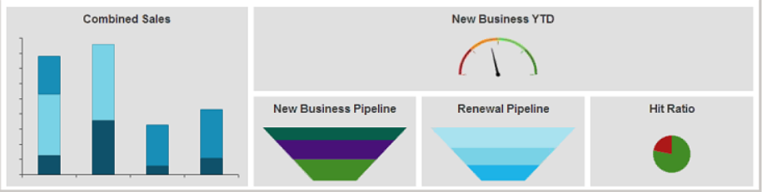

* **Combined Sales:**

This stacked bar chart shows the total value of your pipeline for *New Business Opportunities, Renewal Opportunities,* and *Expiring Policies*. The chart is separated into three bars representing opportunities with targeted close dates and policies with expiration dates within 0-30, 31-60, 61-90, 91-120 and 121-150-day time frames. Each bar shows the value of the total pipeline, segmented by type of business, over its specified time frame.

Select Premium or Revenue from the Opportunity Value dropdown menu to view the value of your opportunities on a premium or revenue/commission basis. Select whether to display Annualized or Estimated premium or revenue values from the Policy Value dropdown menu.

New Business Opportunities values display in dark blue. Renewal Opportunities values display in light blue. Expiring Policies values display in medium blue. To show or hide any of these categories of chart values, click on its label in the legend on the right hand side of the chart.

Note: The Renewal Policies values in the chart are calculated at the policy level, rather than the line level.

* **New Business YTD:**

This gauge indicates your progress toward your yearly sales target, based on a comparison of the value of the new business opportunities you have closed as *Won* and the total of your sales targets configured in Employee/Broker Detail. As you make progress toward your sales targets throughout the year, the needle will move toward the green area on the right. If you exceed your sales targets, the needle will remain at 100%.

***Note:*** Decimal values are rounded to the nearest thousand, million, or billion (depending on the scale of the chart).

Select ***Premium*** or ***Revenue*** from the *Value* dropdown menu to display monetary values on either a premium or a revenue/commission basis.

* **New Business Pipeline:**

This funnel displays your new business opportunities segmented by *Stage*, providing insight into the stage in the sales process in which your opportunities are concentrated and the value of the opportunities in each stage.

To filter the chart by *Target Close Date*, enter your desired ***Target Close Start*** and ***End*** dates, or click the ***calendar*** button to select a date. Select ***Premium*** or ***Revenue*** from the *Value* dropdown menu to display monetary values on either a premium or a revenue/commission basis.

**Renewal Pipeline:**

This funnel displays your expiring *Policies* or renewal *Opportunities*, segmented by expiration dates within the 0-30, 31-60, 61-90, 91-120 and 121-150-day time frames, and the premium value of those policies or opportunities.

Policies must meet the following conditions to display in this chart:

* Policy Expiration Date within the next 150 days
* Service Summary Stage of Issued or Migrated
* The Producer selected for the chart is the first producer on the Pr/Br Commissions tab of a line on the policy.
* The policy has not already been renewed.

Opportunities must meet the following conditions to display in this chart:

* Opportunity business type of Renewal
* Open opportunities with a Target Close Date that has passed (i.e. "overdue" opportunities)
* Open opportunities with a Target Close Date within the next 150 days

Select Opportunities or Policies from the Renewals dropdown menu to view either renewal opportunities or renewal policies in the chart. Select Premium or Revenue from the Opportunity Value dropdown menu to view the value of your opportunities on a premium or revenue/commission basis. Select whether to display Annualized or Estimated premium or revenue values from the Policy Value dropdown menu.

Each range of expiration dates displays in a different color. The height of each funnel segment represents the Premium or Revenue value of the Opportunities or Policies with expiration dates within that range. To show or hide any of these date ranges, click on its label in the legend on the right side of the chart.

This funnel displays your expiring *Policies* or renewal *Opportunities*, segmented by expiration dates within the 0-30, 31-60, 61-90, 91-120 and 121-150-day time frames, and the premium value of those policies or opportunities.

* **Hit Ratio**

This pie chart displays the ratio of won opportunities to lost opportunities, based on the original estimated value of each opportunity.

To filter the chart by *Closed Date*, enter your desired *Closed Start* and *End* dates, or click the *calendar* button to select a date. Select *Premium* or *Revenue* from the *Value* by dropdown menu to display monetary values on either a premium or a revenue/commission basis.

# JOB AIDS



## JA.1 Epic Quotes

|  |
| --- |
| To gain access to a carrier's site, including obtaining a login and password, reach out to:  [**nycarrieraccess@acrisure.com**](mailto:nycarrieraccess@acrisure.com) |

### Search Available Carriers

Use this Interactive Map for available carriers by State:

[**https://cast.semcat.net/pub/carrier_state_map**](https://cast.semcat.net/pub/carrier_state_map)

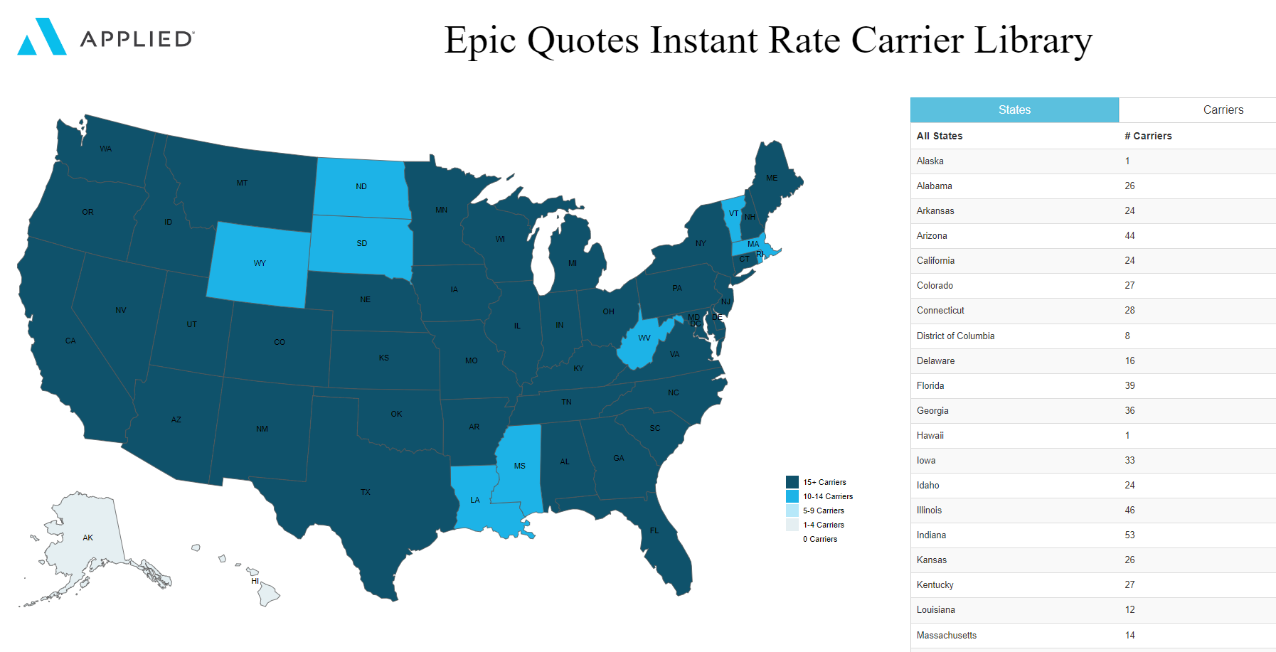

### One-Click Carrier Quoting (New Business)

1. For an **existing prospect or client**:
   1. Locate the Prospect or Client and click Quotes from the left panel
2. For a **new prospect or client**:
   1. Create a new Prospect or Client and complete the detail screen
   2. Click Continue to add additional contacts and contact information
   3. Click Quotes from the left panel
3. Complete the Quote information screen and click ADD

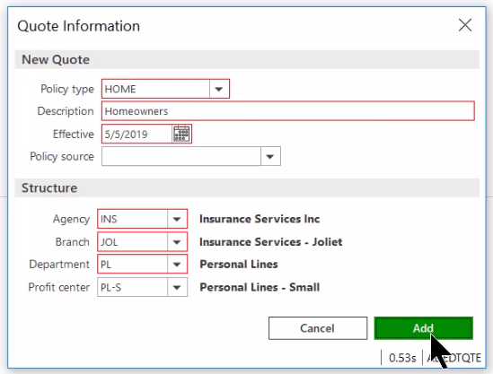

1. If you are licensed for the data prefill program, you will see this screen

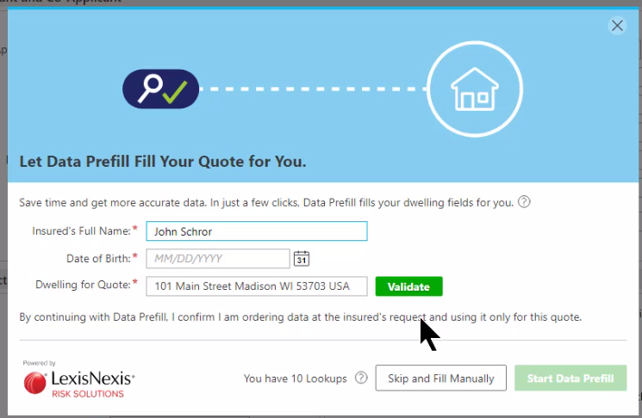

1. When you move from tab to tab, a tab that has the required fields completed turns green; a tab missing required fields turns red

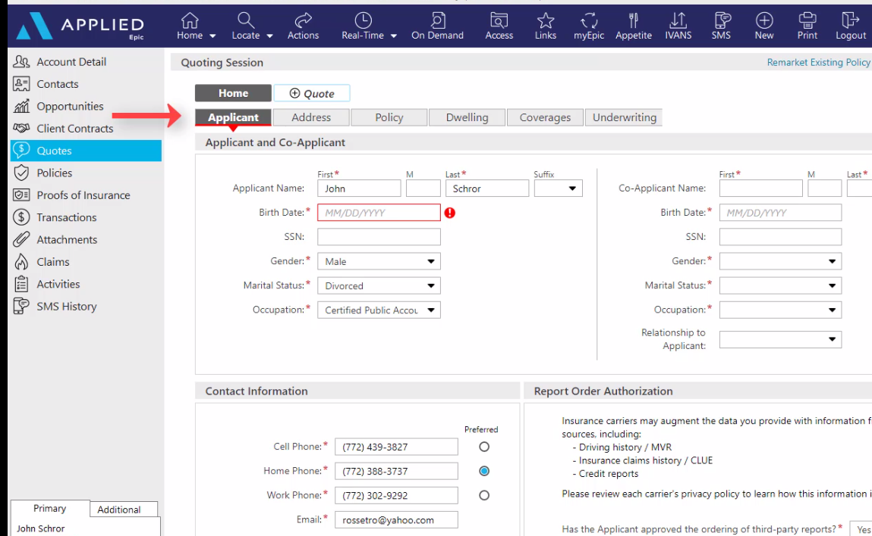

1. Fill in the missing required fields
2. Under the Address tab, if the address is not USPS validated, type the correct address, and click Validate

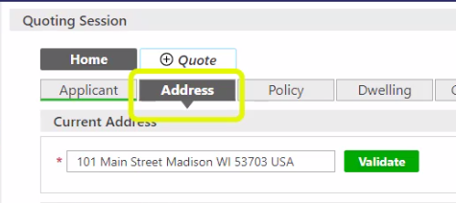

1. If still no match, use the Full Edit button to enter the address  
   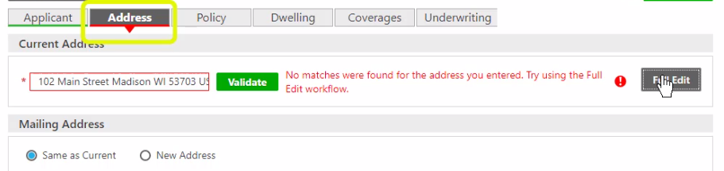
2. The Dwelling tab offers lots of options (i.e., Search Google, Find on Zillow, Visit Assessor, Distance to Coast, etc.) and you can change from map to satellite.

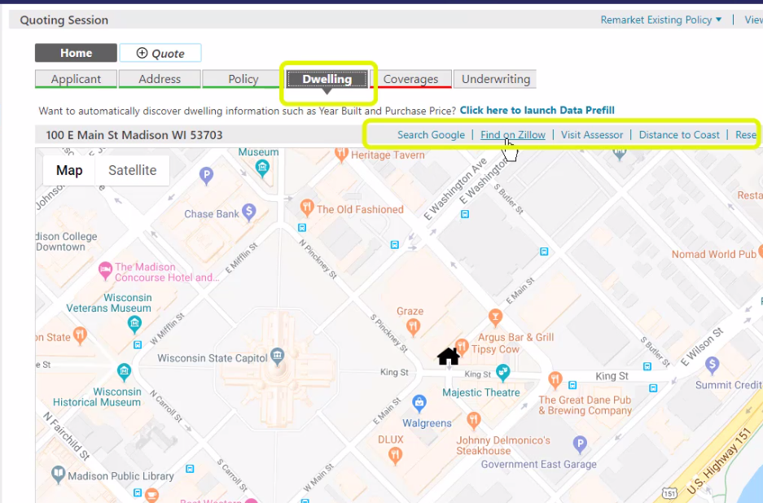

1. Enter information in all required fields under the Dwelling, Coverages, and Underwriting tabs.
2. If you are curious as to which carrier requires a specific field, hover your mouse over the asterisk and the carriers will be listed.

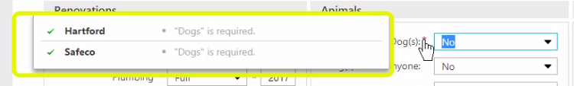

1. When all detail has been entered, click GET QUOTES

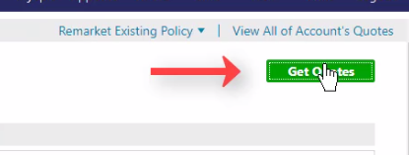

1. IVANS one-click or instant rate quotes will display automatically  
   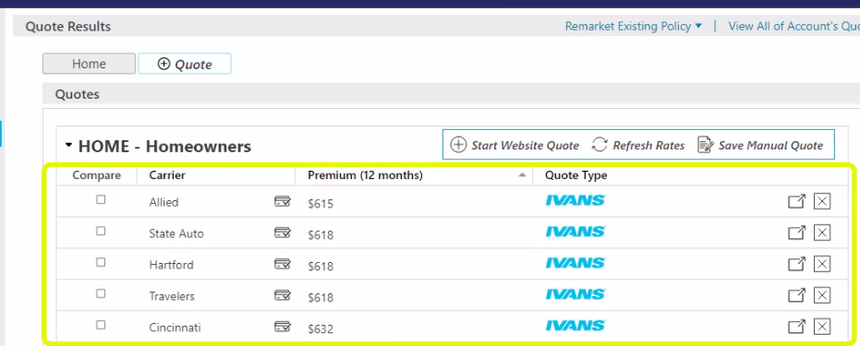
2. Chubb Masterpiece quotes are processed through Chubb (not IVANS). Select the “Get Rate” button to get into their desktop.



1. If additional required information is needed for a carrier, hover your mouse over the message to see which required fields are missing data. Clicking on the message takes you back to the quote tabs.

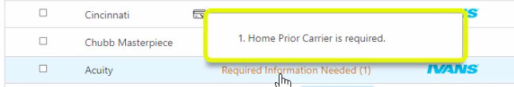

1. Enter the missing information and then click the Get Quotes button
2. If the Agent ID button appears, it means that this is the first time you are processing a quote with that carrier. Enter the ID number and click Get Rate. Enter your username and password for that carrier if prompted and select “Remember Credentials” so you won’t have to enter it again.



1. Review quote results. The little box with the checkmark indicates that a credit check was performed by the carrier

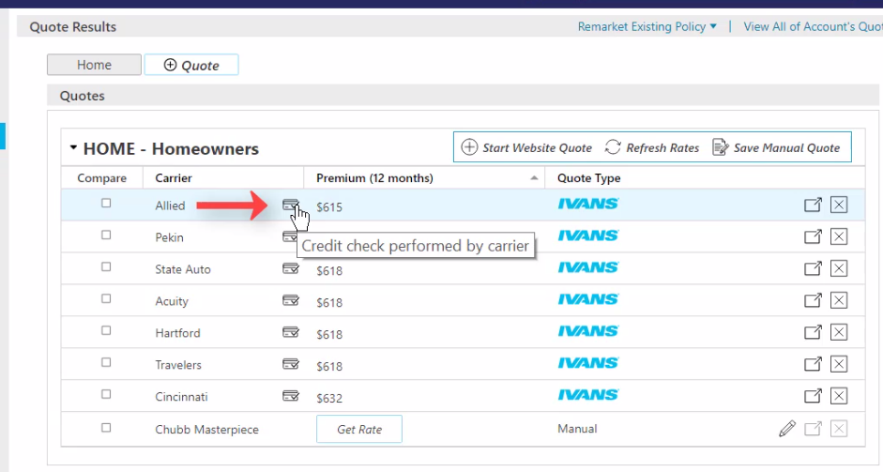

1. The box with the arrow on the right takes you to the carrier’s website

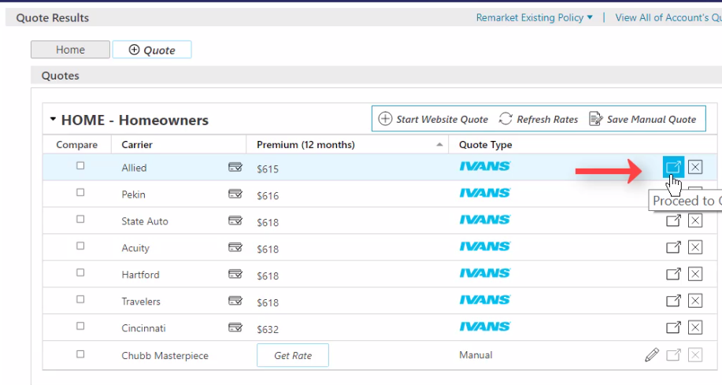

1. To quote with carriers not available via “One-Click,” see Live Fill workflow at the end of this section.
2. If the carrier is not a “One Click” carrier or a “Live Fill” carrier, you can save a manual quote entering the detail yourself by clicking the “Save Manual Quote” button 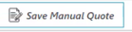

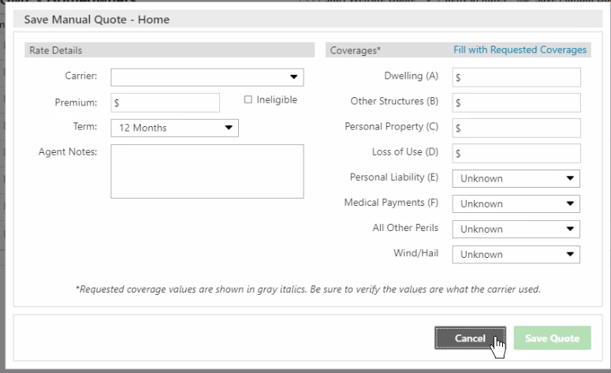

1. To compare quotes, check the boxes of the carriers you wish to compare and then click the “Compare” column header

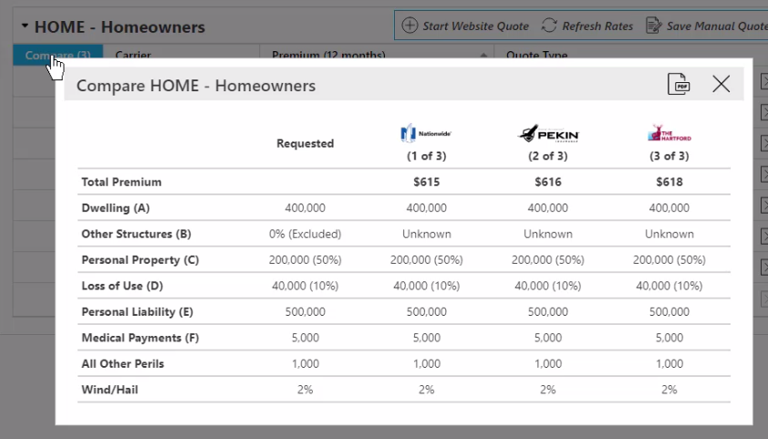

1. You can also generate a PDF to provide a comparison to the client.
2. To see the details of a quote, select it

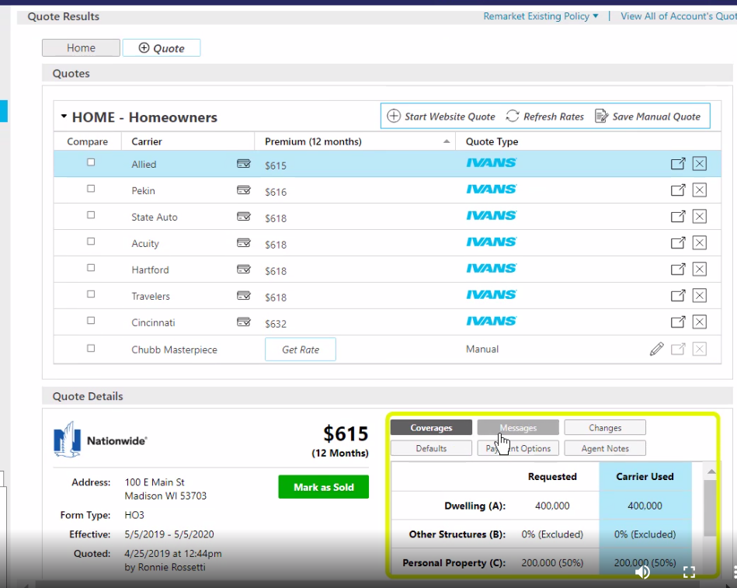

1. Click the buttons to see more detail

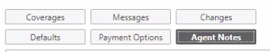

1. Once you’ve decided on a carrier, proceed to the carrier’s website by clicking the box with the arrow to the right and order the coverage to be bound.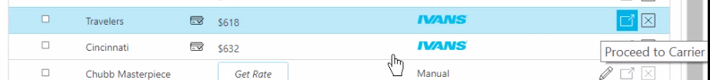
2. Click Mark as Sold and complete the “Accept Quotes” screen

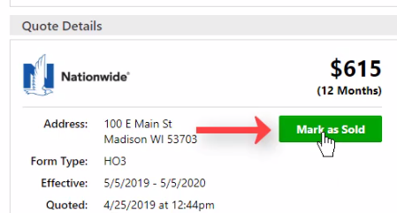  
  
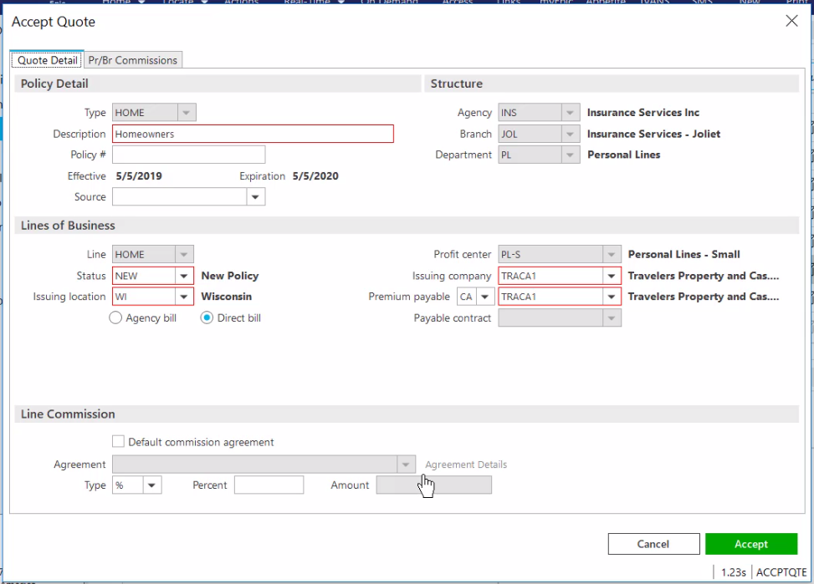

1. Don’t forget to add the PR/BR commission information under the PR/BR Commissions tab.

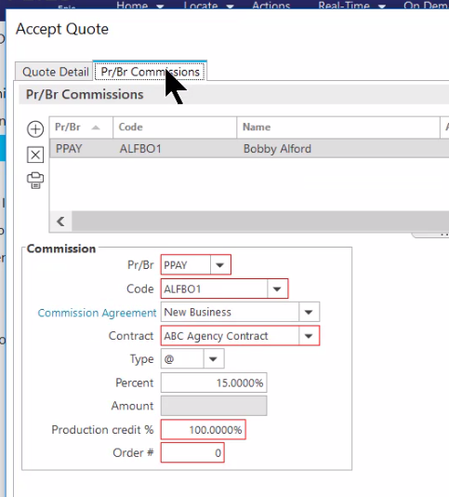

1. Once the Accept Quote screen is completed, click Accept at the bottom right and Epic will enter this quote as a “submitted” policy in the Policy area of the client’s account.
2. If the “Change Client Type” screen appears, click YES to update the policy to contracted and the prospect to client.
3. The quotes will be stored for history. The quote you selected will be marked as SOLD.
4. Download will update the service summary stage to “Issued” on the policy you created via Quotes.

### Quoting via Live Fill

1. To quote with carriers not available via one-click, click the “Start Website Quote” button. 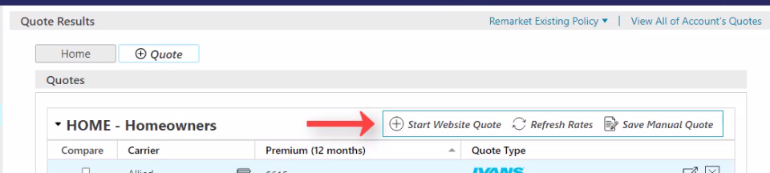
2. Click the drop down to see a list of all your appointed carriers and select a carrier

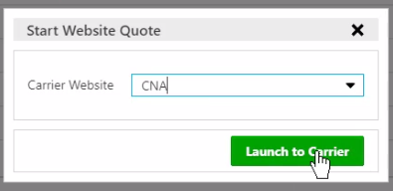

1. This will launch you into the carrier’s quoting portal
2. Run your quote as you normally would on the carrier’s portal
3. Epic will pre-fill information you entered in QUOTES. Information in data fields showing green or yellow came from Epic Quotes. Anything in white is a carrier-specific question.
4. You have the ability to change any of the prefilled data if needed.
5. Once the quote is processed, you have the ability to save it in the Quote Results page and get a side-by-side comparison with other One-Click quotes.
6. Once you are finished with one carrier, you can close out of it, select the next carrier from the drop-down list and go through the process again.
7. To save the quote, click the “Save Quote” button at the top right 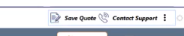
8. Enter information, then click Save Quote.

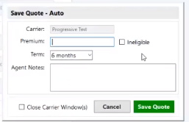

1. The quote will be saved on the “Quote Results” page, showing quote type as “Website”

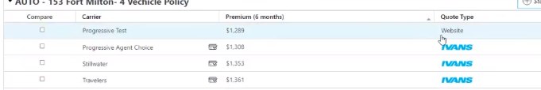

1. Click the boxes in the Compare column of the rates you wish to compare (including the website quotes) and then click the Compare column header to see the results.

### One-Click Carrier Quoting (Remarket Existing Policy)

1. If you are using Renewals Manager, you can highlight the expiring policy from there and click the Get Quote button.
2. If not, locate and select the client
3. Click Quotes in the left panel

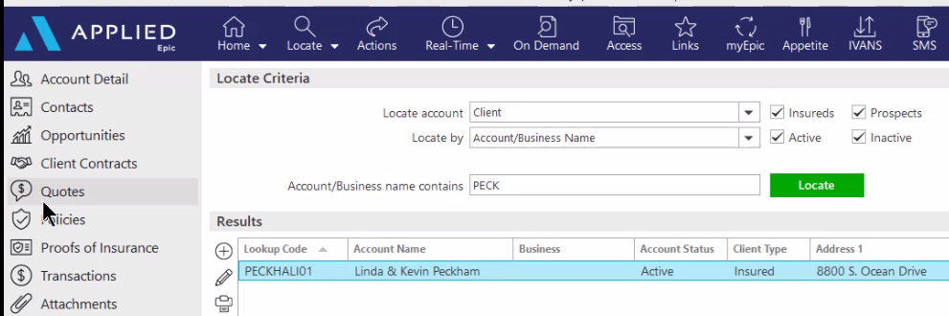

1. Cancel out of the new quotes screen. Instead click the link to “Remarket Existing Policy” at the top right

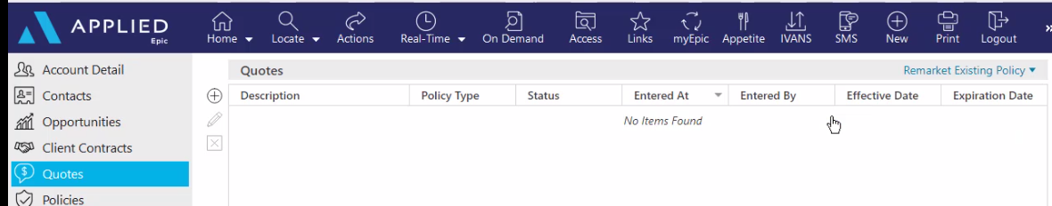

1. Select the policy you wish to remarket
2. Complete the required information on Remarket Quote Information screen and select ADD

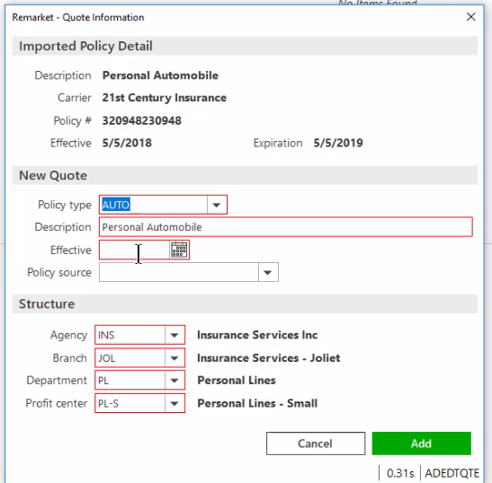

1. If you are licensed for the data prefill program, you will get this screen

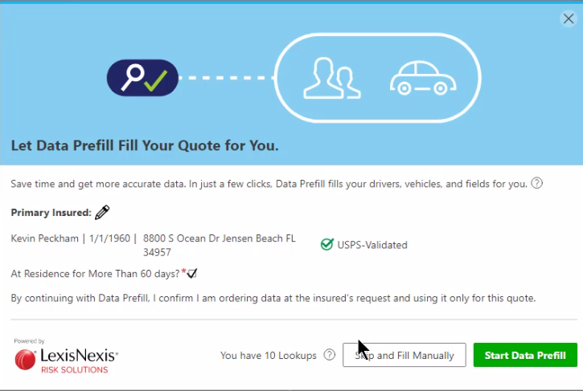

1. To view the information that came in from the existing policy, click the Summary tab  
   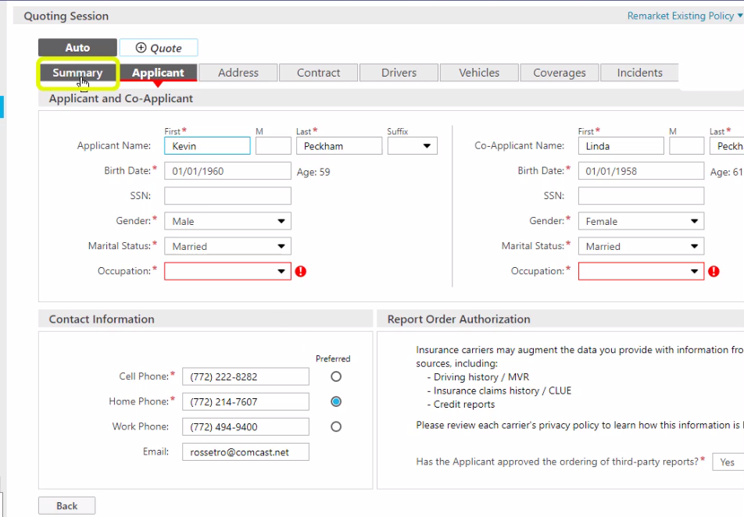
2. Go through each tab to see if there are any missing required fields.
3. Missing required fields will be in red, completed required fields will be in green. Enter the missing required information.
4. If another quote is needed for the insured, click the Add Quote button

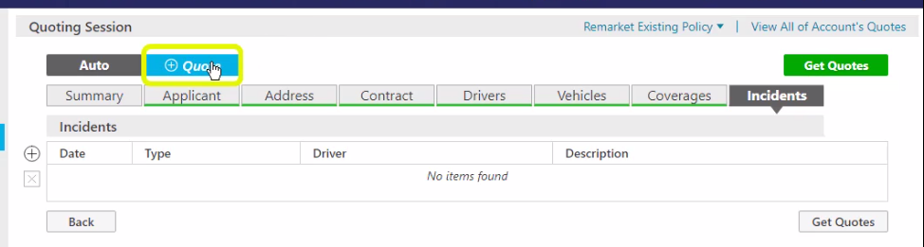

1. When all the fields have been completed, select Get Quotes

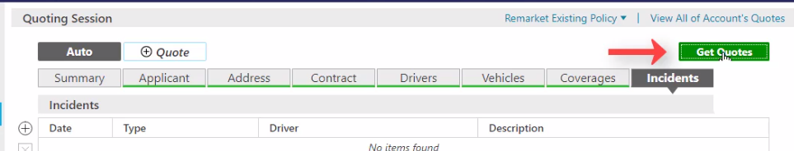

1. IVANS One-Click or Instant Rate Quotes display automatically
2. Highlight a quote to view details.
3. To compare several quotes, check the compare boxes, then click the Compare column header.
4. When you decide on a carrier, go to the carrier website, and order the coverage to be bound.
5. Mark it as Sold
6. Complete the Accept Quote screen, including information in the PR/BR Commissions tab, then click the Accept button at the bottom right.
7. All the carriers and their quotes are retained for historical purposes.
8. If you go to the Policy area, you will note that the expiring policy renewed with the carrier you selected for binding and the service summary stage has been marked as Submitted. The download will update the stage to Issued.

## JA.2 Marketing Module Lite

|  |  |  |
| --- | --- | --- |
| **MANUALLY GENERATED ACTIVITY** | | |
| Quote – New Business | **QNEW** | Created for documentation during the new business quoting process. |
| Quote – Renewal/Rewrite | **QREW** | Created for documentation during the rewrite quoting process for midterm or at renewal. |
| **SYSTEM GENERATED ACTIVITY** | | |
| New Marketing Submission | **AMMK** | # Added master marketing submission for &AcctName& |
| Moved Market Lines to Current Policies | **BND1** | # Bind Policy via Master Marketing |
| Create 1 **QNEW/QREW** manual activity (F9) for each carrier approached. Attach all quoting related emails, documents, applications, etc. to the appropriate carrier specific **QNEW/QREW** activity and update notes, and description as needed.  **Amount Qualifier/Premium Quoted must be added to the QNEW/QREW. If quoting multiple LOB’s with 1 carrier, add 1 QNEW/QREW for each carrier, noting the TOTAL quoted premium in the Amount field and break out quoted LOB premium in notes.**  Attach all binding related emails, documents, etc. to the **BND1** activity and update notes as needed.  Be sure to choose the proper Policy Status. | | |

## New Business + Rewrite/Remarket

### Add Master Marketing Submission

1. Locate the client in Epic.
2. From the navigation panel, click **Policies**.
3. From Policies-Current/Renewed, change view to **Policies-Marketed.**
4. From Policies-Marketed, click **Add (+)**.
5. Enter Master Marketing Submission details, **RED** is required, example:

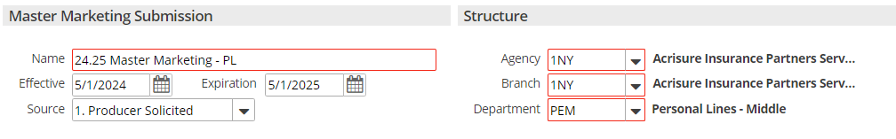

1. From the Type of business drop down, select Personal Lines.
2. From Policies to Market, click **Add (+)**
   1. **For New Business or Adding a New Line:**
      1. From the Add Line window, select **Add New Line**
      2. Click **Continue**
      3. From the Add New Line window, enter details, **RED** is required, example:

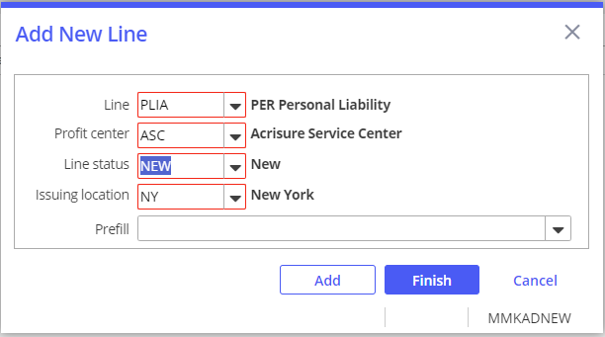

* + 1. Click **Finish** if you are done adding Lines. Click **Add** if you are adding additional lines
    2. Click **Detail**
  1. **For Rewrite/Remarket:**
     1. From the Add Line window, select **Add Existing Line**
     2. Click **Continue**
     3. Check the box of the existing policies you want to market
     4. Click **Finish**
     5. Click **Detail**

1. From the **AMMK** Activity window, select **Closed**.
2. From the Closed drop down, click **Successful**.
3. Click **Finish**.
4. From the navigation panel, enter coverage detail, being sure to complete the Commercial AP section first.
5. **If** adding submission attachments, i.e. Loss Runs, MVRs, Supplemental Applications:
   1. From the navigation panel, click **Submission Detail**.
   2. From Master Marketing Submission Details, click the **Attachments** tab.
   3. Click **Add (+)**.
   4. From the Add Attachments window, select either:
      1. **Existing client document**:
         1. Click **Continue**.
         2. From Available Attachments, select your attachment.
         3. Click **Finish**.
      2. **Existing file**.
         1. Click **Continue**.
         2. Click **Browse**.
         3. Click **Choose Files**.
         4. Double click your file to choose.
         5. Click **OK**.
         6. Click **Finish**.
6. From the navigation panel, click **X**.

### Add QNEW/QREW Activity for each carrier

1. From Policies-Marketed, highlight your Master Marketing Submission.
2. From the blue options bar, click **New**.
3. From the New drop down, select **Activity**.
4. From the Add Activity window, **RED \*** is required, enter details, example:

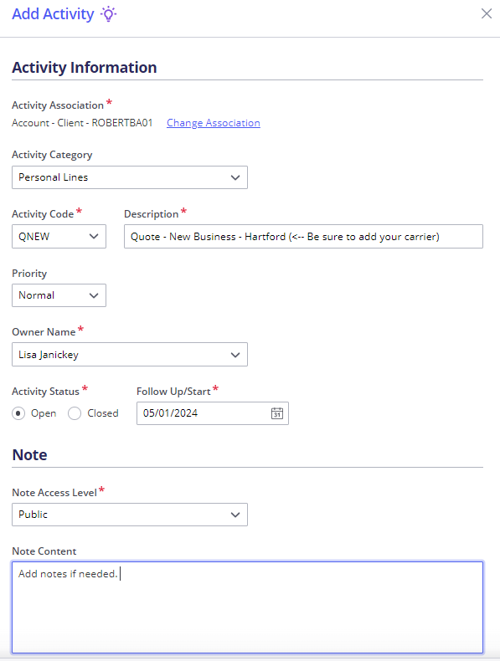

1. Click **Save & Go to Detail**.
2. From the Premium payable drop down, select your Carrier (CA), Broker (External) (BR), Broker (Internal) (IN), example:

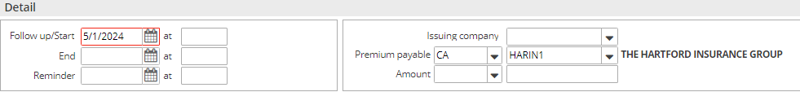

1. Leave activity Open.
2. From the navigation panel, click **X**.

### Create + Submit ACORD Applications

1. From the navigation panel, click **Policies**.
2. From Policies-Marketed, highlight your Master Marketing Submission.
3. From your highlighted Master Marketing Submission, **Right Click**.
4. From the drop down, select **Review Application**.
5. From the Review Application window, click the **Organizational Contact** tab.
6. If needed, update the Organization Contact.
7. From the Review Application window, click the **Distribution tab**.
8. From the Via drop down, select **Attach Without Distributing**.
9. Click **Finish**.
10. **If** submitting via email:
    1. From Policies-Marketed, with you Submission highlighted, from the blue options bar, click **Access**.
    2. From the Access drop down, select **Attachments**.
    3. Highlight your **Print Marketing Submission**, right click.
       1. **If** editing Description name:
          1. From the drop down, select **Edit Attachment Details**.
          2. Amend the Description, example:

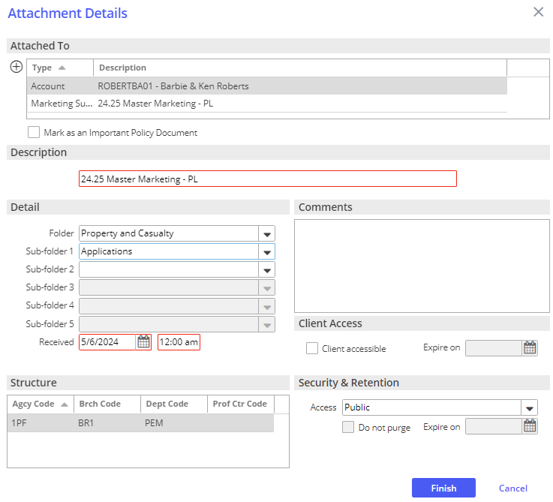

* + - 1. Click **Finish**

1. From the drop down, select **Send via Email**.
2. Add notes, drag + drop your email to the appropriate carrier **QNEW/QREW**.

### Carrier Responses Received

1. From the navigation panel, click **Policies**.
2. From Policies-Marketed, highlight your Master Marketing Submission.
3. From the blue options bar, click **Access**.
4. From the drop down, hover over **Activities**, click **Open Activities**.
5. From Activities-Open Filtered, double click your **Activity.**
6. From Notes, click **Add (+)** to entered detailed notes, example below.
7. Click **Finish**.
8. From the Amount drop down, select **Premium Quoted**, add in quoted premium, example:

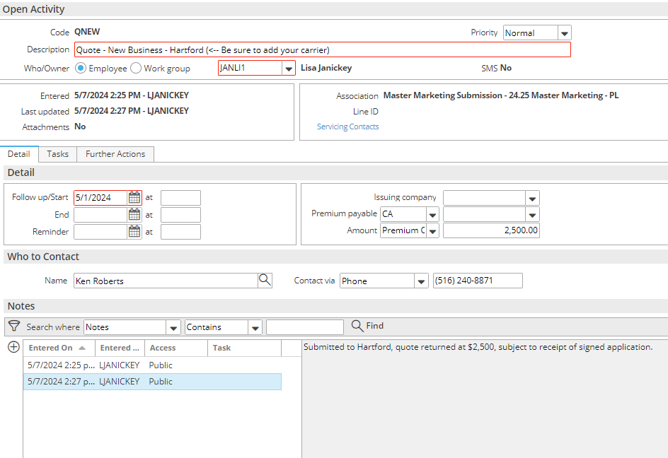

1. From the navigation panel, click **X**.

### Carrier Selected for Binding

1. From the navigation panel, click **Policies**.
2. From Policies-Marketed, highlight your Master Marketing Submission.
3. From the blue options bar, click **Access**.
4. From the drop down, hover over Activities, click **Open Activities**.
5. From Activities-Open Filtered, double click your **Activity.**
   1. **If** carrier **is** selected for binding:
      1. From Notes, click **Add (+)** to entered detailed notes.
      2. From the blue options bar, click **Actions**.
      3. From the Actions drop down select **Close Activity**.
      4. From the Close Activity window, from the Closed drop down, select **Successful**.
      5. Click **Finish**.
   2. **If** carrier is **not** selected for binding:
      1. From Notes, click **Add (+)** to entered detailed notes.
      2. From the blue options bar, click **Actions**.
      3. From the Actions drop down select **Close Activity**.
      4. From the Close Activity window, from the Closed drop down, select **Unsuccessful**.
      5. From the Reason drop down, select the reason.
      6. Click **Finish**.
6. From the navigation panel, click the **X**.

### Move Binding Carrier Submission to Policies – Current/Renewed

1. From the navigation panel, click **Policies**.
2. From Policies-Marketed, highlight your Master Marketing Submission.
3. From your highlighted Master Marketing Submission, **Right Click**.
4. From the drop down, **Create Carrier Submission**.
5. Enter Carrier Submission details, **RED** is required, example:

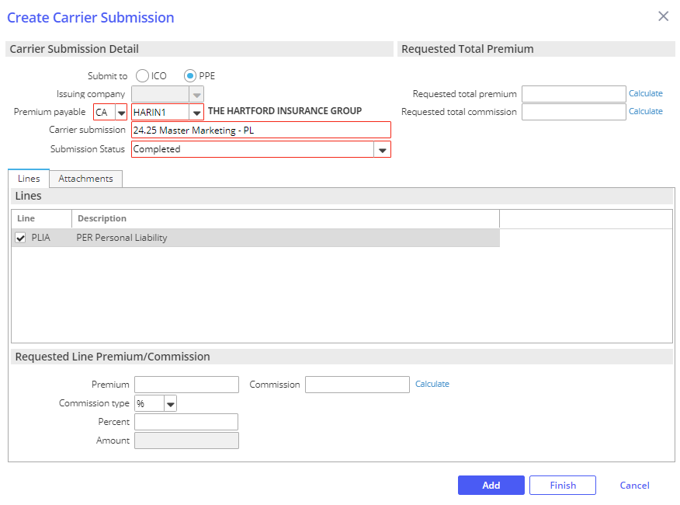

1. Click **Finish**.
2. From Policies-Marketed, highlight your Master Marketing Submission.
3. From your highlighted Master Marketing Submission, **Right Click**.
4. From the drop down, select **Update Stage to Entered/Submitted**.
5. Click **Finish**.
6. From Policies-Marketed, highlight your Master Marketing Submission.
7. From your highlighted Master Marketing Submission, **Right Click**.
8. From the drop down, select **Create Carrier Response**
9. Enter Carrier Response details, Issuing Company + **RED** is required, example:

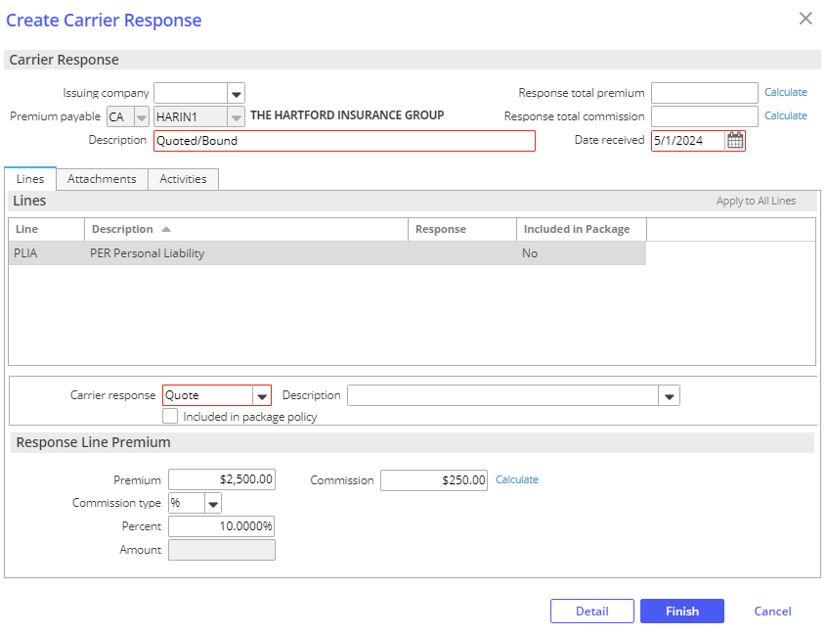

1. Click **Finish**.
2. From the In Process Carrier Response Window, select **Yes.**
3. From the Yes drop down, select **Move Marketed Lines to Current Policies.**
4. Click **Finish**.
5. From the Move Marketed Lines to Current Policies window, **RED** is required, enter details:
   1. **Policies Tab**:
      1. Select:
         1. **Add new policy**, for new policy/new business.
         2. **Renew Existing policy**, if created from a renewal
         3. **Update existing policy**, if adding policy lines to an existing policy
      2. From the **Policy** drop down, select policy type or policy.
      3. Enter policy #, if known
      4. From the **Source** drop down, select source.
      5. Verify **Effective** + **Expiration** date.
      6. Update State to **Submitted** or if policy detail edits are needed, **In Process**.
      7. Select **Contracted Policy**.
   2. **Lines Tab**:
      1. Select **Line** tab.
         1. Highlight the policy line(s).
         2. Select **Add to this policy**.
         3. From the **Status** drop down, select **New**.
         4. Select **Agency bill** or **Direct Bill**.
         5. Select Issuing company (writing company).
         6. Verify **Profit Center**.
         7. From Line Commission, check **Use commission agreement**, add % where no commission agreement exists.
      2. Select **Servicing** tab: 
         1. Verify employees in each servicing role.
      3. Select **Pr/Br Commissions** tab:

***Producer Commission will default***

***Use Commission Agreement should default/be checked***

***Production credit should be 100%***

* + - 1. Click **Add (+)**.
      2. From the Pr/Br drop down, select **PPAY** for Producer Payable.
      3. From the **Code** drop down, select producer.
      4. Click **Finish**.

1. Click **Move**.
2. From the Update Submission Status window, Current carrier submission drop down, select **Completed**. Click **Finish**.
3. From the Add an Activity window, enter notes on the system generated **BND1** activity.
4. Click **Finish**.

## JA.3 Accounting Activities

**Accounting Description Key**

$N –New

$P - In Process

$R - Needs review

$C - Complete

When an accounting activity changes, the Description will be updated.

When accounting receives an activity, the descriptor of **$N** the descriptor will change to **$P**, once it is processed by accounting the descriptor will change to **$C.** If additional information is needed, the description will go back to the servicer and the descriptor will change to **$R.**

Tasks are assigned to each activity with an activity that will be assigned back to the user once the activity is completed. The exception to this is if information is needed the task will be assigned back to the user for additional details.

|  |
| --- |
| **Agency Billing/Accounting Activities found in** [**SharePoint**](https://acrisure.sharepoint.com/:w:/s/ACR-ABSAccountingTeam/ESAdZgcBwPdJt0_n5-hNILkBueeqZpQWrGK6rg54rr9l7g?e=4LVSdM&clickparams=eyJBcHBOYW1lIjoiVGVhbXMtRGVza3RvcCIsIkFwcFZlcnNpb24iOiI0OS8yMzExMzAyODcyNCJ9) |

## JA.4 Renewals Manager

|  |
| --- |
| The Renewals Manager helps you prioritize your workload by giving you instant visibility into policies that are up for renewal in the near future and the status of each renewal.  The Renewals Manager populates with policies to which you have structure access that are set to expire within the date range configured for their policy types.  **Policies whose first Service Summary row has an In Process or Submitted status do not display.** |

### Renewal Stages

**Details in the Renewals Manager view are related to the expiring policy.**

|  |  |
| --- | --- |
| **Stage Description** | **How it functions** |
| **Renewal Not Started** | Tied to the Event: **Policy Created** (display policies with this stage in the RM "**0**" days after expiration) |
| **Pre-Renewal In-Process** | Manual - (display policies with this stage in the RM "**30**" days after expiration) |
| **Submitted For Quote** | Manual - (display policies with this stage in the RM "**30**" days after expiration) |
| **Quote Received** | Manual - (display policies with this stage in the RM to "**30**" days after expiration) |
| **Proposed** | Manual - (display policies with this stage in the RM to "**30**" days after expiration) |
| **Renewal In-Process** | Tied to the event: **Policy Renewed** (display policies with this stage in the RM "**30**" days after expiration) |
| **Renewed** | Manual - (display policies with this stage in the RM "**0**" days after expiration) |
| **Did Not Renew** | Tied to the event: **Policy Cancelled** (display policies with this stage in the RM "**0**" days after expiration) |

### Renewal Events

#### Policy Created

This Event is responsible for a new policy as well as a renewed policy to be given the Stage Renewal Not Started. This is the Stage that begins the renewal effort. Policies coming up for renewal will show in the RM, in advance of the renewal date with the Stage Renewal Not Started, according to the time frame assigned to the policy type.

* 150 days for commercial lines policy types
* 90 days for personal lines policy types
* 90 days for employee benefits policy types

#### Policy Renewed

This Event is tied to the Actions>Renew process. When the expiring policy (the current term…the one you are working on renewing) is renewed (via Actions>Renew), the expiring policy (i.e., the current term…the one you are working on renewing) will be given the Stage Renewal In-Process. The renewed policy (i.e., the policy created through the Actions>Renew process) will not show in the RM but will show in the Policy list view (e.g., Policies – Current/Renewed). The renewed policy will be given the Stage Renewal Not Started. This Stage should remain as is until you are ready to work on the renewal of that policy the following year. The renewed policy (i.e., the one created via Actions>Renew) will need to be Issued as normal. The Stage given to the expiring policy (i.e., the current term…the one you are working on renewing) will need to be changed, by the user, to Renewed once the renewal policy has been Issued. This Stage, Renewed, will be the final Stage given to the expiring policy in the RM. An expiring policy with the Stage Renewed will drop from the RM view on the expiration day.

#### Policy Cancelled

This Event is tied to the Actions>Cancel>Issued process. The Stage shown on a policy cancelled via the Actions>Cancel>Issued process will be Did Not Renew. Note: if the policy is reinstated, the Stage will automatically revert to the Stage it was assigned to before it was cancelled.

### Renewal Manager Workflows

|  |
| --- |
| **Note:**  If a cancellation has been issued, the Renewal Manager Stage will automatically be updated to Did Not Renew and will drop off your Renewals Manager list.  If a policy is being non/not renewed, the Renewal Manager Stage will not automatically update. You must update the Renewal State manually by selecting Did Not Renew from Update Renewal Stage. The policy will not drop off of the Renewals Manager list until 1 day after expiration. |

#### View Renewals

1. Click **HOME**
2. From the navigation panel, click **Renewals Manager**
3. Assigned Servicers accounts will be displayed, **policies whose first Service Summary row has an “In Process” or “Submitted” status do not display**:
4. **Personal Lines**: 90 Days prior to expiration
5. **Commercial Lines**: 150 Days prior to expiration
6. **Employee Benefits**: 90 Days prior to expiration
7. Click on your renewal, select:
8. **Go to Policy**: To open policy or line detail for the selected policy
9. **Renew**:
10. If a single policy or line is selected, this button opens policy detail and initiates the Renew action for the selected policy.
11. If multiple policies or lines are selected, this button opens the *Renew* Multiple Policies popup, where you can renew all policies selected.
12. **Marketing Submission**: Open a new master marketing submission with the selected policy's structure, Source, Line of Business and Status already populated.
13. **Remarket with Tarmika**: Bridge to Tarmika
14. **Remarket**: To begin a Remarke*t* quote for the selected policy. You can remarket the following lines of business:
15. Homeowners (Epic Quotes required)
16. Personal Auto (Epic Quotes required)
17. **Update Renewal Stage**: To change the selected policy’s stage to track its progress in the renewal process. As you work on a renewal, remember to update the stage so that Renewals Manager accurately reflects the renewal’s status. Policies in some stages (such as Renewed or Cancelled) may not display in Renewals Manager after their expiration dates.
18. **Market Appetite**: To perform a Market Appetite search to locate the best market for the renewal, either within or beyond your current appointed markets, IVANS Market Appetite will be launched.
19. **Export to Indio**: Export basic client account information into Indio to start a submission.

#### Renew Policy

1. Click your Policy or CTRL click to select multiple Policies.
2. Click **Renew**
3. Follow the **Renew Policy Workflow**
4. The Renewals Manager Renewal Stage:
5. Will change to **Renewal In Process**
6. To update stage, click **Update Renewal Stage**

#### Marketing Submission

1. Click your Policy
2. Click **Marketing Submission**
3. Follow the **Marketing Module Lite** or **Marketing Module Full Workflow**
4. The Renewals Manager Renewal Stage:
5. Will not automatically update
6. To update stage, click **Update Renewal Stage**

## JA.5 Proofs of Insurance

### Auto ID Cards in Epic

|  |  |  |
| --- | --- | --- |
| **SYSTEM GENERATED ACTIVITY** | | |
| Issue Auto ID Card | **AUID** | # Issued auto ID card |

1. Click your Policy
2. From the blue menu bar, click **Actions**
3. Click **Issue Auto ID Card**
4. Verify/Update the tabs:
   1. **Vehicle/Insured:**
5. Highlight the appropriate vehicle
6. Click **Select to Issue**
   1. **Vehicle/Insured, to update form or effective date, i.e. adding a vehicle mid term**
      1. Double click the appropriate vehicle
      2. Verify/Update **Form Description**
      3. Verify/Update **Effective** date
      4. Check **Select to Issue**
      5. Click **Finish**
   2. **State Specific**
   3. **Organization Contact**
   4. **Distribution**:
      1. **Email**: **Send Email from Distribution Manager**
      2. **Fax**: **From Distribution Manager**
      3. **Print**:

a. For a **print preview**, click **Download & Print**

b**.** To **save a copy in Attachments**, select **Print** from the Aia dropdown, click **Finish**. From there you can email directly out of attachments via a right click on your PDF and selecting “Send via Email” to link to your Outlook.

5. Click **Finish**

1. **Activity**, **RED** is required:
   1. **Code, AUID** - #Issued auto ID card
   2. **Description**, best practice is to leave the description that prefills based on your activity, adding in any data if prompted, you can add to the end of the description.
   3. **Who/Owner**
   4. **Follow up/Start**
   5. **Status**, defaults as **Closed, Successful**
   6. **Notes**
   7. Click **Finish**

### Evidence Processing in Epic

|  |  |  |
| --- | --- | --- |
| **MANUALLY GENERATED ACTIVITY** | | |
| EOP Request | **PEOP** | Created for documentation during the evidence issuance process when EVID or REVI does not apply. |
| **SYSTEM GENERATED ACTIVITY** | | |
| Issue Evidence of Insurance | **EVID** | # Issued Evidence of Insurance &PolDesc& &PolEffDate |
| Renew Evidence of Insurance | **REVI** | # Renewed EOP |

|  |
| --- |
| **Notes:**  All correspondence, including the EOP request should be attached to the **EVID** or **REVI** activity. If you are stuck on a request, need further clarification, etc. you may add in a manual **PEOP** activity to track and document the process.  Policy details must be entered in the policies area.  Policy must be **Contracted.**  Service Summary Row must have a Stage of either **Submitted** or **Issued**.  If you have made any changes to your policy limits and are updating your template, please ensure that you have selected the appropriate Service Summary Row to accurately reflect these changes. Otherwise, you may encounter a validation error due to security settings.  You will have the following options whether **Personal** or Commercial **Lines**:    Evidence-Property: Acord 27  Evidence-Commercial Property: Acord 28  Set your Master Template based on your needs, Additional Interest specific, or Coverage Specific. |

#### Add a Master Template

1. Locate client in Epic.
2. From the navigation panel, click **Proofs of Insurance**.
3. From the Proofs of Insurance drop down, click **Evidences**.
4. From Evidence-Property, click **Add (+)**.
5. From the Add Evidence of Insurance, **Type** drop down, select the appropriate Acord form.
6. Enter Title based on needs, examples: 2024.25 Acord 27; 2024.25 Garden City Realty
7. From the Line of Business, Type drop down, select the current Property policy.
8. From the Line of Business, Service summary drop down, select the correct Service summary.
9. To **Copy Additional Interests** from another master evidence template:

1. From Default Additional Interests from other Evidence(s) of Insurance, click **Add (+)**.

1. From the Default Additional Interests window, click the **Default additional interests from** drop down.

1. Select the master template you would like to copy additional interests from.

1. Select each additional interest you would like to copy.

1. Select **Default the additional interests special conditions**, if applicable.

1. Select **Default the additional interests attachments**, if applicable.

1. Click **Finish**.

1. Click **Detail**.

1. From the navigation panel, click each section to enter coverage details, example:

1. **Policy Level Coverages**:  Enter policy level coverage.

1. **Risks/Coverage**: Click **Add (+)** to select location specific coverage.

1. **Special Conditions**: Enter template level special conditions.

1. **Attachments**: Add template level attachments.

1. **Remarks**: Add template level remarks.
2. From the navigation panel, click **X**.

#### Issue an Evidence of Property Insurance

* 1. From the navigation panel, click **Proofs of Insurance**
  2. Click **Evidences**
  3. Click on the appropriate template
  4. From, **Additional Interests**:

**Select an existing Additional Interest**:

* + 1. From Additional Interests, click the appropriate Additional Interest

**Add an Additional Interest**:

1. From Additional Interests, click **Add (+)**
2. **Additional Interest**
3. **Policy Level Coverages**, Use main policy coverages will default
4. **Risk/Coverages**, Use main risk/coverages will default. Uncheck and click Add (+) to pick from Risks/Coverages.
5. **Documents Attached**, additional interest level documents, these will appear each time you issue a COI for the holder.
6. **Additional Interests Details**
7. From the blue menu bar, click **Actions**
8. Click, **Issue Single Additional Interest** to select the highlighted or **Issue Evidence** to select multiple additional interests.
9. Verify/Update:
   1. **Organization Contact**
   2. Verify/Update **Additional Interest Distribution:**
   3. **Download & Print,** to preview.
   4. Click **Finish**
10. Activity, **RED** is required:
11. **Code**, **EVID** – # Issued Evidence of Insurance &PolDesc& &PolEffDate
12. **Description**, best practice is to leave the description that prefills based on your activity, adding in any data if prompted, you can add to the end of the description.
13. **Who/Owner**
14. **Follow up/Start**
15. **Status**, defaults to **Closed**, **Successful**
16. **Notes,** notes regarding conversation with client
17. Click **Finish**

#### Renew an Evidence of Property Insurance

* 1. From the navigation panel, click **Proofs of Insurance**.

* 1. From the Proofs of Insurance drop down, click **Evidences**.

* 1. From Evidence-Property, click the appropriate template to highlight.

* 1. From the menu bar, click **Actions**.

* 1. From the Actions drop down, click **Renew Evidence**.

* 1. Enter Title, example: 2024.25 Acord 27; 2024.25 Garden City Realty

* 1. **Renewal policy**, pick appropriate from drop down
  2. **Service summary**, pick appropriate from drop down

1. Select the appropriate Default boxes:

1. **Description of Operations**: Will pull the existing template level Description of Operations

1. **Special Conditions**: Will pull the existing template level Special Conditions

1. **Additional interests with risks and coverages**: Will pull the existing schedule of Additional interests.

1. **Include inactive additional interests**: Will pull inactive additional interests.

1. **Additional interests special conditions**: Will pull additional interest level special conditions.
2. Click **Detail**.

1. From the Add an Activity window, add notes if needed, click **Finish** to close the **REVI** activity.

1. From the navigation panel, update the coverage details.

1. From the menu bar, click **Actions**.

1. From the Actions drop down, click **Issue Evidence**.

1. **Organization Contact** Tab, verify agency address and contact information.
2. **Holder Distribution** tab, click **Select All** to renew all holders or select holders as needed, uncheck clients name.

1. **Delivery Options**, select from the Via drop down.

1. To preview COIs before issuing, click **Download and Print**.
2. Click **Finish**.
3. From the Add an Activity window, click **Finish** on the **EVID** activity.
4. A copy of the renewal batch is automatically attached in the client’s Attachments.

### Certificate Processing in Epic

|  |  |  |
| --- | --- | --- |
| **MANUALLY GENERATED ACTIVITY** | | |
| COI Request | **PCOI** | Created for documentation during the certificate issuance process when CERT or RCER does not apply. |
| **SYSTEM GENERATED ACTIVITY** | | |
| Issue Certificate | **CERT** | # Issued Certificate ( &OintNm& ) |
| Renew a Certificate | **RCER** | # Renewed COI |

|  |
| --- |
| **Notes:**  All correspondence, including the COI request should be attached to the **CERT** or **RCER** activity. If you are stuck on a request, need further clarification, etc. you may add in a manual **PCOI** activity to track and document the process.  Policy details must be entered in the policies area.  Policy must be **Contracted.**  Service Summary Row must have a Stage of either **Submitted** or **Issued**.  If you have made any changes to your policy limits and are updating your template, please ensure that you have selected the appropriate Service Summary Row to accurately reflect these changes. Otherwise, you may encounter a validation error due to security settings.  You will have the following options whether **Personal** or **Commercial** **Lines**:    Certificates-Liability: Acord 25  Certificates-Property: Acord 24  Certificates-Intermodal Interchange: Acord 22 |

#### Add a Master Template

1. Locate client in Epic.

1. From the navigation panel, click **Proofs of Insurance**.

1. From the Proofs of Insurance drop down, click **Certificates**.

1. From Certificates-Liability, click **Add (+)**.

1. From Add Certificate, Type drop down, select **Acord Certificate of Liability Insurance**.

1. Enter Title, example: 2024.25 GL, Auto, Umbrella.

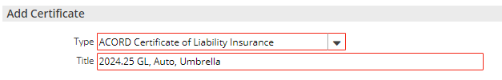

1. Click **Detail**.

1. Verify Named Insured + Address, this will prefill on all COIs.

1. Add applicable line of business, example:

1. From the navigation panel, Liability drop down, click **General Liability**.

1. From Available Templates, click **Add (+)**.

1. From the Line of business drop down, select the current General Liability policy.

1. From the Service summary drop down, select the correct Service summary.

1. Enter **Description**, example: 2024.25 General Liability.

1. Check **Default template**, to default coverage for each holder.
2. From the Type of Insurance/Limits tab, limits will populate based on the policy details entered in Epic.

1. If applicable, for an Acord 855 NY Construction COI Addendum option at the holder level, click **Acord 855 NY tab**.

1. From the Acord 855 NY, enter data as needed.

1. Repeat steps A-G as needed to add Auto, Excess/Umbrella, Workers Compensation + Other.

**Notes:**

**Available Templates:** Multiple templates can be added, and each template can include coverage and limit information applicable to the circumstance.

**Include history:** This will bring in all expired policies if you need to include historical policy details into the certificate.

**Include all lines of business:** This will bring in any other active lines of business.

**Line of business:** Select the appropriate policy.

**Service summary:** Select the appropriate Service Summary Row for the line of business, as the coverage and limits are based on the Service Summary Row.

**Description:** Enter title, when multiple templates are being utilized at the policy level be descriptive so you can differentiate.

**Default template:** By checking this, you will default this line of business to as holders are added.

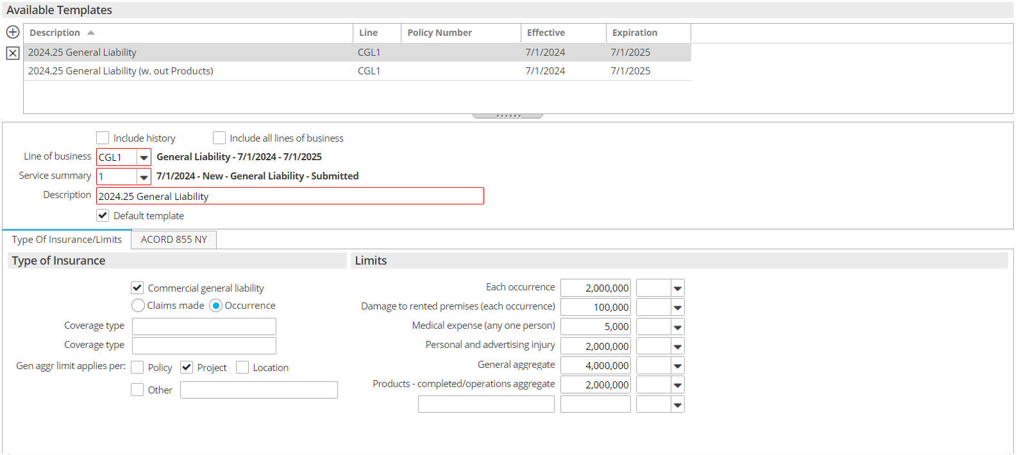

**Navigation panel, Description of Operations:** This will appear on every holder’s certificate that you use this template for, this is a template level Description of Operations.

**Navigation panel, Attachments:** These will appear on every holder’s certificate that you use this template for, this is a template level Attachment.

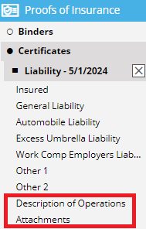

#### Add a Certificate Holder

1. From the navigation panel, click **Proofs of Insurance**.

1. From the Proofs of Insurance drop down, click **Certificates**.

1. From Certificates-Liability, double click your template.

1. From the navigation panel, click **Holders**.

1. To **Copy Holders** from another master certificate template:

1. Click, **Copy from Another Certificate**.

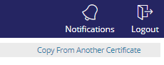

1. From the Default Holders window, click the **Default holders from** drop down.

1. Select the master template you would like top copy holders from.

1. Select each holder you would like to copy.

1. Select **Default the Holders description of operations**, if applicable.

1. Select, **Default the holders attachments**, if applicable.

1. Click **Finish**.

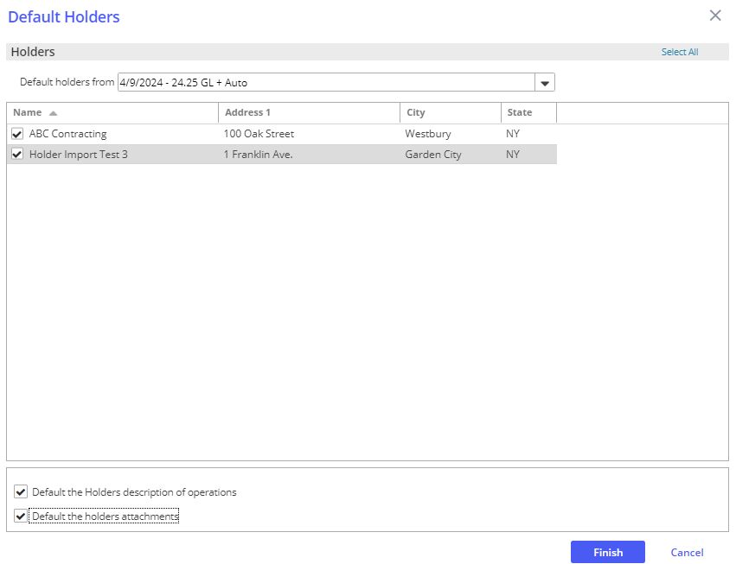

1. To add a **New Holder**:

1. From the navigation panel, click **Holders**.
2. From Holders, click **Add (+)**.

1. **Holder/Templates tab**:

1. **Holder**: Enter Name, Address and distribution method via the Distribute via drop down.

1. **Templates for this Holder**: Templates will default based on master template selection. Should template need to be changed, do so via the line of business drop downs.

1. **Include Acord 855 NY**: If you included an Acord 855 NY at the policy level, check this box to include a copy at the holder level. When you issue the COI the form will be included in it's original state.

1. **Email Recipients**: This will only be available if you select Email in the Distribute via drop down in the Holder section. This email address will prefill in the Delivery Options if you select to send via Email during issuance.

1. **Description of Operations tab**:

1. Enter the enter holder specific description of operations.  If you add language to the summary field, be sure to check the box to Print Holder Summary so it will appear on the certificate.  There is also room below this field to add more detailed information if needed.

1. **Documents Attached tab**:

1. Add attachments at the holder level, these will appear each time you issue a COI for the holder.

1. **Holder Details Tab**:

1. Check the applicable Additional Insured On + Subrogation Waiver On boxes.

1. Verify the Named Insured + Address. If you need to add a different Named Insured, click the magnifying glass to select the appropriate Named Insured from the **Contacts** area of the client’s account.

1. **Acord 855 NY**:

1. If you have an Acord 855 NY set up for your template and/or you need an Acord 855 NY specific to the holder and have checked off the Include Acord 855 NY box at the Holder/Templates tab, you can enter holder specific data.

1. From the navigation panel, click **X**.

#### Issue a Certificate

1. From the navigation panel, click **Proofs of Insurance**.

1. From the Proofs of Insurance drop down, click **Certificates**.

1. From Certificates-Liability, click the appropriate template to highlight.

1. From Holders, click appropriate holder to highlight.

1. From the menu bar, click **Actions**.

1. From the Actions drop down, click **Issue Certificate** for multiple holders, **Issue Single Holder** for one holder.

1. Organization Contact Tab, verify agency address and contact information.

1. Holder Distribution tab:

1. **Distribute to**: Uncheck the client name.
2. Check the Holder and click on the holder to highlight. The information showing beneath the Distribute To list pertains to the highlighted item. If issuing multiple holders, check off the additional holders, repeat as necessary.
3. **Scanned Signature**: Select from the drop down, this is a required field.
4. **Delivery Options**:  Select from the Via drop down. If emailing, subject is a required field.  You can also cc and bcc the certificate.
5. To preview COI before issuing, click **Download and Print**.
6. Click **Finish**.
7. From the Add an Activity window, click **Finish** on the **CERT** activity.
8. A copy of the COI is automatically attached in the client’s Attachments.

#### Renew Certificate

1. From the navigation panel, click **Proofs of Insurance**.

1. From the Proofs of Insurance drop down, click **Certificates**.

1. From Certificates-Liability, click the appropriate template to highlight.

1. From the menu bar, click **Actions**.

1. From the Actions drop down, click **Renew Certificate**.

1. Enter Title, example: 2024.25 GL, Auto, Umbrella.

1. Select the appropriate Default boxes:

1. **Description of Operations**: Will pull the existing template level Description of Operations

1. **Attachments**: Will pull the existing template level Attachments.

1. **Holders**: Will pull the existing schedule of holders.

1. **Include inactive holders**: Will pull inactive holders.

1. **Holders Description of Operations**: Will pull holder level Description of Operations.

1. **Holders attachments**: Will pull holder level attachments.

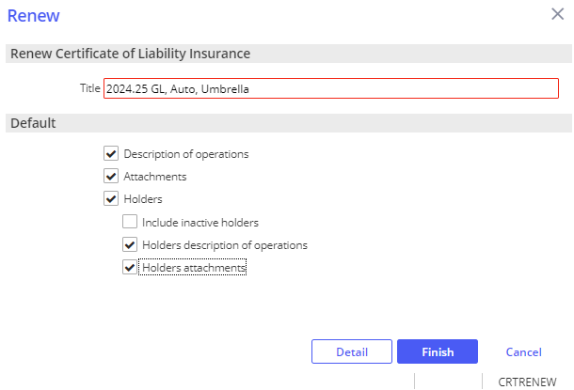

1. Click **Detail**.

1. From the Add an Activity window, add notes if needed, click **Finish** to close the **RCER** activity.

1. From the navigation panel, update the coverage details.

1. From the menu bar, click **Actions**.

1. From the Actions drop down, click **Issue Certificate**.

1. Organization Contact Tab, verify agency address and contact information.
2. Holder Distribution tab, click **Select All** to renew all holders or select holders as needed, uncheck clients name.

1. Delivery Options, select from the Via drop down.

1. To preview COIs before issuing, click **Download and Print**.
2. Click **Finish**.
3. From the Add an Activity window, click **Finish** on the **CERT** activity.
4. A copy of the renewal batch is automatically attached in the client’s Attachments.

### EPIC Binder

|  |  |  |
| --- | --- | --- |
| **SYSTEM GENERATED ACTIVITY** | | |
| Issue Binder | **BIND** | # Issued binder &PolDesc& &PolEffDate &Policy#& |

#### Issue Binder

1. Locate client in Epic
2. From the navigation panel, click **Proofs of Insurance**
3. Click **Binders**
4. Click **Add (+)**
5. Add **Description**
6. Highlight the appropriate policy
7. Click **Detail**
8. From the navigation panel, review/update binder details

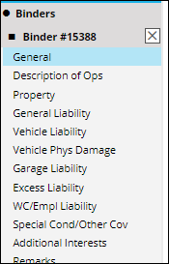

1. From the blue menu bar, click **Actions**
2. Click **Issue Binder**
3. Verify/Update, **RED** is required:
   1. **Organization Contact**
   2. **Additional Interest Distribution**
   3. **Download & Print**, to print preview
   4. Click **Finish**
4. **Activity**, **RED** is required:
   1. **Code**, BIND - # Issued binder &PolDesc& &PolEffDate &Policy#&
   2. **Description**, best practice is to leave the description that prefills based on your activity, adding in any data if prompted, you can add to the end of the description.
   3. **Who/Owner**
   4. **Follow up/Start**
   5. **Status**, defaults as **Open** to follow up as needed
   6. **Notes**

Click **Finish**

#### Extend Binder

1. Locate client in Epic
2. From the navigation panel, click **Proofs of Insurance**
3. Click **Binders**
4. Highlight the appropriate Binder
5. From the blue menu bar, click **Actions**
6. Click **Extend Binder**
7. Verify/Update**, RED** is required**:** 
   1. **Expiration**, defaults to 30 days, select time
   2. **Description**
   3. Click **Finish**

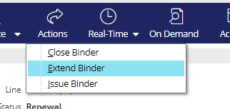

1. From the blue menu bar, click **Actions**
2. Click **Issue Binder**
3. Verify/Update, **RED** is required:
4. **Organization Contact**
5. **Additional Interest Distribution**
6. **Download & Print**, to print preview
7. Click **Finish**

#### Close Binder (Policy/Endorsement Received)

1. Locate client in Epic
2. From the navigation panel, click **Proofs of Insurance**
3. Click **Binders**
4. Highlight the appropriate Binder
5. From the blue menu bar, click **Actions**
6. Click **Close Binder**

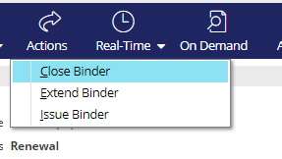

1. Verify/Update, **RED** is required:
   1. **Closing Details**
2. **Closing description**
3. **Disposition**
   1. **Close Open Activities,** if applicable
   2. Click **Finish**

## JA.6 DocuSign Integration

**From Attachments in the Client’s account**:

1. Right-click the attachment and select **Send to eSignature**

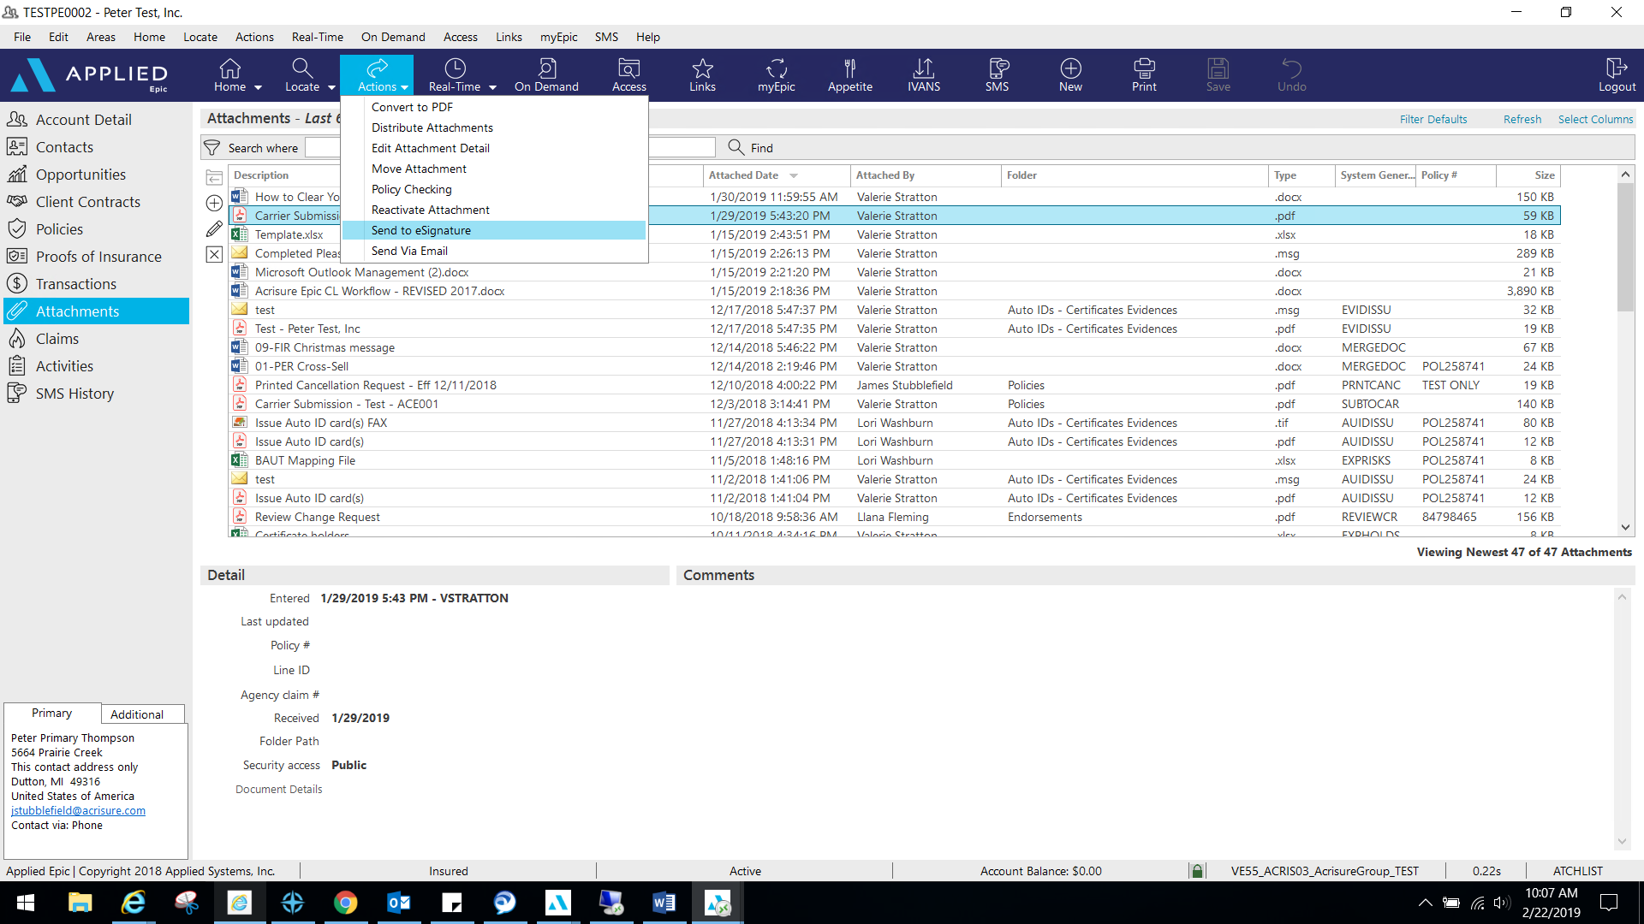

1. 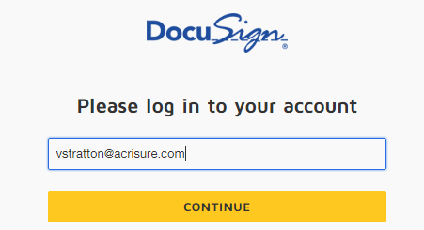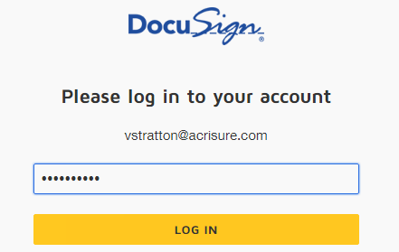Log into **DocuSign** using your email address and password.
2. Allow DocuSign permission to integrate with Epic.

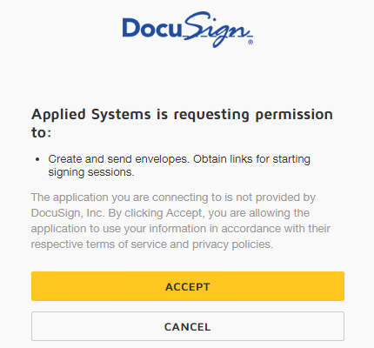

1. Select an Epic Contact; click the TO button

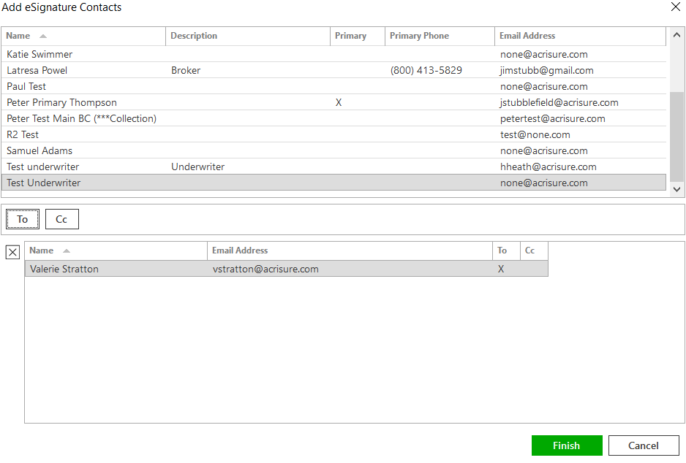

1. Please wait while Epic directs the document to DocuSign for signatures fields.
2. Add appropriate fields for signature, date, text, etc. by dragging and dropping onto the document.

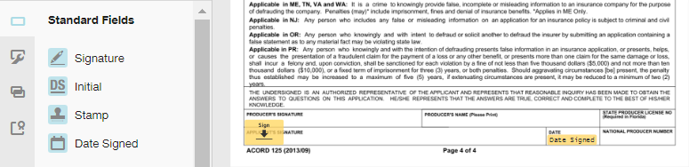

1. If you are using a template, you will need to remove the extra recipient. Actions>Edit Recipient.  
   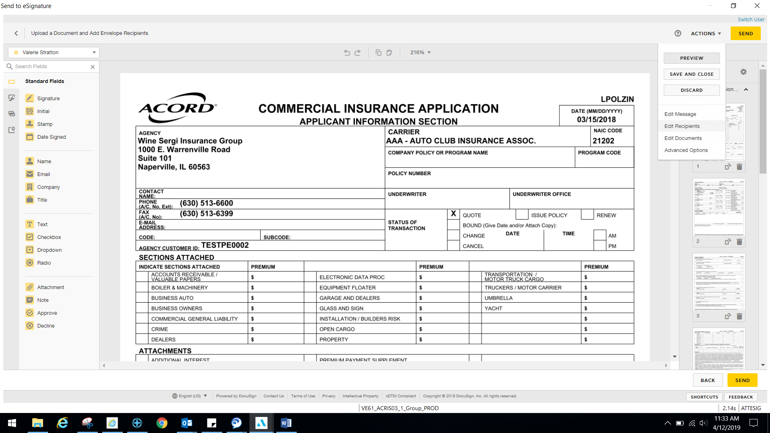
2. Once finished, select Actions>Edit Message.

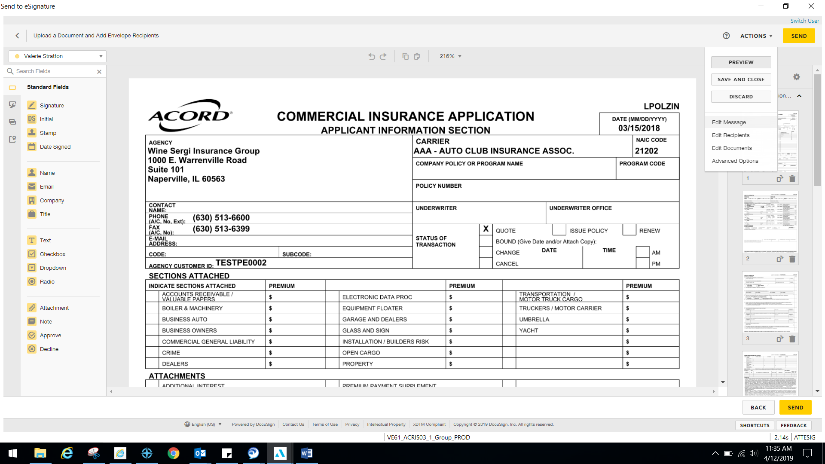

1. Edit the email subject line and personal message to client and select Done.

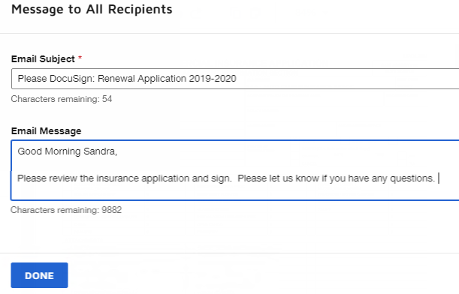

1. Select Send in the top right or bottom right corner when finished.

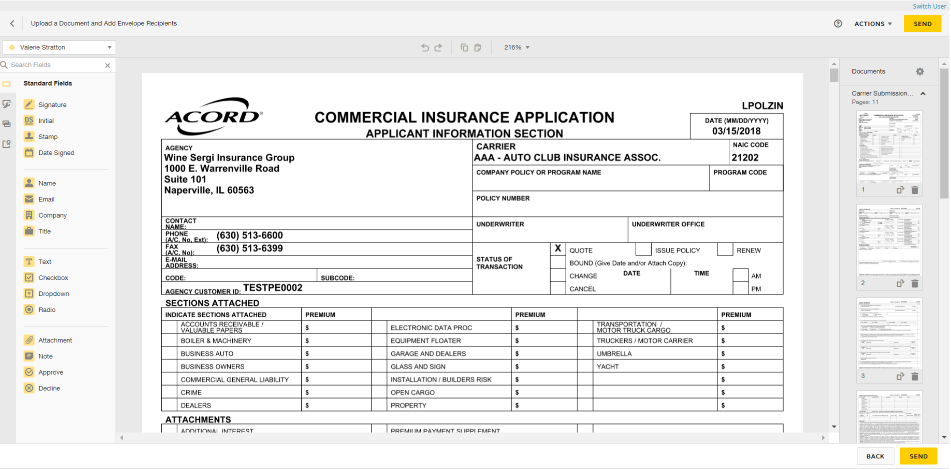

1. You will be redirected to your DocuSign account to manage your envelopes. Close out when finished.
2. **ESIG** will be the automatic activity generated once finished and will automatically remain open for follow up. Close **ESIG** as successful if there is another open activity related to this process.

## JA.7 Attachment Naming Conventions

|  |  |  |
| --- | --- | --- |
| **Document Type** | **Naming Convention** | **Example** |
| Applications | YY-YY (Line of Business) Application, Carrier (to be Completed, signed etc) YY-YY (Line of Business) Application, Carrier (completed, signed etc) | 23-24 Auto Application Travelers, to be completed/signed 23-24 General Liability Hartford Contractor Supp completed and signed |
| Audit | YY-YY (Line of Business) Audit, Carrier | 22-23 General Liability Audit, Travelers 22-23 Workers Comp Audit, Travelers |
| Cancellation Confirmation | YY-YY (Line of Business) Cancellation, Eff MM-DD-YY, Reason | 23-24 Auto Cancellation, Effective 6-29-23, Non-Payment of Premium |
| Carrier Submissions | YY-YY (Line of Business) Submitted to (Carrier) | 23-24 General Liability, Auto Umbrella Submission to Mike@Hartford |
| Emails |  | Request to Sam/Insd for information on 2012 Ford Request to Jim/Liberty/UW request for MVR information |
| Endorsement Received | YY-YY (Line of Business) Endt (#) received Eff MM-DD-YY change description | 23-24 General Liability, Endt #5 received, Eff 5-1-23 amending sales to $500,000 |
| Endorsement Request to carrier | YY-YY (Line of Business) Endt (#) to(Carrier) Eff MM-DD-YY change description | 23-24 Auto Endt to Travelers Eff 6-29-23 Adding 2024 Ford Explorer Vin (last 4)  23-24 General Liability to Fran @ Travelers Endt Eff 6-29-23 Amend Sales to $500,000  23-24 Home Endt to processing team Effective 6-29-23 Increase home limit to $550,000 |
| Intent to Cancel | YY-YY (Line of Business) Intent to Cancel, Eff MM-DD-YY, Carrier, reason | 23-24 General Liability, Intent to Cancel, Eff 6-29-23 IPFS, non-payment of premium 23-24 Auto, Intent to Cancel, Eff 6-29-23 Travelers, Underwriting - MVR John Smith |
| New Policy -CL | YY-YY (Line of Business) Policy, Carrier, Effective Date | 23-24 General Liability Policy, Travelers, Eff 6-29-23 |
| New Policy - PL | YY-YY (Line of Business) Policy, Carrier, Effective Date | 23-24 Workers Comp Policy, Travelers, Eff 6-29-22 |
| Nonrenewal Notice | YY-YY (Line of Business) Non Renewal Notice, Eff MM-DD-YY, Carrier, reason | 23-24 Auto Non- Renewal Notice, Eff 6-29-23 Travelers, no longer a market |
| Quotes | YY-YY (Line of Business) Quote Carrier, Quote $ | 23-24 Workers Comp Quote, Hartford, $500 |
| Reinstatement | YY-YY (Line of Business) Reinstatement Eff MM-DD-YY | 23-24 Auto Reinstatement Eff 06-29-23 |
| Renewal Policy - Non Select Middle Market CL and all PL Policies | YY-YY (Line of Business) Policy, Carrier, Effective Date | 23-24 Auto Policy, Travelers, Eff 6-29-23 |
| Renewal Policy - Select Middle Market CL Policy | YY-YY (Line of Business) Policy, Carrier, Effective Date | 23-24 General Liability Policy, Travelers Eff 6-29-2023 |

**For policy terms that do not run annually, you can adjust the YY-YY as needed by adding in a MM/YY – MM/YY.**

**System generated attachments do not have to be renamed to follow the naming convention**

## JA.8 CSR24 – Set Up Portal User from EPIC Contacts

To set up a Contact as a Portal User:

1. Locate the Client’s Account in Epic
2. Click **Contacts**
3. Click **Create Portal Account button**

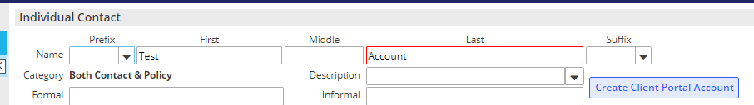

1. Click the Contact you wish to set up as the Portal User
2. In the top blue options bar, click Portal

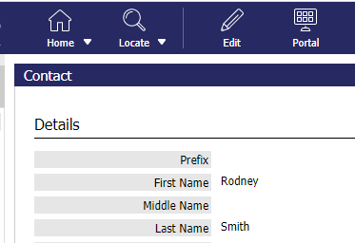

1. Username defaults to contact’s email address; change if necessary
2. Click the blue “Change Password” link and enter a temporary password

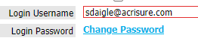

1. Check the box to Require User to change password on next login

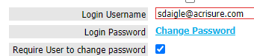

1. Select a Start Page to assign to this client contact (you will see your agency’s start page(s) in the dropdown list)
2. At the bottom of the screen, click this link

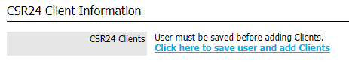

1. At the top of the screen, click the SAVE button



1. You will notice that back in the Contacts area, the Portal user box will be checked for the contact you just added.

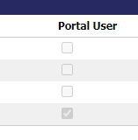

1. Repeat the process for any contact listed as needed.

## JA.9 CSR24 – Making Attachments Client Accessible

1. Locate the Client’s Account in Epic
2. Click Attachments from the left navigation panel
3. Right click on the attachment you wish to give your client access to, and select **Edit Attachment Detail**

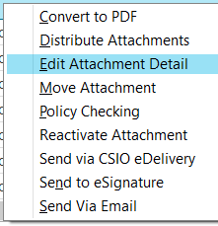

1. In the Attachment Details window:
   * Update the description as needed
   * Select the appropriate folder (select a folder only from this list)
   * Check the **Client Accessible** box
   * 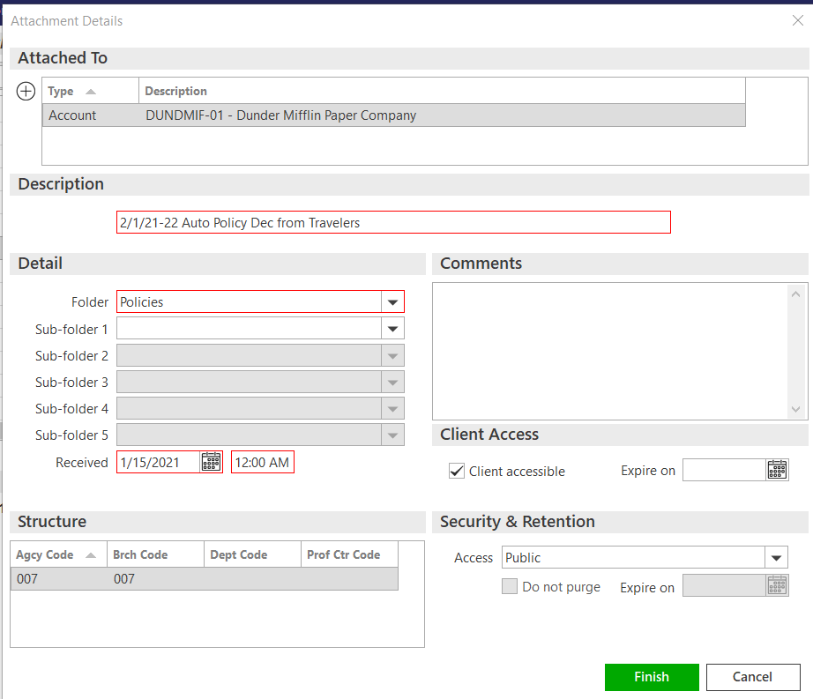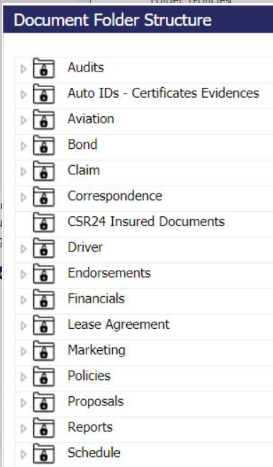Click **Finish**

## JA.10 Front End Batch Scanning in Epic Browser

#### Front End / Batch Scanning Process

**Generate Employee Barcodes**

1. From Home Base, click Procedures in the Navigation Panel
2. Select Document Management
   1. Click Print Front End Barcodes

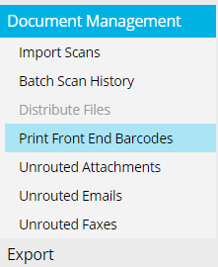

* 1. Click **Employee Barcodes** radio button.
  2. Insert employee code options.
     + In the first *Display employee codes* field, type at least one letter of the first employee code to be displayed. In the second field, type at least the first letter after the last employee code to be displayed. (For example, if you want to display all employees with codes that start with "G" or "H," enter **G** in the first field, and **I** in the second field.)

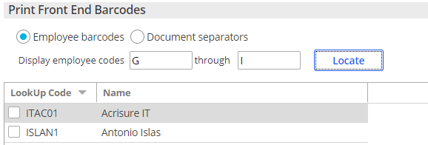

* 1. Click **Locate**

1. Select Employee(s) needed.
   1. You may select multiple Employees at one time
   2. Click **Print**
   3. Save Employee Barcodes to your One Drive for future use. Employee Barcodes can be used multiple times.
2. Select **Document Separators** radio button and Click **Print**.

#### Scan Mail

1. From Home Base, click **Procedures > Document Management > Import Scans**  
   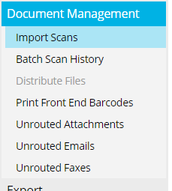
2. Separate employee mail into stacks, place employee barcode on top and place separator pages in between each completed piece of mail. ***Repeat these steps for each employee.***
3. Put all mail in one stack and place it on Scanner.
4. Scan mail to your computer:
   * Via email or
   * Via save to One Drive
5. Drag and Drop PDF into the **Import Scans** area or click Browse to locate the document on your computer.

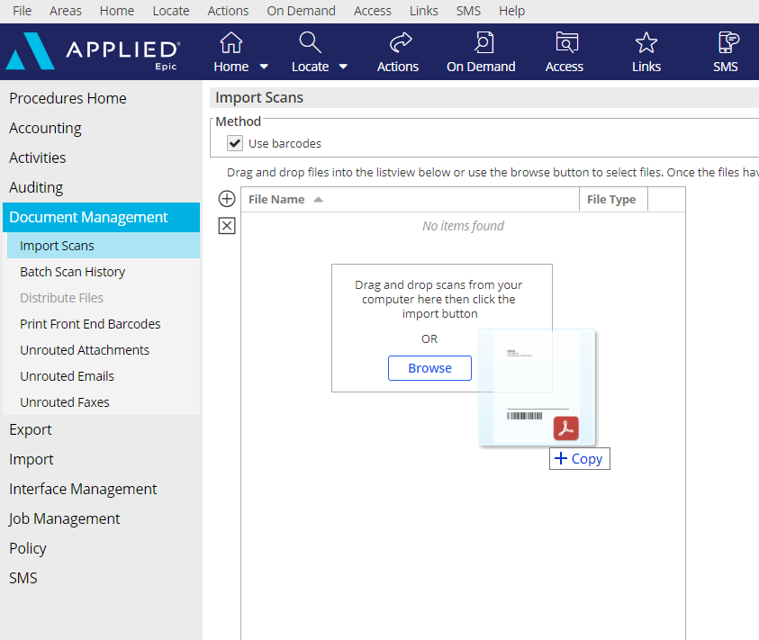

1. Once the Document is in **Import Scans** area, Click **Import.**

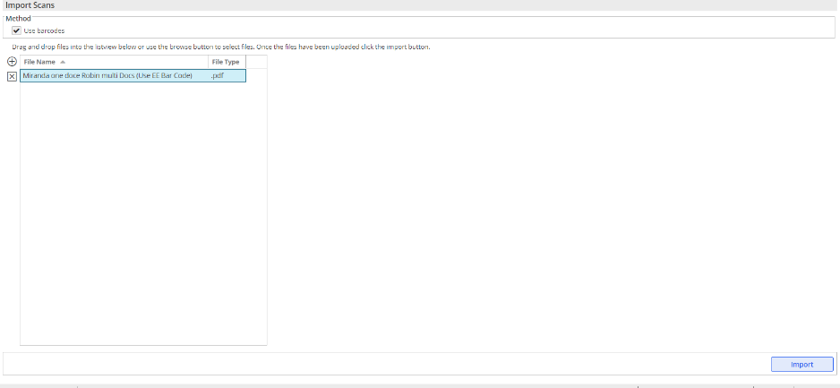

1. Employees will receive their scanned documents in **Unrouted Attachments** on their Home Base

#### Managing Unrouted Attachments (Front End Scanning)

1. From the New/Waiting area of the Home Base, click **Unrouted Attachments**
2. Displayed will be a list of items scanned. A preview of the highlighted item will appear on the right

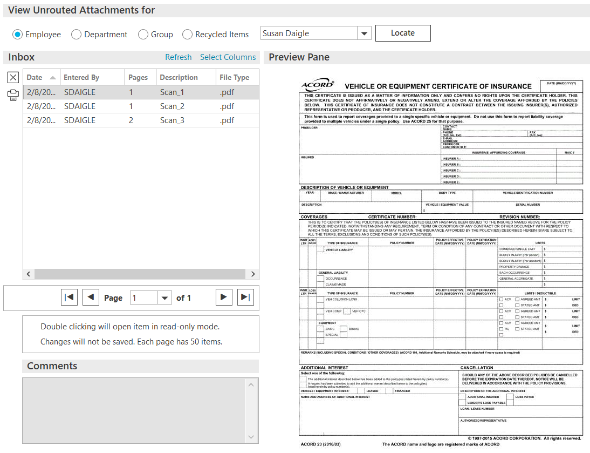

1. Highlight the item you want to manage, then click **ACTIONS**. You will get a drop-down list of available functions

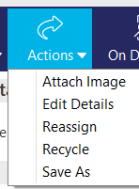

* **Attach Image** – the best practice is not to use this under Actions, but instead drag and drop from Unrouted attachments to the client’s account.
* **Edit Details** – edit the description of the scanned item before you drag and drop
* **Reassign** – reassign to another employee if the item was directed to you by mistake
* **Recycle** – if the item does not pertain to a client and you do not need to save it
* **Save As** – save the scanned item outside of Epic

## JA.11 Creating a Proposal or Summary in Epic

### General Information

|  |
| --- |
| **Notes:**   1. The same proposal group works from either the Current/Future lines or the Marketed lines (at the carrier response stage) 2. Each line of business is configured to pull the following four (4) areas from the Epic policy details into the Line of Business page:    * Additional Coverages    * Forms & Endorsements    * Remarks (only when the Print on form is checked)    * Additional Interest 3. When using the Summary Group, users will have to associate the Line of business to both the Premium Summary pages and the Detail pages for each selected policy. This will ensure that the policies will appear on the premium summary page as well as the policy detail pages. 4. Remember to enable Macros when the Word document generates as this is how the data merges into the document. 5. The overall formatting of each page of the Proposal and Summary templates has been designed to meet the legal specifications of Acrisure and to meet general needs of most of the users. The word document will need to be reviewed carefully as some data may need to be manually updated. Tables and data fields with no information should be updated or deleted and spacing should be adjusted to provide a professional look and feel. 6. Before selecting Finish, you can add/move/delete pages, using the buttons on the left. 7. If you have multiple LOB of the same type, extras will drop to the bottom of the list. Be sure to reorder them before pressing Finish. 8. The premium summary page must appear after all the LOBs. Note: after merging, it can be moved. 9. LOBs without an associated Line will be suppressed by default. Uncheck the box next to Suppress blank templates to bring in the page even if there is not a LOB connected yet (e.g. you want to offer Cyber but it is not included on your account yet). |

### Summary of Insurance + Proposals

|  |
| --- |
| 1. From you clients navigation panel, click Policies 2. Select Policies – Current/Renewed or Policies - Marketed 3. From the blue menu bar, click **On Demand** 4. Click **Proposal**   **Refer to the screen shot below and the corresponding numbers with the following steps:**     1. From **Lines of Business**, Add (+)/Remove (X) the policies that will need to be included in the Proposal/Summary of Insurance.    1. Click the **Add** (+) button and choose from either:       1. The available current/renewed policies, if generating from the current/renew policies view       2. The available lines being in the marketing submission, if generating from the marketing area 2. From **Proposal Templates/Proposal Documents** select the appropriate option from the **Proposal Group** drop down. The NY Platform has the following options and each one has preselected pages within the group. Choose the option that best suits your needs: 3. CL Acrisure Summary of Insurance 4. CL Proposal (Landscape) 5. CML Pre-Renewal Document & Questionnaire 6. PL Acrisure Summary of Insurance 7. PL Proposal (Landscape)   f. TRU. Acrisure Trucking Proposal   1. The Proposal Templates/Proposal Documents box will display all the preselected pages available based on the selected Proposal Group. This list must be reviewed, and pages deleted or rearranged based on guidelines determined by your leadership.    1. You must have a **Cover Page** and it must be in the top position. Associate a Line of Business to the **Cover Page** to pull agency information.    2. Associate a Line of Business to the **Location Summary** page to pull premises data. 2. Individual Contacts are from the Account Contacts tab and will default with the Primary contact. added here will pull through to the Authorized Persons page. |

# JA. 13 Indio

**Notes:**

**For all documents requiring E-Signature, Indio is the preferred platform method.**

**Log in to AcrisureNY Indio via Epic:**

1. Locate your client

2. From the blue menu bar, click Links

3. Double click Personal Lines – Resources

4. Double click Indio

**Log in to AcrisureNY Indio via web browser:**

[**Indio (useindio.com)**](https://acrisureny.useindio.com/signin)

## New Business Submission Processing

1. Click the LINK to access Indio online
2. Enter your login (email address); click Continue
3. Select AGENT
4. Enter Password; click Log In
5. Home base will show list of accounts that you are tied to, if accounts have been added previously
6. To Import an Account from Epic, Click the Import Account Button

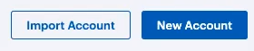

1. Enter the Epic Client Lookup Code (Prospect or Insured), click Preview

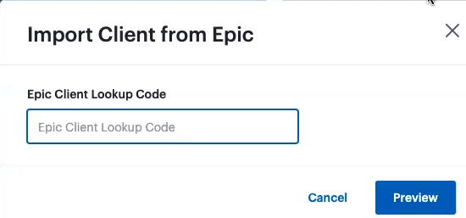

1. To add a new account, click the New Account button
2. Enter Account Information, i.e. Business Name, Regions and Epic Client Lookup Code, if known.
3. Click Next

## E-Signature

1. From gray menu bar, click **Accounts**

1. **Accounts List**, your list of accounts
2. **Filter**, to filter your account view
3. **Search**, to search for an account

2. Click your account

3. From the navigation panel, select **E-Signatures**

4. **If you need to select an inhouse signor that is not included as a Contact in Epic, or the PC Servicer 1 in Epic, manually add an Assigned Agent:**

**Add Assigned Agent manually, if applicable:**

1. **Hover over Assigned Agents**
2. **Click Edit**
3. **Click + Agent**
4. **Make your selection from the drop down.**
5. **Click Add**
6. **Click Save**

5. Click + New or New E-Signature

6. From Add Documents, Drag and drop to upload files OR browse

7. Click **Next**

8. From **Add Signers**, check the box to add a signer

9. **If you would like to** **Set Signing Order, where multiple signers exist:**

**Set Signing Order, if applicable:**

* 1. **Check Set Signing Order**
  2. **Click Next**
  3. **Drag signers to your desired order.**
  4. **Click Next**

**If you do not need to or want to** **Set Signing Order, click Next.**

10. From the navigation panel, left click each data field and drag to the appropriate section of your document where applicable:

1. **Signature**
2. **Initials**
3. **Name**
4. **Date**
5. **Text**
6. **Checkbox**

11. From your document, left click each data field to choose the appropriate signer.

12. From **Who needs to complete this field**, use the drop-down arrow to assign a signer. Where multiple signers exist, each will have its own designated color.

13. From the navigation panel, check **Signature Request Expiration,** to add an expiration date, add number of days

14. From the navigation panel, check **Send Email Reminders to**, to send reminders, add days, add number of days

15. Click **Next**

16. From **Send Options**:

1. **Notify Signers**, select applicable:
2. By emails and in the Indio portal
3. Only in the Indio portal
4. **E-Signature Name**:
5. Name your document, example: Consent Form; Lost Policy Release; Supplemental Application
6. **Message**, if applicable
7. Click **Send**

17. Click **Done**

18. From **E-Signatures**:

* 1. **In Progress**, your in-progress eSignatures**:**
     1. To view status, click on the **color-coded icon** from the applicable document in the list
     2. Click the **Ellipsis** to:
        1. View Document
        2. Download
        3. Edit Expiration and Reminders
        4. Resend Invitation to Sign
        5. Edit Signers
        6. Delete E-Signature
  2. **Completed**, your completed eSignatures.

# JA. 14 Non-Insurance Product Policies

|  |
| --- |
| **Follow the below steps to set up a policy for the Acrisure Non-Insurance Products (Acrisure Cyber, PEO, Acrisure Title Referral)** |

## Add Policy

* Policy is set up like other P&C policies.

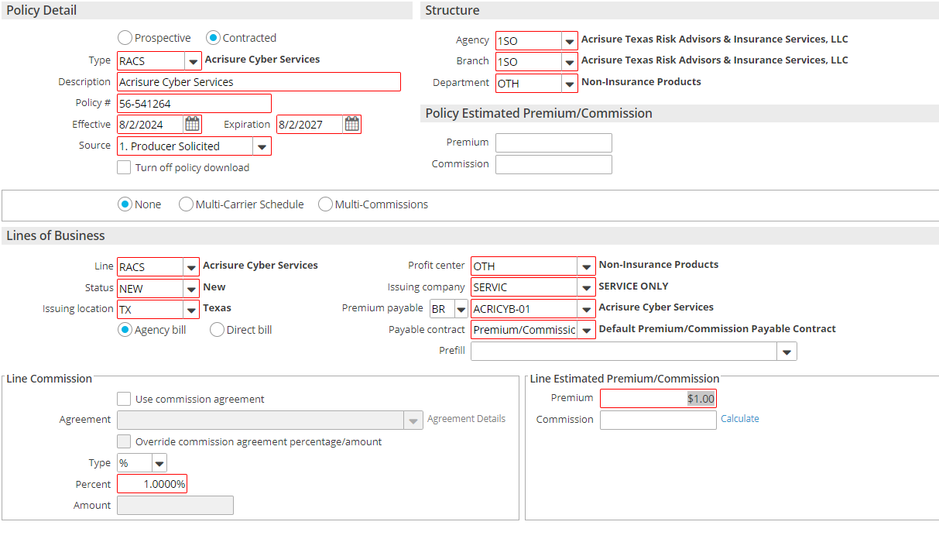

* **Type** is an “R” Policy code
* **Department** should be OTH – Non-Insurance Products
* **Line** of the policy will default when the policy is set up
* **Issuing location** would be the primary location
* **Agency Bill** bubble should be selected
* **Profit Center** should be OTH – Non-insurance products
* **Issuing Company** should be Service Only
* **Premium Payable** should be changed to BR and chosen from the chart below.
* Note the below PPEs for the corresponding Non-Insurance products.

|  |  |  |  |  |  |  |
| --- | --- | --- | --- | --- | --- | --- |
| **Policy Code** | **Description** | **ICO Code** | **ICO Description** | **PPE Type** | **PPE Code** | **PPE Description** |
| R401 | 401k Referral | SERVIC | SERVICE ONLY | BR | HUMAINT-01 | Human Interest |
| RACS | Acrisure Cyber Services | SERVIC | SERVICE ONLY | BR | ACRICYB-01 | Acrisure Cyber Services |
| RODP | On Demand Pay Referral | SERVIC | SERVICE ONLY | BR | DAILPAY-01 | Daily Pay |
| RPA2 | Payroll Referral | SERVIC | SERVICE ONLY | BR | ISOLVE0-01 | iSolved |
| RPEO | PEO | SERVIC | SERVICE ONLY | BR | Varies based on who it's written with | |
| RSLO | SMB Loan Referral | SERVIC | SERVICE ONLY | BR | ONDECK0-01 | OnDeck |
| RTIT | Acrisure Title Referral | SERVIC | SERVICE ONLY |  |  |  |

# JA. 16 Conversion Cleanup – Update Incorrect Policy Type

## Policy is in Submitted or Issued status:

1. Right click on the incorrect policy
2. Select **Endorse/Revise > Add Line Mid-Term**

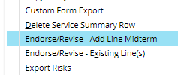

1. Enter **Effective Date** of Change as the **Effective Date of the Policy**
2. Enter **Description** as **Conversion Cleanup**
3. Click the **Add** button to add the correct **line of business** policy type

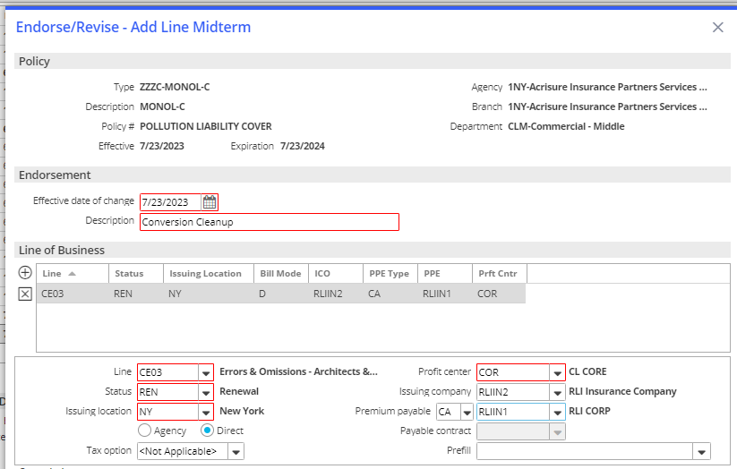

1. Click **Detail**
2. Choose the **CHGL** Activity – Mark Closed/Successful
3. Click **Finish**

## Change Policy Type Header – If Applicable

1. From the left navigation panel, click **Servicing/Billing > Policy**
2. On the **Policy Detail,** change the policy header **type** to the correct policy and update the description (if needed)

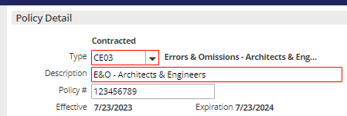

1. From the left panel, click **Line**
2. Click once to highlight the incorrect policy in the list and change the status to ZER (Created in Error)

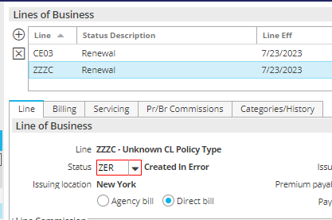

1. Click the **X** on the left panel to close out of the policy detail.
2. Select **Yes Perform Action** > **Issue/Not Issue Endorsement**

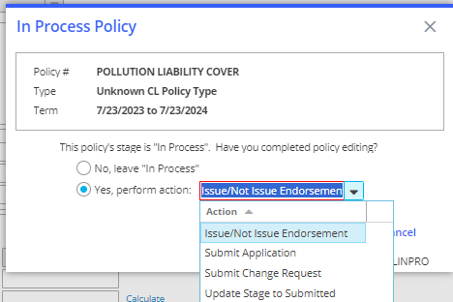

1. Click **Finish**
2. Click **Finish** again.
3. The policy should look like this

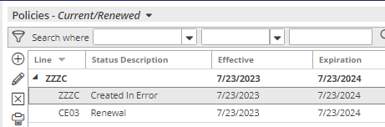

**At renewal**, if you choose **Actions > Renew**, **uncheck the line created in error**, and continue with the renewal process. This will completely remove the additional line from the policy for the renewal term.

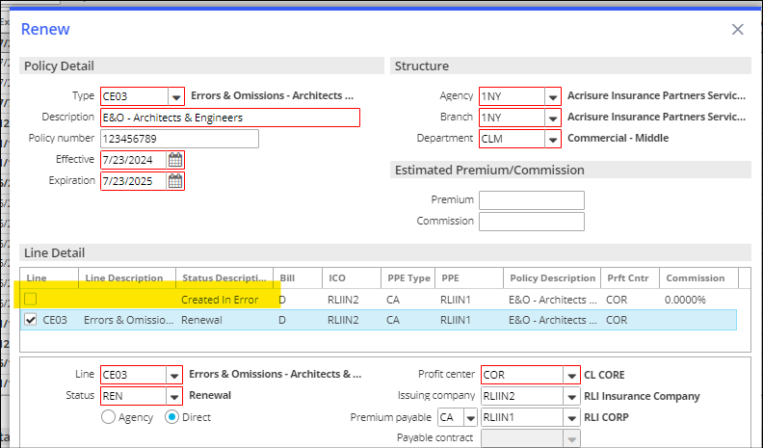

## Inactivate an Incorrect POLICY/ MIGRATED LINE(S)

1. Double-click the incorrect/migrated policy to open
2. Click on **Servicing/Billing > Policy** on left navigational panel
3. In Policy # - Add **DNU_** to beginning of policy #

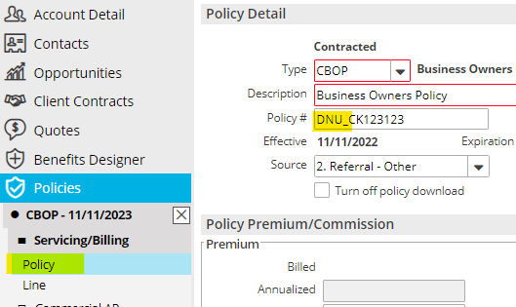

1. Click on **Servicing/Billing > Line** on left navigational panel
2. Update Policy Status to **ZER** – Created in Error

* Click Apply to All Lines in top right corner of area
* Apply to all lines > Click Yes

1. Click **X** on left navigational panel to return to ‘Policies – Current/Renewed’
2. Highlight one of the lines from the incorrect/migrated policy
3. Click **Actions > Change Effective/Expiration Date**
   1. Update Expiration Date – to one day following the Effective Date of the Policy
4. Click **Finish**
5. An activity of **CEED** is created
6. Close the activity as Successful.
7. Click **Finish**

## Policy is In Process Status

1. Double click the Policy to correct
2. From the left navigation panel, click **Servicing/Billing > Policy**
3. Change the Policy **Type** to the correct one
4. Update the **Description** (if needed)

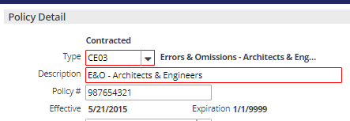

1. From the left navigation panel, click **Line**
2. Click the **ADD** Button under Lines of Business

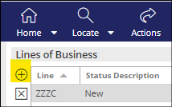

1. Select the correct Policy **Line** Type from the dropdown list

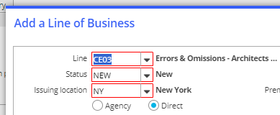

1. Update **required fields**
2. Click **Finish**
3. Highlight the incorrect policy line type and click the ⌧ to delete the line

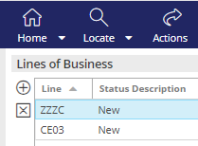

1. Click **Yes** on the popup message to delete the incorrect line

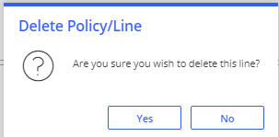

1. Update ACORD detail (as needed on the left navigation panel)
2. When finished, click the **X** on the left panel to close out of the detail
3. Click **Yes Perform Action > Issue/Not Issue Policy**
4. Click **Finish**
5. Click **Finish** again.

# JA. 17 Policy Setup – Invoice Needed prior to Binding

|  |
| --- |
| The following workflow details the modifications to the renewal or marketing workflow when an invoice is needed, or you are providing an Applied Pay link prior to binding coverage with the carrier. |

## Create Policy

### Policies – Current/Renewed (no marketing module used)

|  |
| --- |
| 1. Highlight policy, **ACTIONS > Renew** 2. Update Policy number to **TBD** 3. Confirm accuracy of or update Policy type, Effective date, Expiration date, Agency, Branch, Department, Line type, Status, Bill type and Profit center 4. Update Issuing and Billing company to the **Issuing Company** and the **Premium Payable** carrier or broker listed on the Quote. 5. Confirm accuracy of or update Line Commission percent 6. Click DETAIL   A screenshot of a computer  Description automatically generated   1. **RPOL** activity – add notes (including that this policy is not bound) and amend Follow-up/Start date to a future date to pend for receipt of policy and click FINISH. 2. Update application details and when finished click the X in the navigation panel to close. 3. Leave policy “In Process” and FINISH. 4. Highlight the renewed policy, **ACTIONS > Change Policy Prospective/Contracted Status** and click YES to amend the policy to Prospective. |

### Policies – Marketed (marketing module used)

|  |
| --- |
| 1. Follow marketing or marketing lite workflow through Creating Carrier Response 2. Highlight carrier submission, **ACTIONS > Move Marketed Lines to Current Policies** 3. **Policies tab**    1. Select Add new policy, Renew existing policy, or Update existing policy    2. Enter Policy type    3. Confirm the accuracy of or update the Description, Effective date, and Expiration date    4. Update Policy # to **TBD**    5. Enter Source    6. Update Stage to **In-Process** and **Prospective**      1. **Lines tab**    1. Select Line(s) to be added to this policy    2. Confirm accuracy of or update Status, Profit center, Line commission percent, and Line Estimated Premium and Commission    3. Update the Issuing and Billing company to the **Issuing Company** and the **Premium Payable** carrier or broker listed on the Quote.    4. Review Billing, Servicing, Pr/Br Commissions tabs for accuracy or update as needed.    5. Repeat for each line where applicable 2. Click MOVE 3. Update Submission status to Completed and click FINISH   A screenshot of a computer  Description automatically generated   1. **BND1** activity – add notes (including that this policy is not bound) and amend Follow up/Start date to a future date to pend for receipt of policy and FINISH |

## Create Invoice Request for Accounting

|  |
| --- |
| 1. Highlight prospective policy 2. Add applicable Accounting activity and add a note to **Invoice** (reference the accounting [Platform Activities Guide - Servicers](https://acrisure.sharepoint.com/:w:/s/ACR-ABSAccountingTeam/ESAdZgcBwPdJt0_n5-hNILkBueeqZpQWrGK6rg54rr9l7g?e=4LVSdM&clickparams=eyJBcHBOYW1lIjoiVGVhbXMtRGVza3RvcCIsIkFwcFZlcnNpb24iOiI0OS8yMzExMzAyODcyNCJ9&wdLOR=cC0B69E85-42BA-450A-8908-0E0D906D9928) for further details) |

## Quote Accepted/Rejected

### Quote Accepted

|  |
| --- |
| 1. Highlight prospective policy, **ACTIONS > Change Policy Prospective/Contracted Status** and click YES to amend the policy to Contracted.   A screenshot of a computer screen  Description automatically generated   1. Double click to open policy and go to Servicing/Billing    1. Policy – Update Policy #    2. Line – Confirm accuracy of Pr/Br Commissions 2. X to close application 3. Update the Stage to Submitted and FINISH      1. If premium is different at binding - locate your accounting activity and re-assign to the invoicing team asking to correct the invoice/transaction. Attaching supporting documentation as needed. |

### Quote Rejected

|  |
| --- |
| 1. Highlight prospective policy, **ACTIONS > Issue/Not Issue Policy**    1. Update the Expiration date to match the Effective date    2. Select Not Issue (repeat for all lines in a package policy)    3. Change Status to ZER    4. FINISH   A screenshot of a computer screen  AI-generated content may be incorrect.   1. Locate your accounting activity and re-assign to the invoicing team asking to reverse the transaction explaining the quote was not accepted. 2. Locate the expiring policy (if applicable) and change its status to **X-N** or **X-R,** depending on the policy's current status. |

# JA. 18 Attachments – Rename or Move

## Rename Attachments

* + - 1. Right click on your attachment.
      2. From the drop down, click **Edit Attachment Detail**.
      3. From Attachment Details, verify/update:

a. **Description,** follow the**NY Platform Attachment Naming Conventions**

b. Click **Finish**

## Move Attachments

1. Right click on your attachment.

2. From the drop down, click **Move Attachment**.

3. From Move Attachments, verify/update:

a. **Destination,** select **To another account**

b. **Move To**:

i. **Account type**, from the drop down, select **Client.**

ii. **Account code**

c. **Attach To**

d. Click **Finish**